REPORT
GAFSP CSO Country Mission
BANGLADESH
April 2- 4, 2013

EXECUTIVE SUMMARY
The Third Mission by the CSO representative to the Steering Committee conducted last April 2-5, 2013 in Bangladesh succeeded in generating updates re. the Integrated Agricultural Productivity Project (IAPP), updates on the Technical Assistance Component of IAPP being carried out by FAO, more knowledge on PRAN, IFC or the Private Sector Window of GAFSP and their relations with the IAPP (Public Sector Window). It also succeeded in catalysing the first ever meeting among key actors and actresses of both GAFSP Windows in Bangladesh.
Definitely the IAPP was in full swing having convened twice the Steering Committee, completed hiring of some 700 management, technical and frontline staff, established management systems, trained and deployed 375 community facilitators to reach out to more than 350,000 farmers. The private sector window project was likewise ongoing, reaching out to 3,000 new farmers in contract growing arrangement with the agri-business processing company, PRAN.
Key issues raised during the Mission included: 1) the weakness of IAPP solely dedicated to agriculture productivity without a marketing component, 2) the non- interaction and coordination of two GAFSP funded projects, one from the public sector window (IAPP) and the other from the Private Sector Window (PRAN) of GAFSP; and 3) the limited role of the coalition of NGOs and Producers organizations in Bangladesh in IAPP governance ( i.e., National Project Steering Committee) and project implementation;
The Mission ended with the dialogue among stakeholders expressing interest to coordinate more close and for Action-Aid to continue to catalyze the forum of both GAFSP windows

MAIN REPORT

Background
AFA and FAO would like to discuss further the details of planned study tours of IAPP FO partners to FNN and SEWA. The GAFSP Steering Committee was discussing the relationship between the projects funded by the public sector window and the private sector window. The GAFSP private window had approved a project with PRAN. Action Aid was conducting a research on the PRAN project. It would be good to know the findings of the research on PRAN, and see how it related to the IAPP. The analysis could be fedback during the discussion of the GAFSP SC on this matter.

Objectives
The mission had three objectives: 1) discuss in more detail the planned study tour in SEWA and FNN by FAO; 2) get feedback on the IAPP project, status of implementation, and 3) get feedback on the PRAN project so as to better understand dynamics of the private and public sector projects of GAFSP.

The mission was conducted by Soc Banzuela, CSO-Asia representative (alternate) and Amirul Islam, Deputy Director, Food Rights and Sustainable Livelihoods, Action Aid Bangladesh and Secretariat –in-charge, Kendrio Krishok Moitree (Central Farmers Alliance)

Activities
Courtesy Calls and meetings were made with IAPP, FAO, PRAN, and IFC officials on April 3 and a Conference attended by CSOs, IAPP, FAO, PRAN, and IFC officials was conducted the next day. Planning meeting with AAB was done after.

Key Findings from Meetings with Government , SEs and CSOs

April 3, 2013, AM Visit to IAPP PMU, , IAPP Conference Room
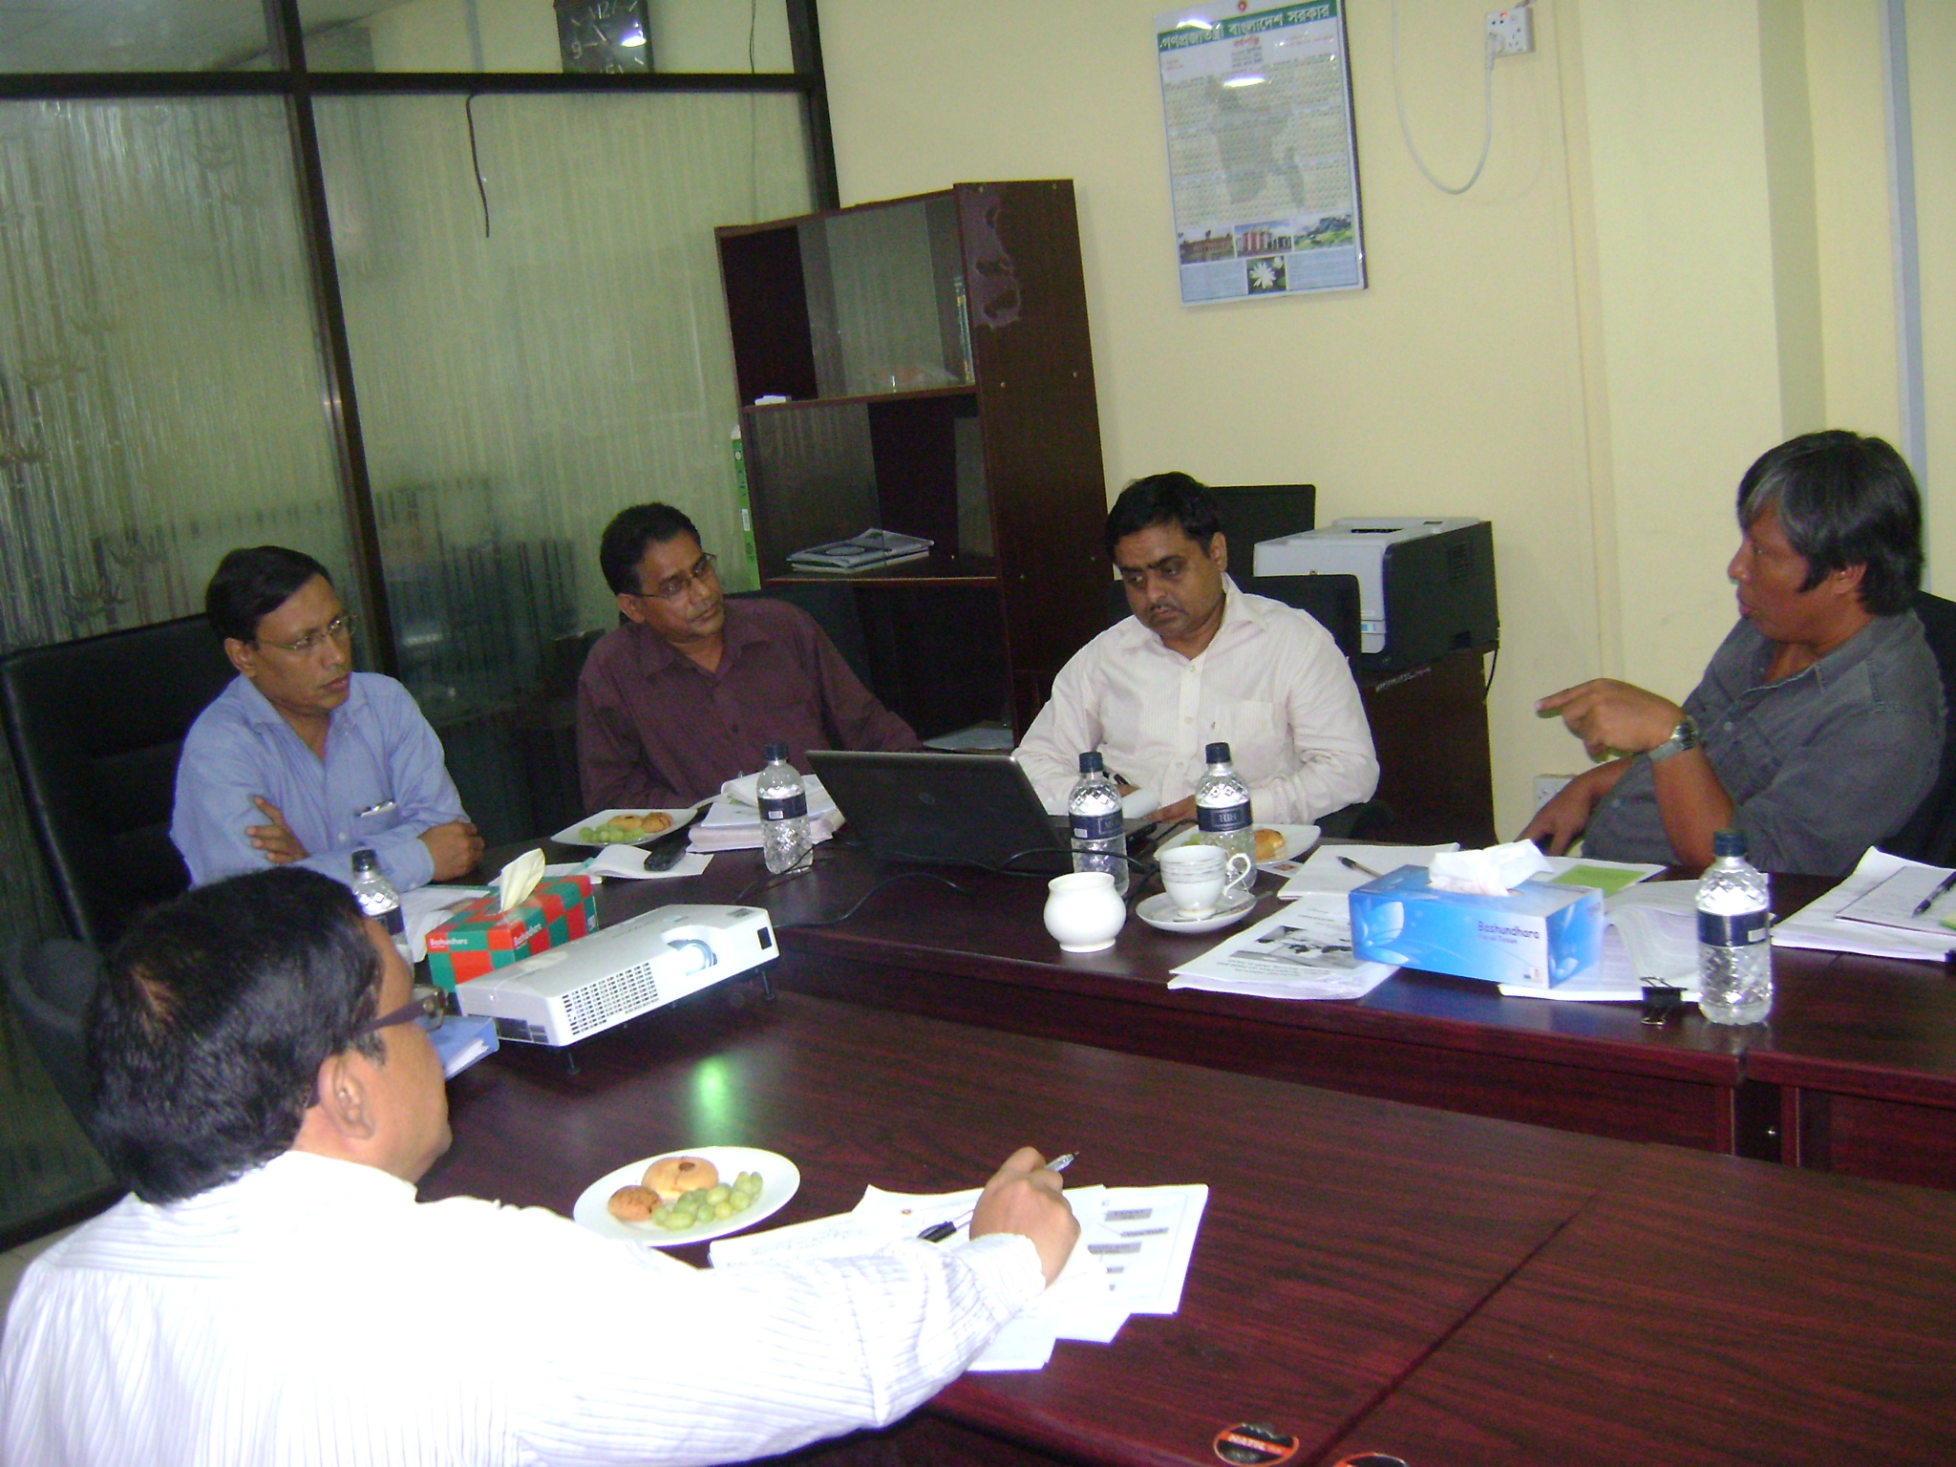
Present were Project Director, Deputy PD, MIS head, M and E head.
1. PMU presented IAPP updates highlighting:
- key figures such as the recruitment of 704 project staff, 375 of which are community facilitators,
- the counterparting and leveraging scheme between the government's agriculture projects and the IAPP where key personnel of the project were deputized and paid by the MOA and where current MOA-funded agriculture projects were integrated into the IAPP.
- the video on field visit by WB mission where demonstration farms of irrigated and enhanced seed were presented by the community
- the google-based project information management system locating individual farmers baseline data

2. PMU of IAPP expressed key concern that expected crop and livestock production surplus given IAPP intervention may eventually result to farmers' disappointment and income failure if market to ensure higher prices for their products would not be available. The project is primarily a production-enhancement project and has no marketing component. Given this, it expressed interest in meeting with the private sector window of GAFSP, especially with PRAN, and asked Action Aid to possibly facilitate the interaction.

3. The National Project Steering Committee headed by the MOA Minister had met twice. Representative from CSO was BRAC who attended the first meeting and did not attend the second. Farmers representatives from the two regions were selected by the PMU based on their capacity to articulate farmers voice. In the future when they are more organized, they can possibly elect their representatives to the National Project Steering Committee.

April 3, 2013 AM: Visit to FAO Office
Meeting with Mahmud Hossain, Imanum, and Asna
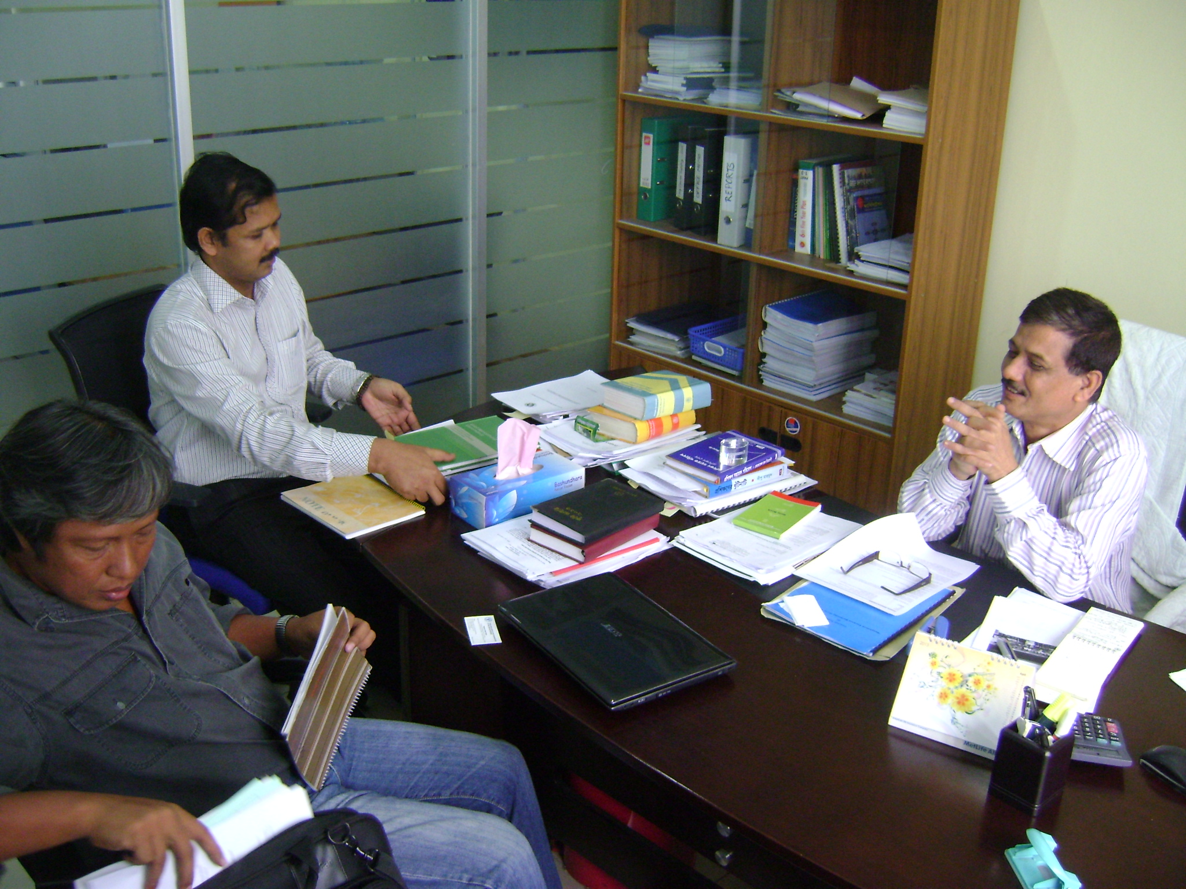
1. The mapping workshop and session in strengthening farmers organizations and federation building held last December went well. (see Amirul of Action Aid's documentation).
2. They saw farmers' federation building as the way to go but setting up one may not be possible in the limited project period.
3. They viewed farmers' exchange as important capacity building technology among key players and frontliners of IAPP and were exploring a field trip to Cambodia or PAKISAMA in the Philippines. SEWA was also considered but was still studying its nature whether it was a farmers' federation or more of a trade union.

April 3, 2013 PM: Visit to International Finance Corporation (IFC)-BANGLADESH Office
Met with Kyle (Country Manager), Farshed (Investment Officer), and Masrur (Advisory Services)
1. IFC has been a major financing and advisory institution in Bangladesh with 300 million USD exposure. IFC work involved the creation of an enabling environment for agribusiness in the country at the input, processing, and investment promotion areas and fostering public-private dialogue.
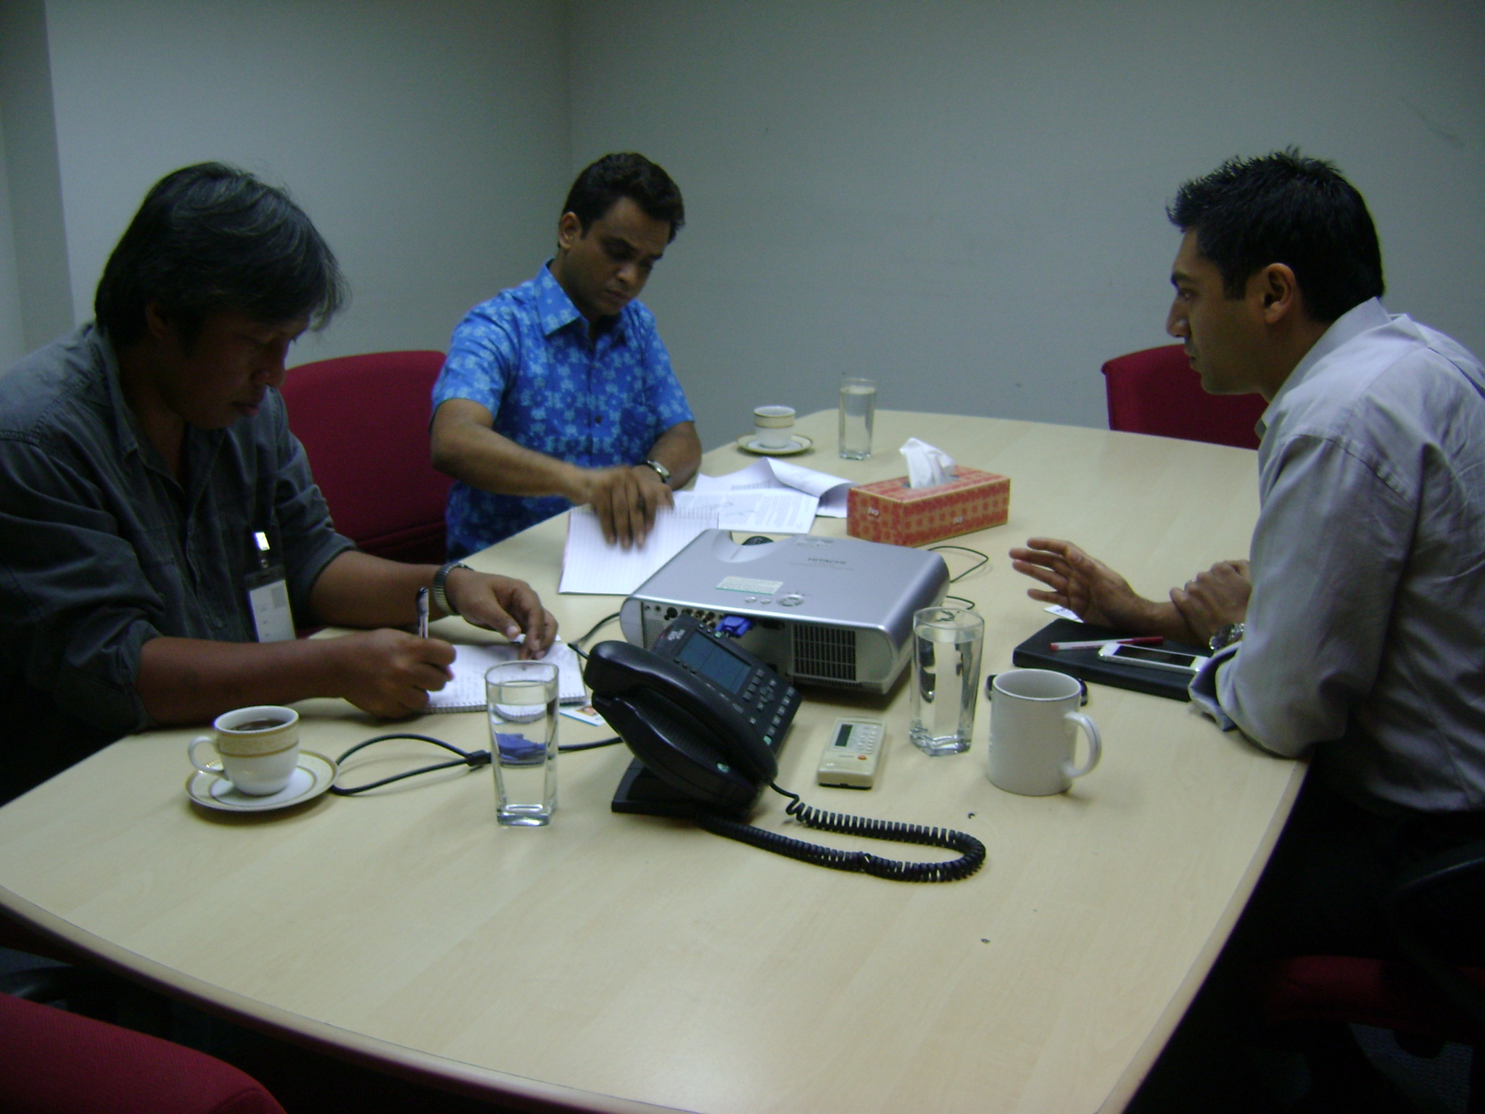
2. Agriculture as a sector was getting more attention from IFC. IFC has been working with corporations and has never worked with farmers cooperatives.
3. IFC Bangladesh has not met IAPP Director nor has enough knowledge about IAPP. A GAFSP point person has been recently appointed to help establish greater coordination between two GAFSP Private and Public sector windows in Bangladesh and in other GAFSP projects in Asia.
4. IFC's development indicators were primarily farmers reached and jobs created.
5. IFC investment to PRAN started in 2009, and applied to GAFSP, on commercial terms, to fill in a 5 million USD loan amount deficit within IFC.
6. IFC was impressed at PRAN's contract growing arrangements with some 50,000 farmers. IFC wanted more PRANs established in Bangladesh.
7. Kyle expressed interest to join Laura Mecagni in attending the 22nd April Meeting of GAFSP Steering Committee's Working Group 1 to discuss Goals, Strategies, Structure.
.
April 3, PM: Visit to PRAN Office

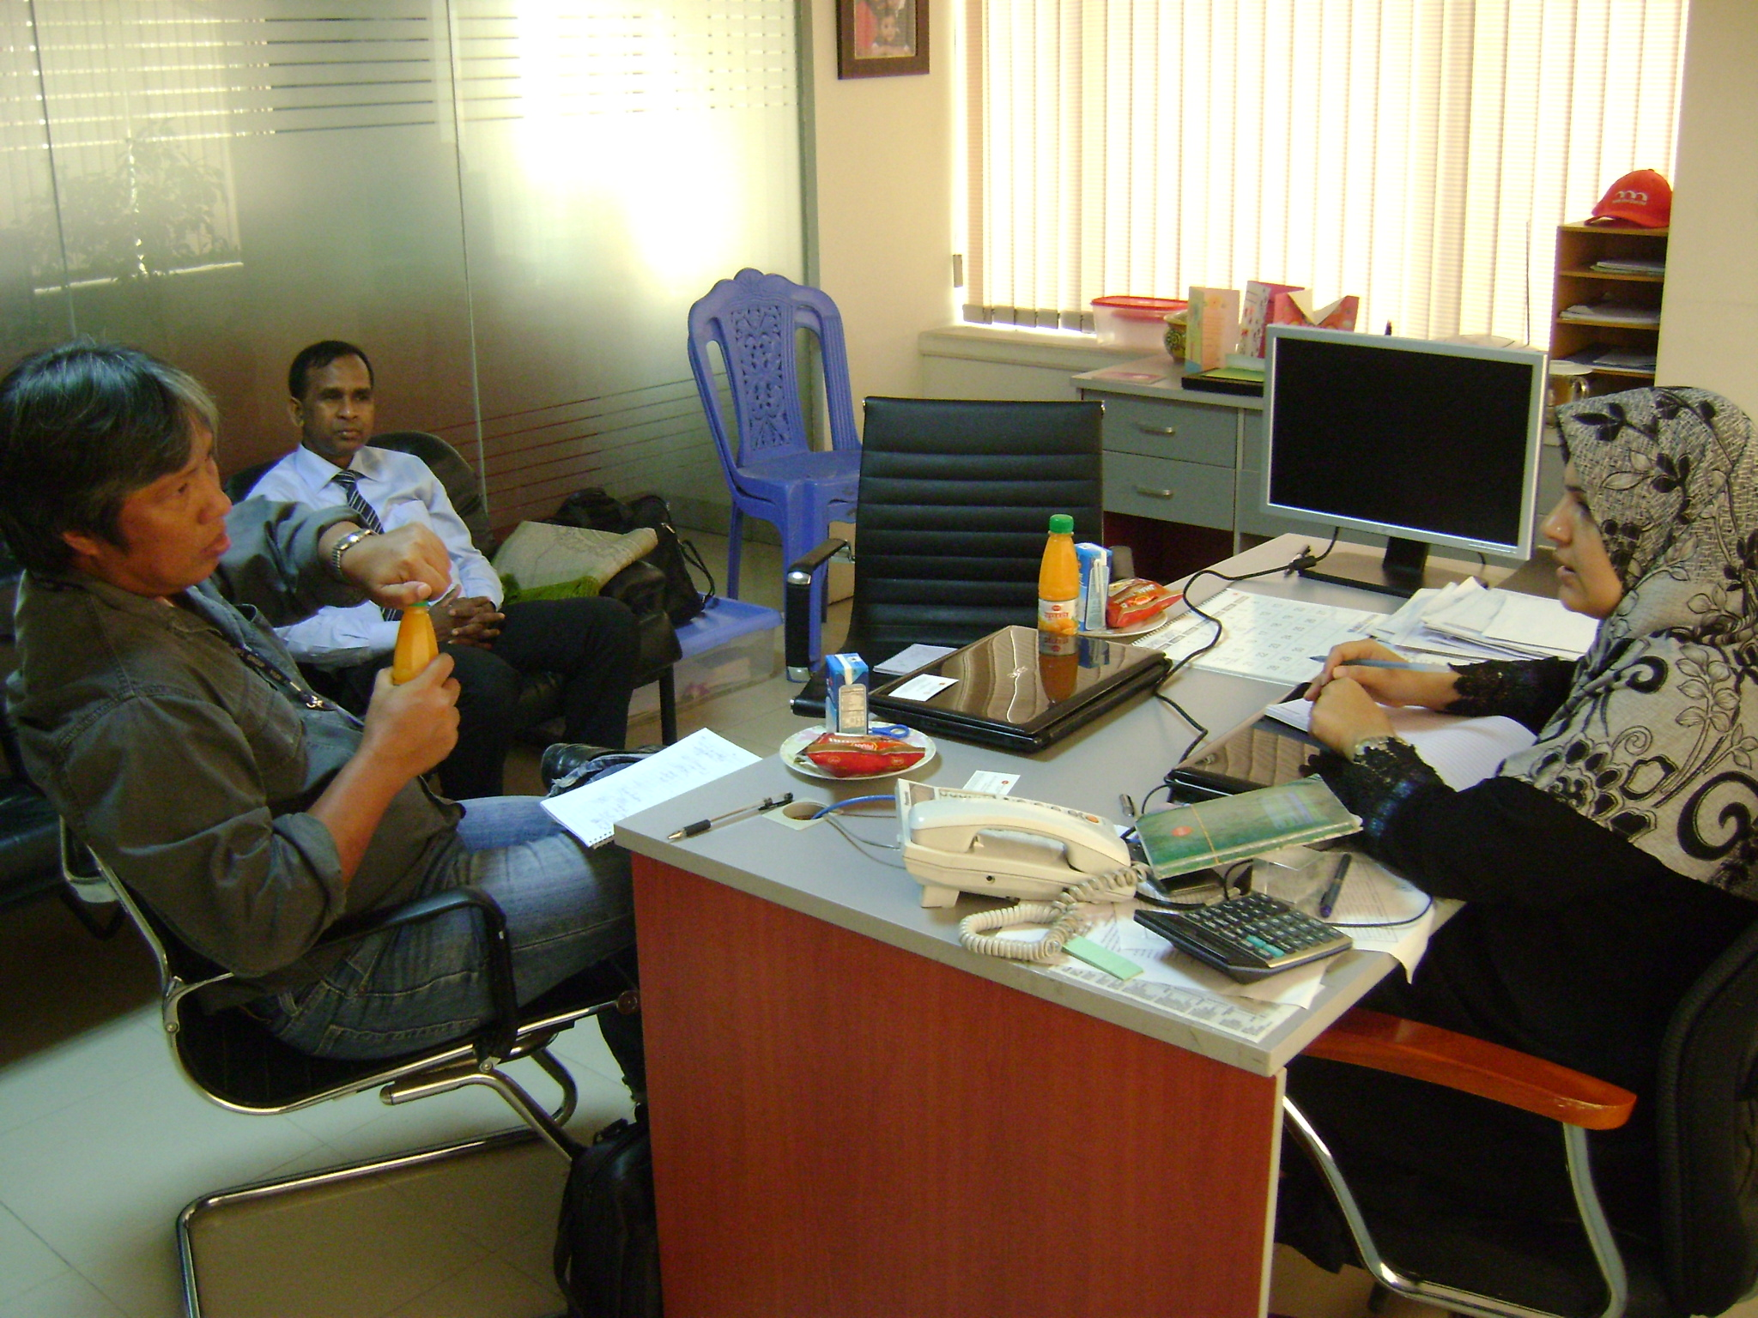
A meeting at the Office of Uzma Chowdhurry, Finance Director of PRAN and with owner-founder, Major General (retired) Chowdhurry was held on 3rd April PM.
1. Significant information on the 31 year old company include the employment of 32,000 people by 31 businesses under the PRAN Group, one third of them are on food; contract growership with 75,000-100,000 small farmers, and distributorship with 12,000 small business owners, 5000 of which are in food businesses.
2. Vision. They articulated their analysis, vision, and strategy to poverty alleviation in Bangladesh, highlighting the importance of agri- processing to improve farmers productivity and ensure market for their products. Reflecting its vision, PRAN, means Program for Rural Advancement Nationally.
3. PRAN History.
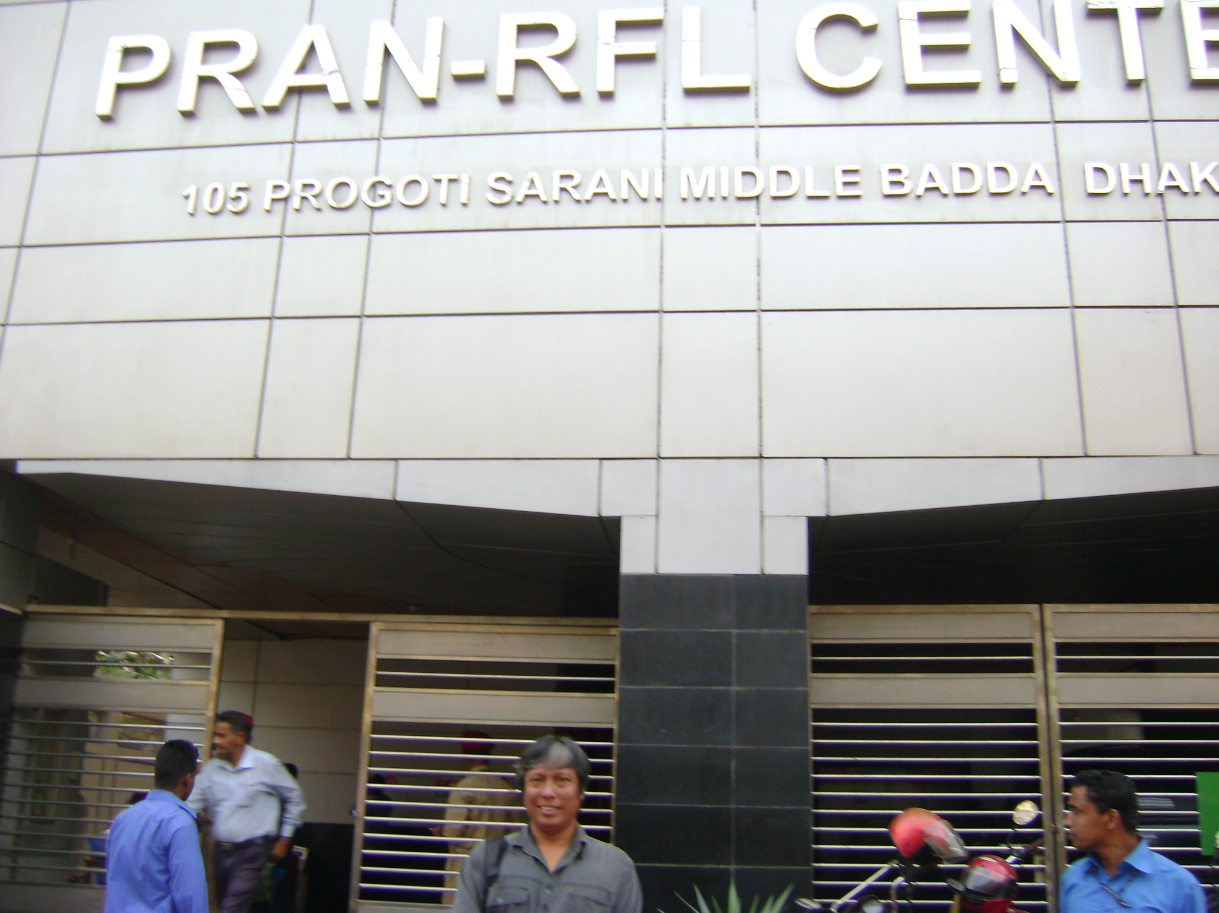
Beginning. After retiring as Major General of the Bangladesh Army, Chowdhurry (42), zeroed in on his passion for agriculture, believing it was key to poverty alleviation and job creation. Combining real estate development with growing mushrooms, garlic, cucumber, pineapple, his companies found processing mangos into juices (canned, bottled, tetra- packed) profitable. The business grew and more juices and scented rice were packed.
Export. In 1998, PRAN started exporting, mostly in India, which included products such as spices, mustard oil, pickles. They improved shelf-life of processed tomatoes and in 2003, dairy, to reach greater number of consumers. PRAN was exporting to 93 countries already and generated ISO and Halal certification, produced organic vegetarian products though not all of them were officially Certified organic.
To date, PRAN processed 1,200 food items. PRAN has been the country's biggest processor of sugar, though largely imported. It has reached out to farmers to better grow mangos and other crops e.g., peanuts. Produced from good quality seeds, PRAN, for example, manufactured tomato paste at 5,000 MT/year placed in cold storage facilities. PRAN had very strong links with Chinese engineers and technicians and companies who supplied PRAN with state- of- the- art machineries and efficient technical support. Got financing largely from private sources, through Letter of Credits (LCs)..
Contract Growing. PRAN employed 32,000 people and had existing contract-growing arrangement with 75,000 farmers. Buy-back guarantee assured market for farmers' produce, bought at market price but never lower than the production cost, which gave farmers a degree of assured income so long as quality requirements stipulated in contract were fulfilled.
Organizing Agri-Hubs. PRAN had 400 extension workers to organize agri-hubs each with some 3,000 neighbouring farmers. They start with selected 50 influential small land-owners/cultivators, train them in PRAN's Farmers' Academy, for one-to two weeks, depending on crop or product, then they in turn organize the rest of the members of Agri-Hub.
Agriculture practice. PRAN grew its own seeds and sometimes it imported them e.g., peanuts from China were bigger. PRAN was not very particular with the issue on organic nor GMO, with the view that it was helping feed a growing population--now 160 million. What was important to them was its capacity not to waste food and lose farmers' income by processing them.
Distribution. PRAN's has 5000 distributors, small business owners, for its food items, and 7000 for its plastics products. It has 40 depots/factories nationwide, and 600-700 trucks buying and selling continuously.
Value addition to farmers. PRAN claimed they were able to eliminate middlemen and established long-term relations with farmers. Asked on profit-sharing with farmers, PRAN instead invested profits to increase farmers production, reduce wastage, and increase price given more value addition.
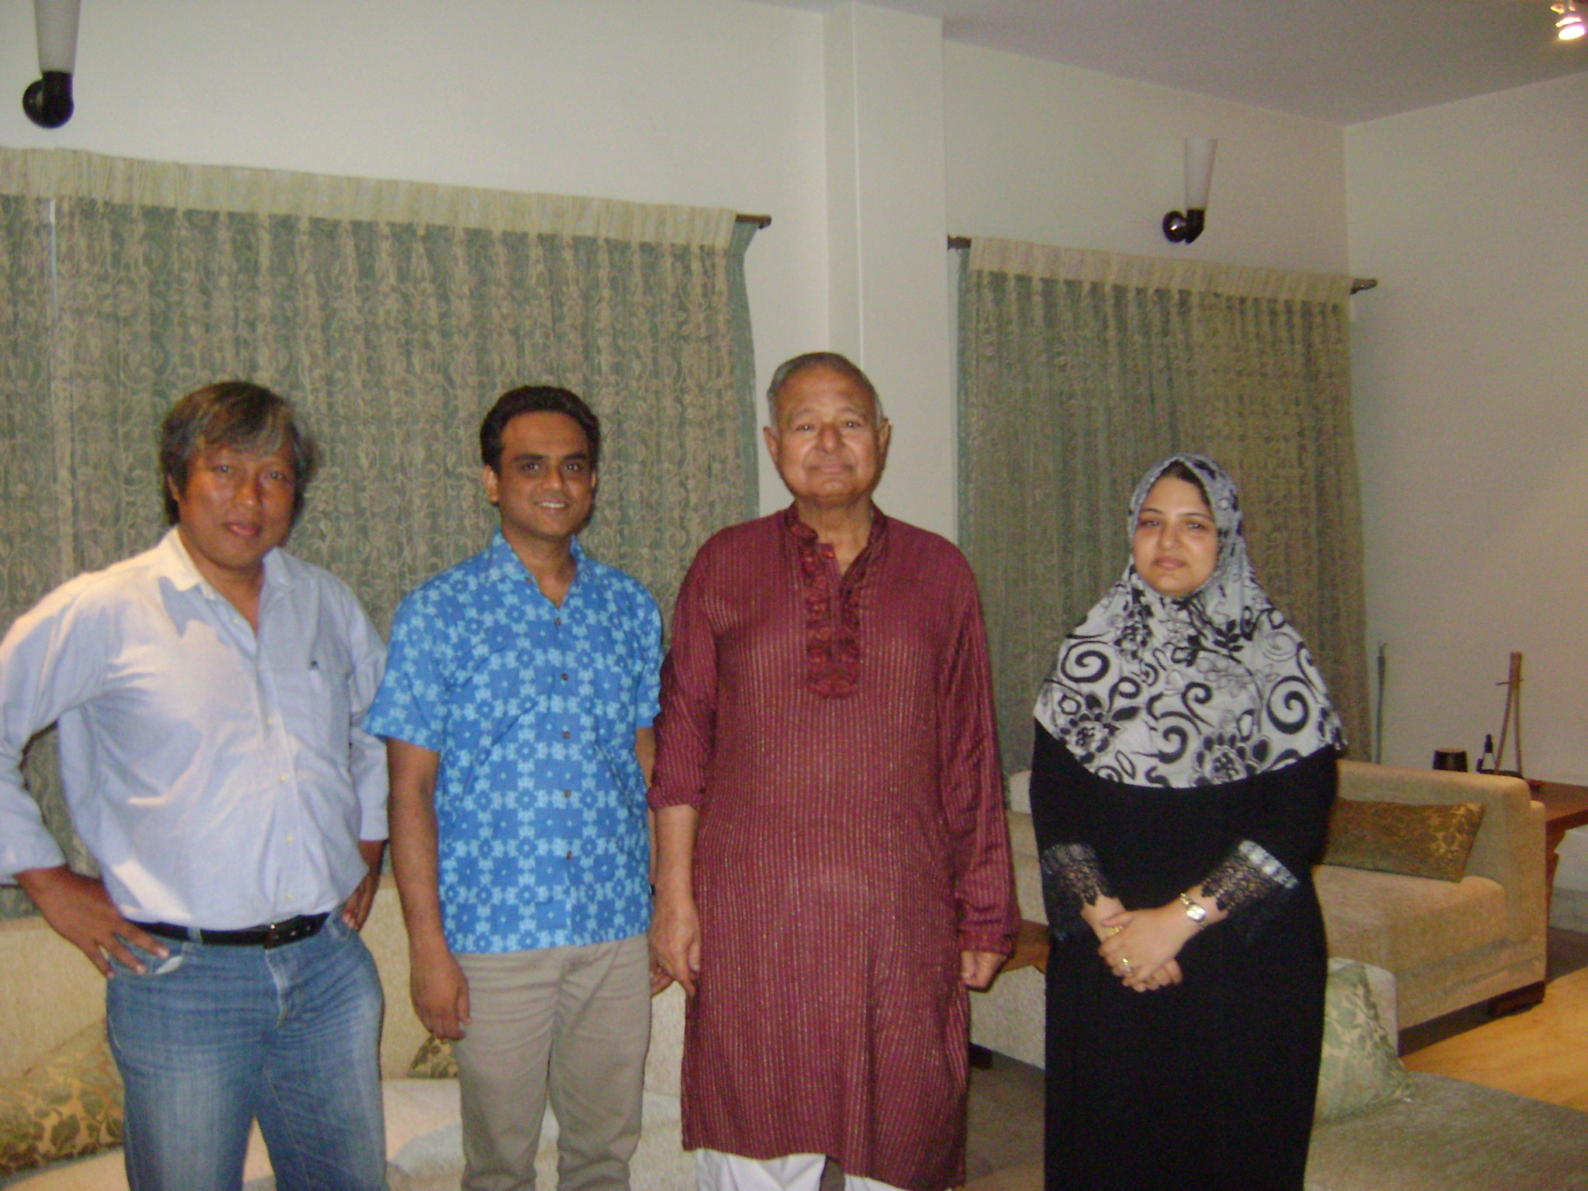
Asset. PRAN was estimated to have 100 million USD asset, without accounting for the real estate values.
IFC-GAFSP Investment. PRAN borrowed from IFC at commercial rate (5%), 15 million USD to increase their reach to 3,000 farmers to produce eight products initially, such as noodles, tomato paste, mustard oil, fortified cereal, pickles (mango, olive, tamarind, garlic), etc. IFC provided 10M USD and GAFSP shelled out 5M USD. They estimated that in 3-4 years they would be able to pay off.
Governance and Thrust. PRAN's CEO was the 71 year-old father, with two of four children acting as Directors (Uzma takes care of Finance and Admin). Gen Chowdhurry's current passion was on building the Bangladesh Dairy Industry. He believed that with 50,000 TK investment, a family farm could grow two milking cows, enough to earn daily beyond poverty line.

April 4 whole day : PUBLIC SECTOR-PRIVATE WINDOWS Consultation at Action Aid Conference Room
(please see Annex 1 for the Proceedings of CSO consultation )
1. It was the first time all key stakeholders in the GAFSP-Bangladesh met. Amirul Islam of Action Aid gave the opening remarks. In his intervention, he situated the third CSO conference in the context of the need for coordination between the Private and Public Sector Windows of GAFSP (Pls see Annex 2: Opening Remarks). As any first meetings, especially of individuals and institutions who come from different sectors, ideologies, and programs, discussions were expectedly animated.
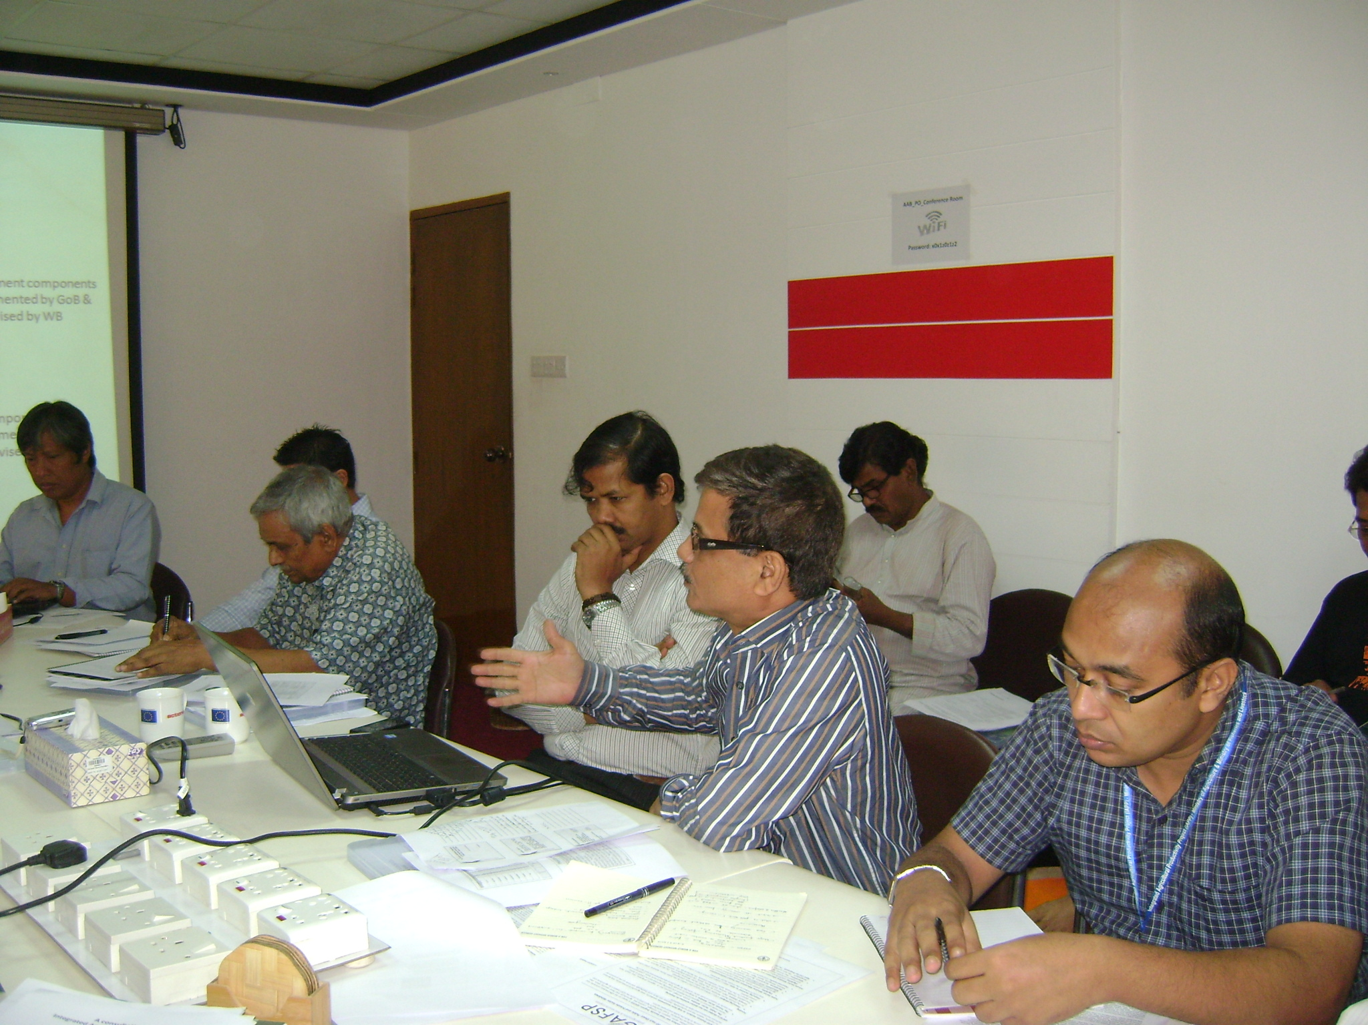
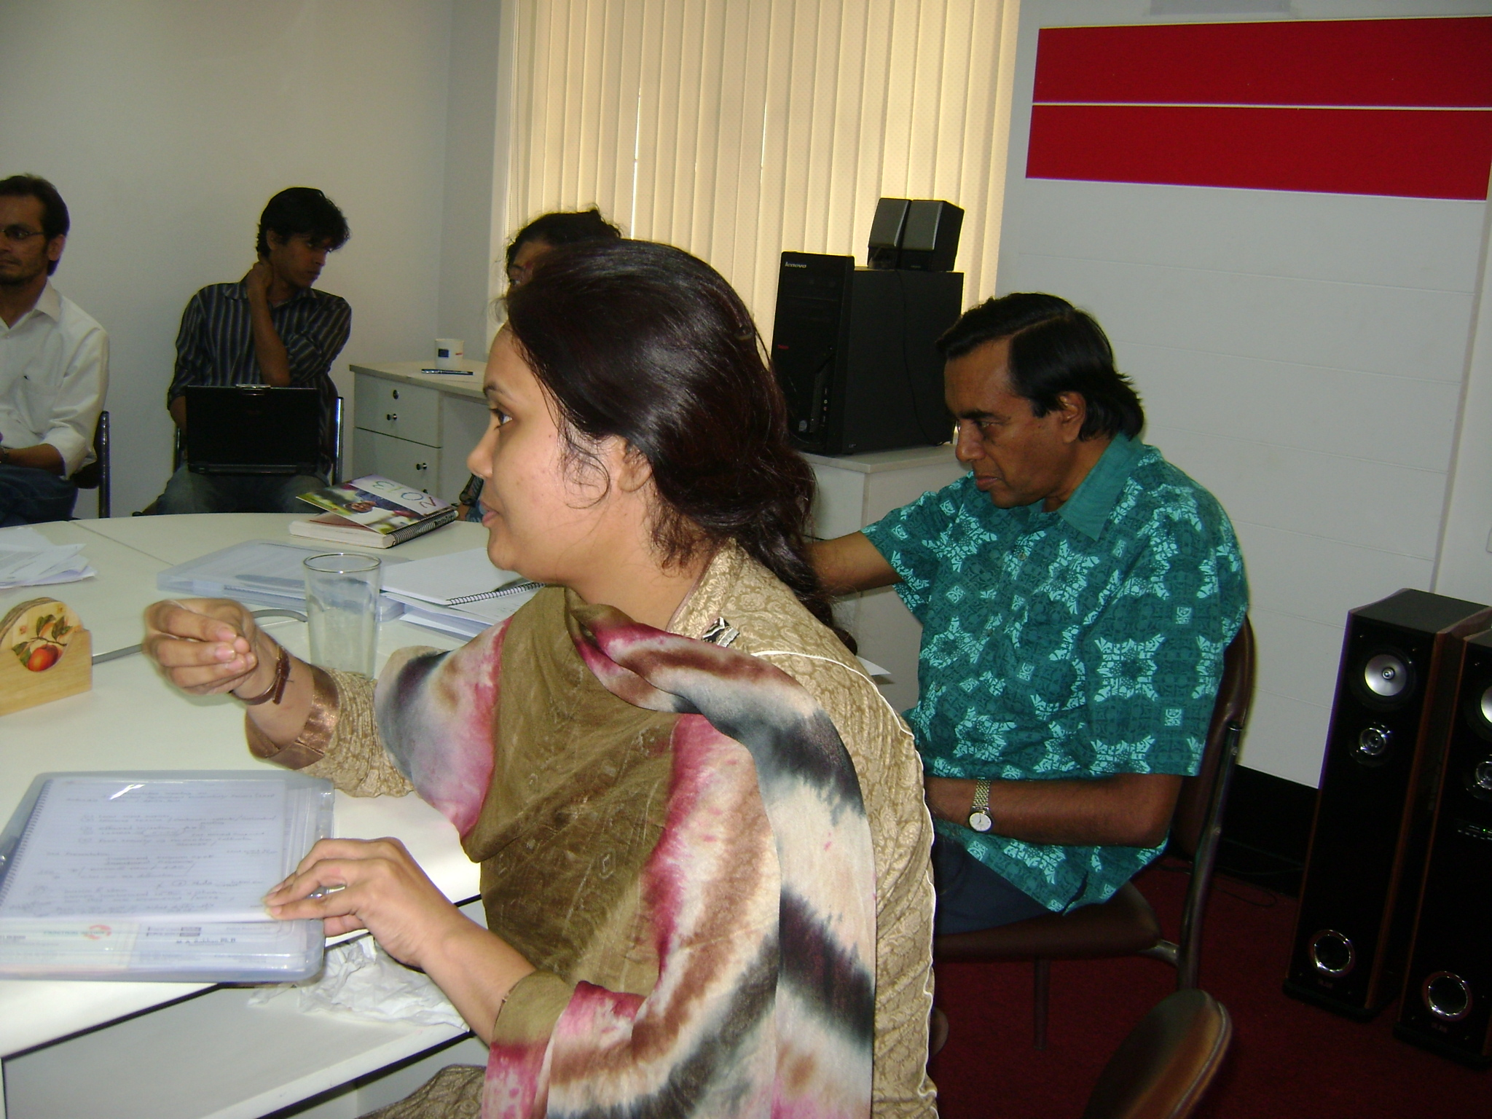
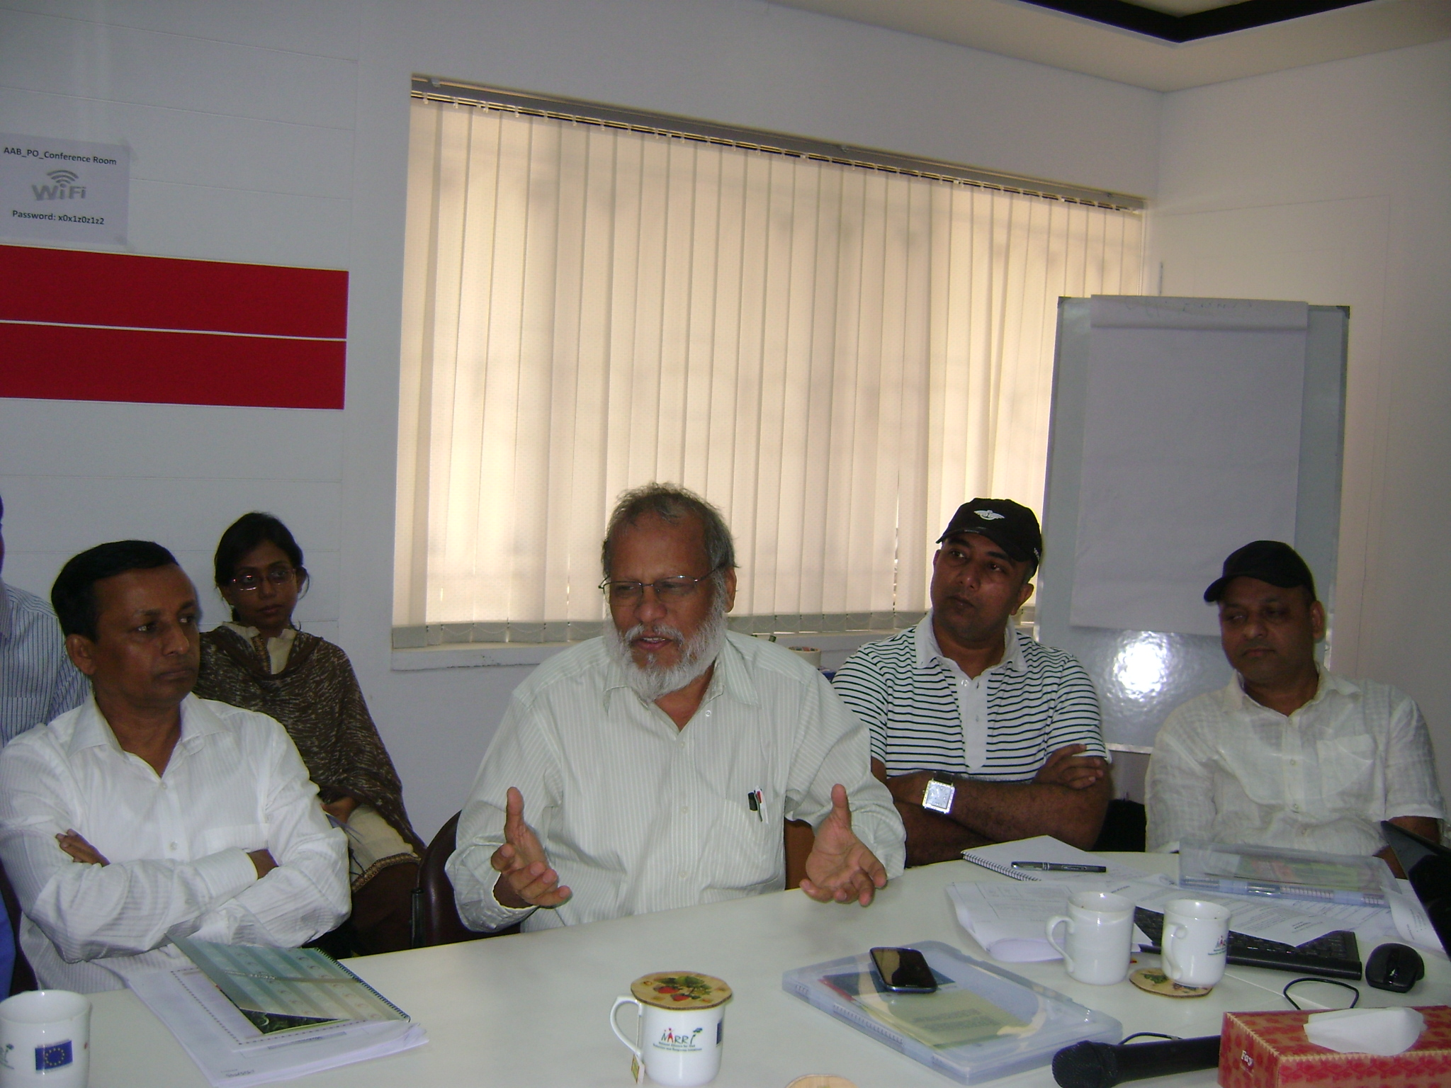
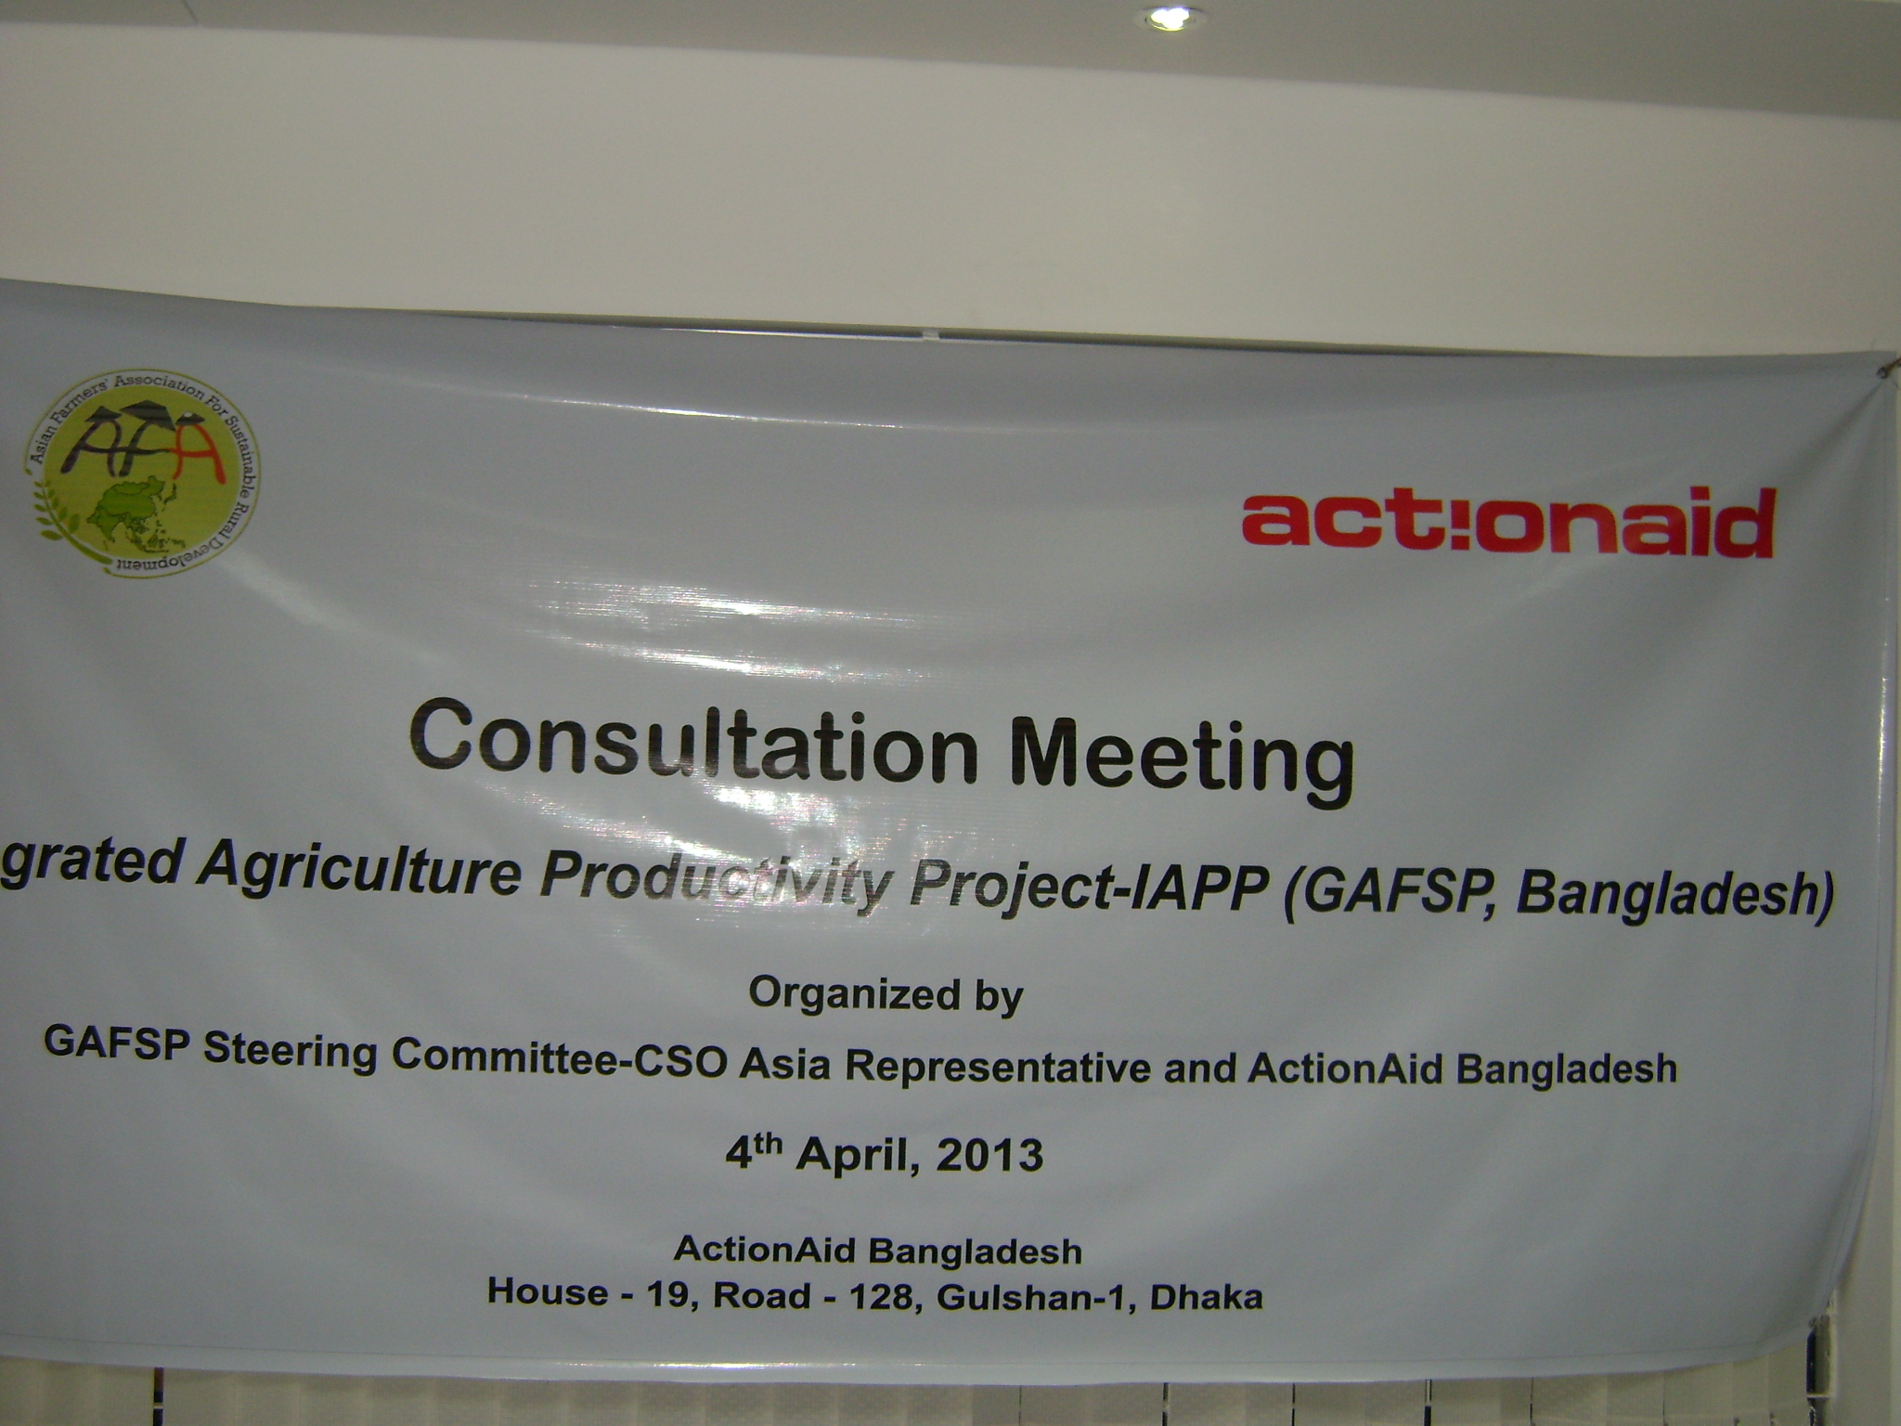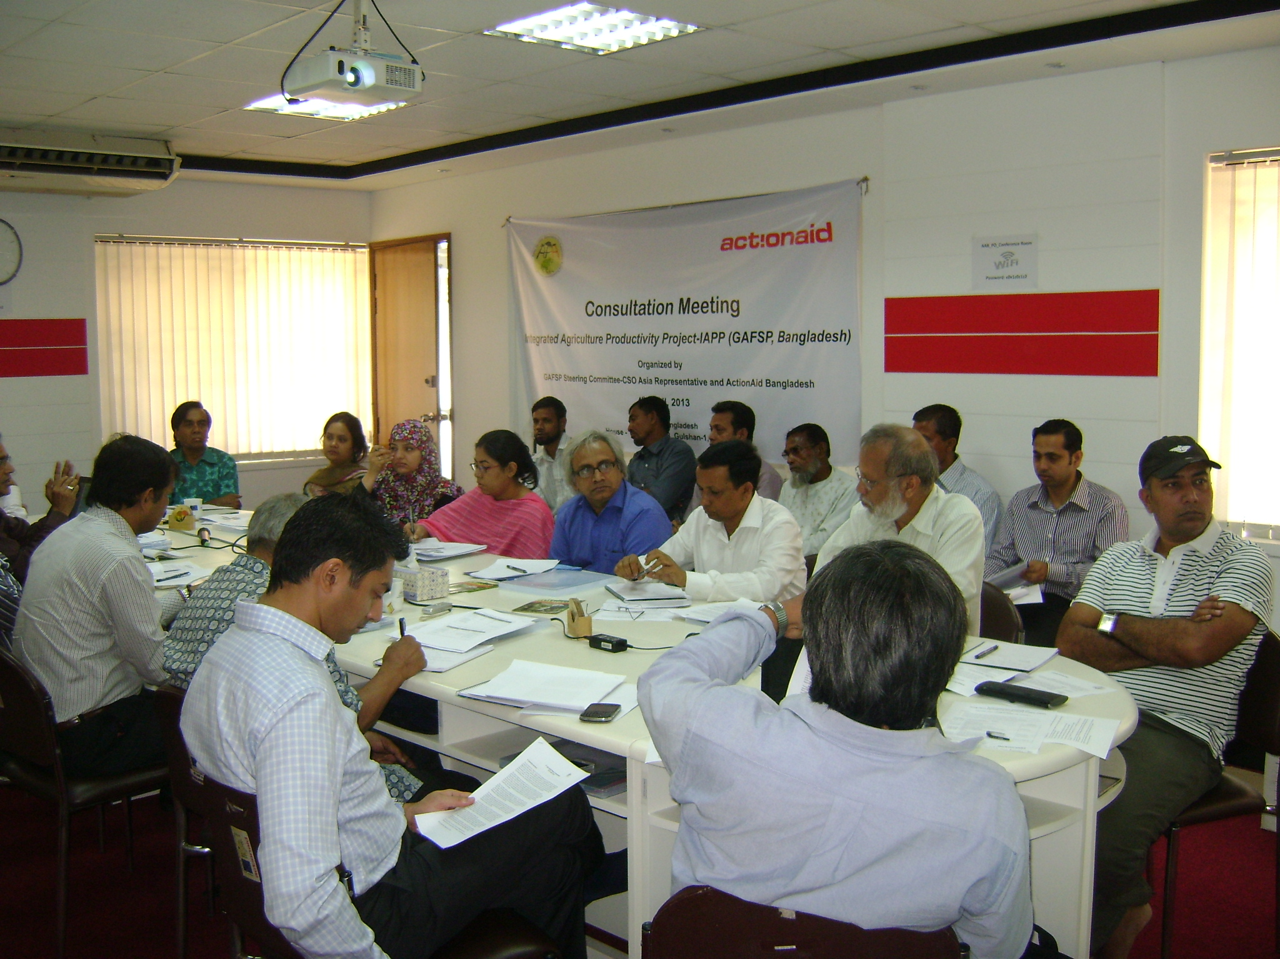
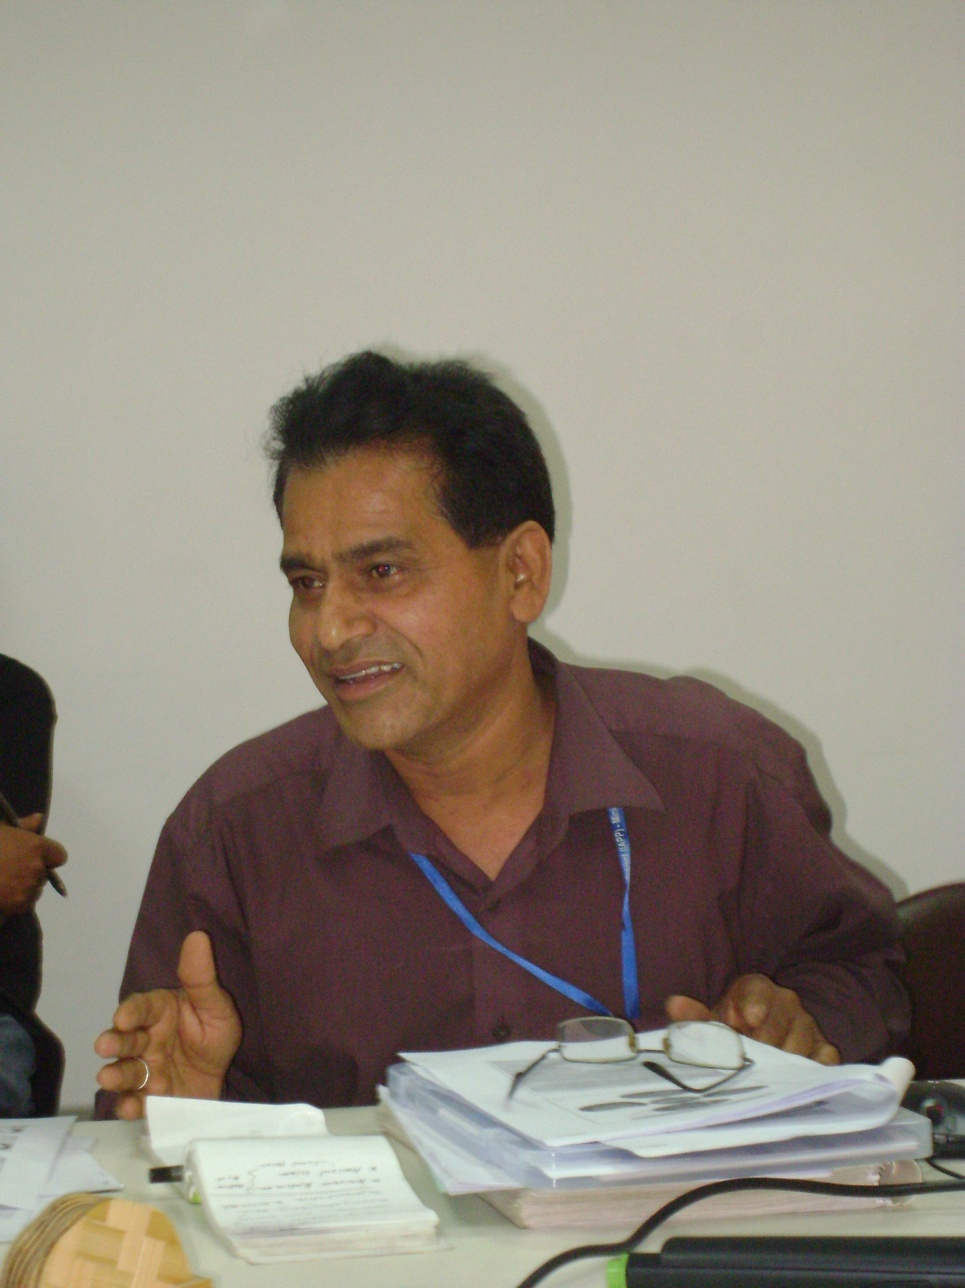
2. IAPP updates were presented in powerpoint highlighting current deployment of staff, demonstration centers, the recent World Bank Mission, and google-based farmer-beneficiary information system (pls see Annex 3: IAPP updates).
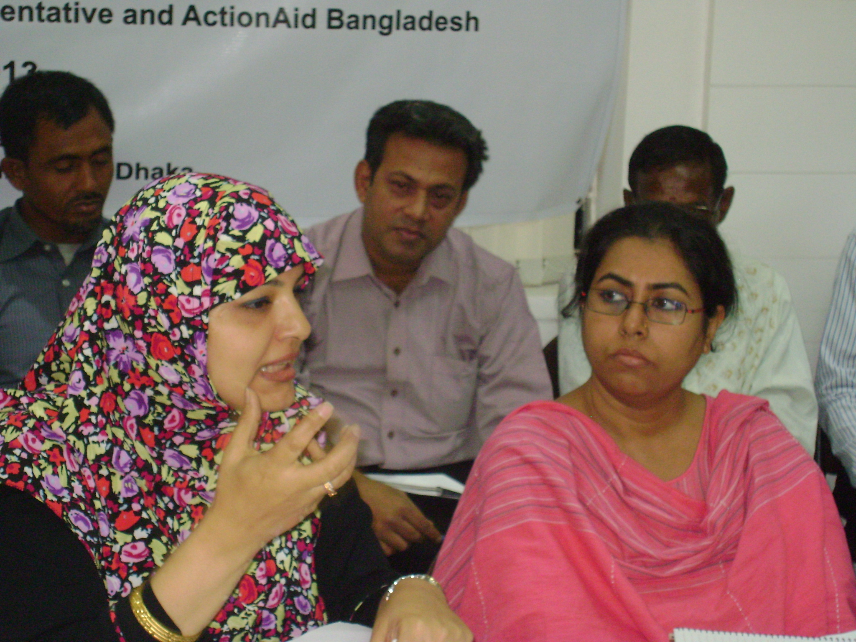
3. FAO Technical Assistance program updates were likewise presented highlighting the recently conducted mapping of farmers organizations , training of 375 community facilitators, study tours of IAPP staff on community mobilization, and conduct of short term training events dealing with monitoring and evaluation, agriculture governance, among others. (Pls see Annex 4: FAO TA Updates).
4. PRAN was introduced highlighting the role of agri-processing in agriculture development, poverty alleviation and job creation, the history and extent of PRAN's operations, the financing from IFC-GAFSP, and the expression of interest to understand more the IAPP.

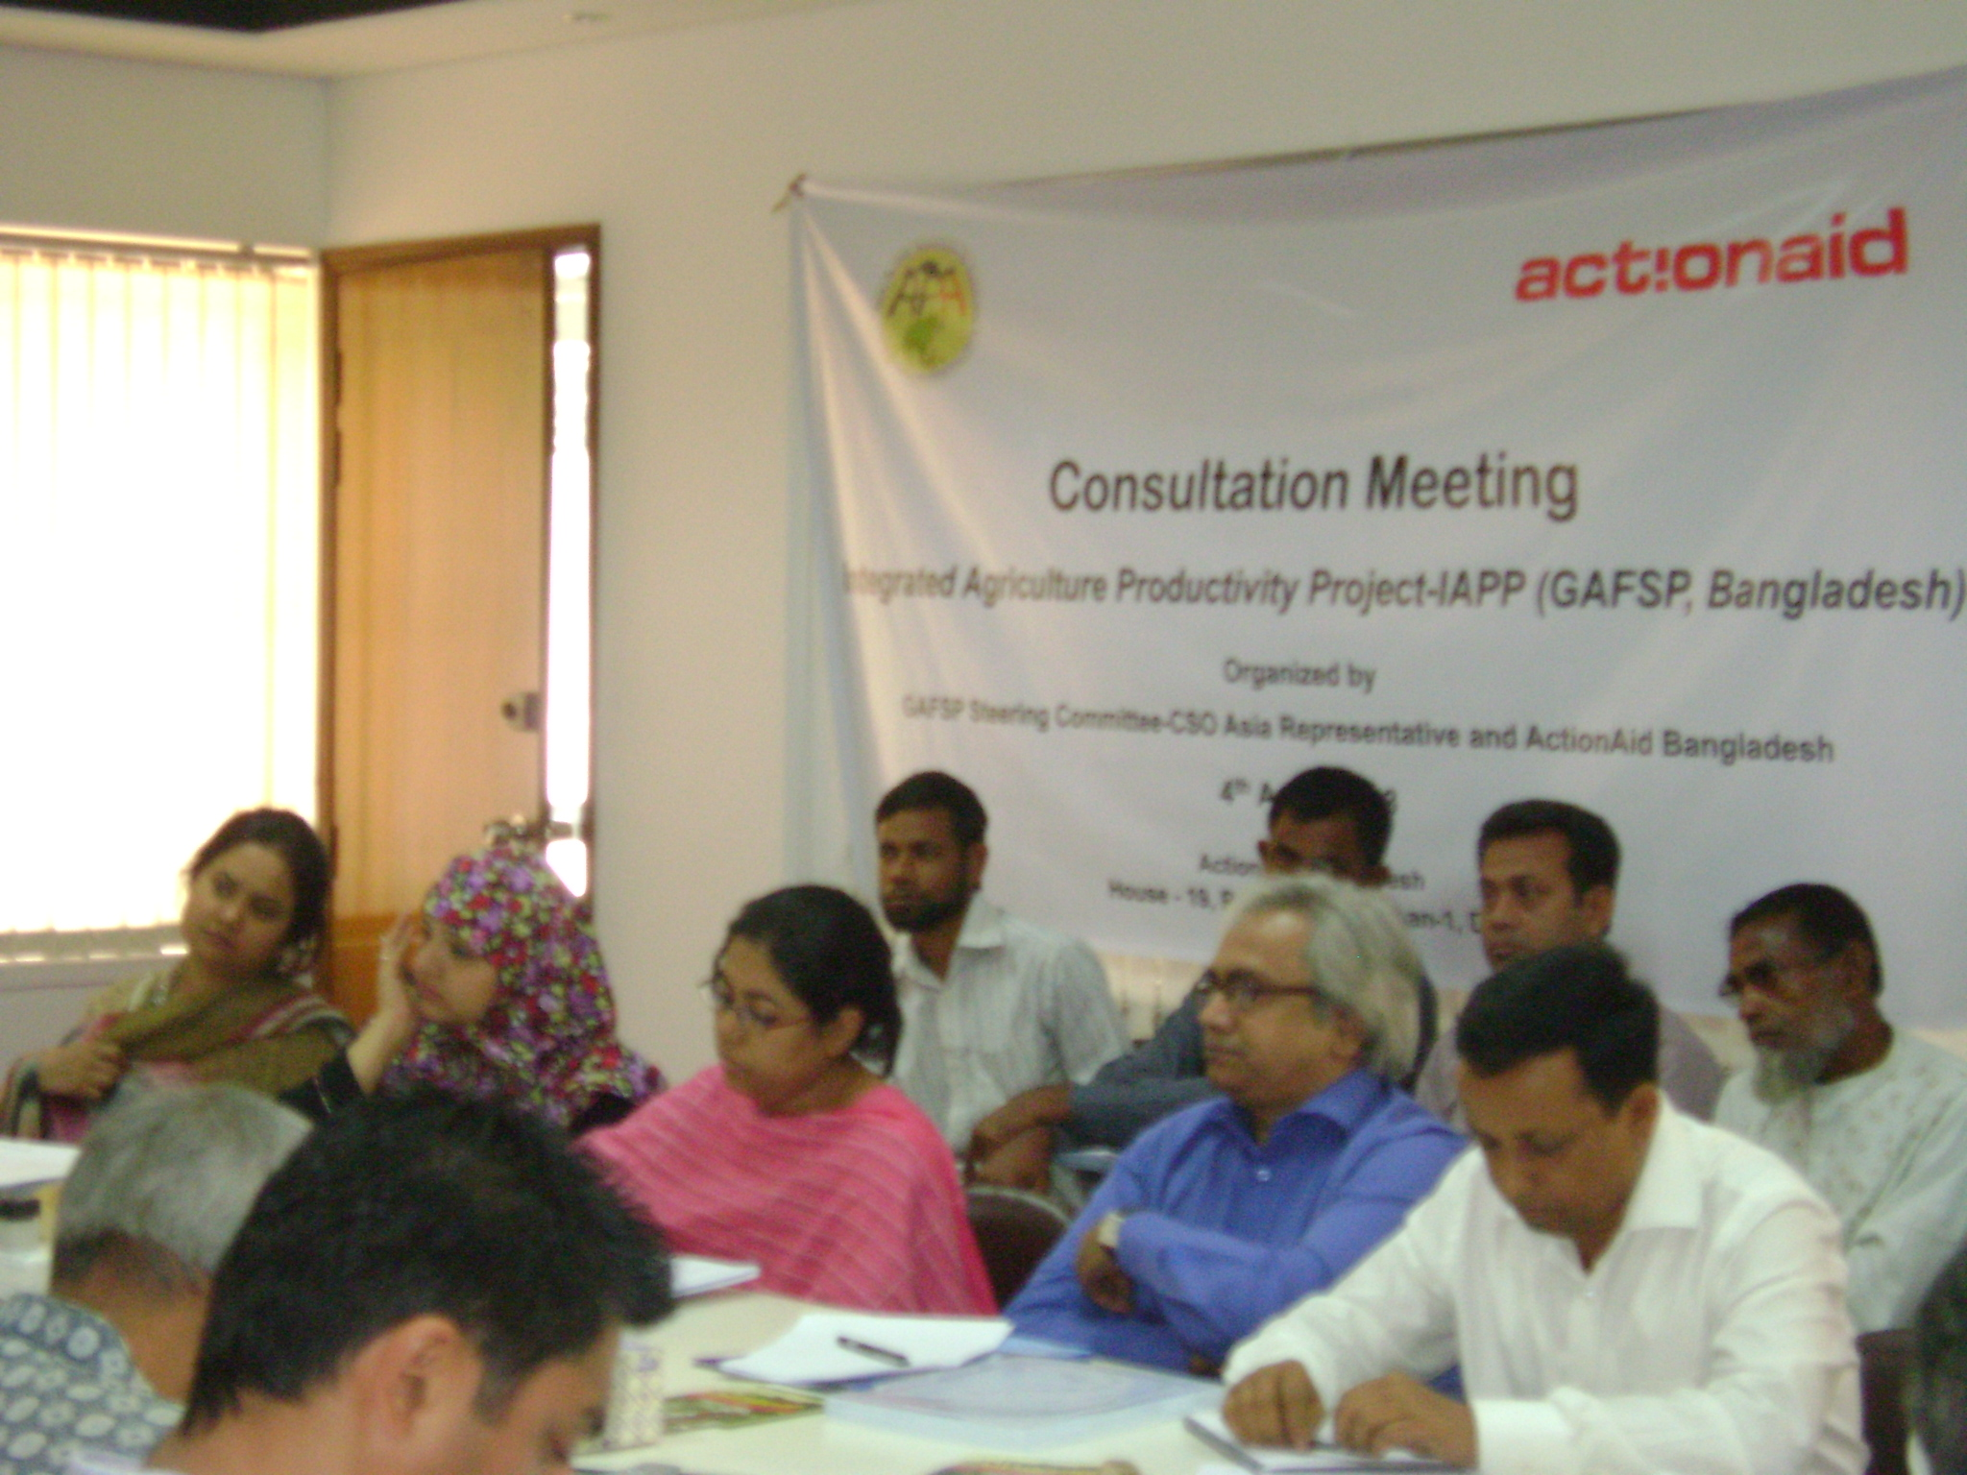
5. Research on PRAN commissioned by Action-Aid, and conducted Mahfuzur Rahman, a journalist, ( in blue shirt in picture on left) revealed generally positive assessment by farmers-contract growers raising some issues re sustainable agriculture, monitoring and evaluation, farmers empowerment. (Pls see Annex 5: Draft Report)
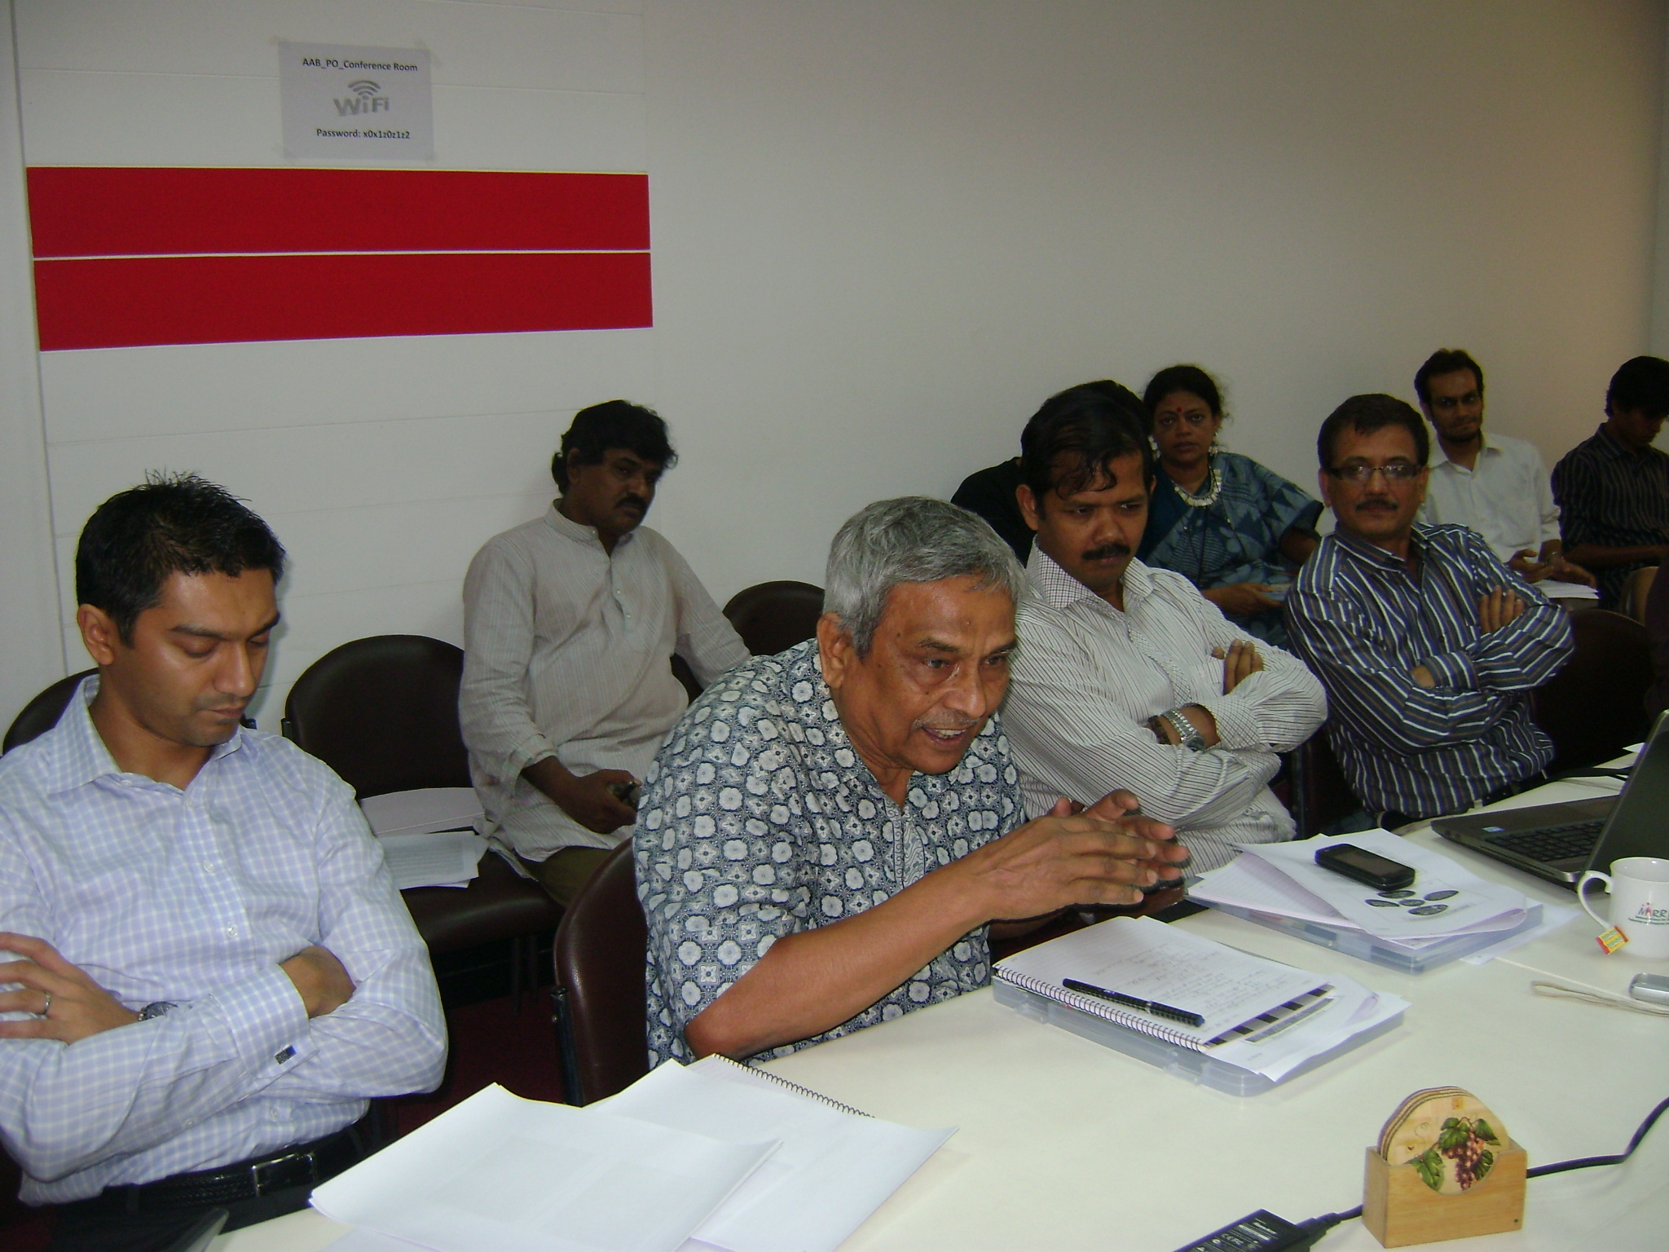
6. IFC's financing and advisory services to private sector in Bangladesh was introduced, including the support given to PRAN since 2009, impressed by its contract growing arrangement with 50,000 farmers and the IFC'S 15 million USD loan at commercial rate to PRAN, 5M USD of which was from GAFSP fund.
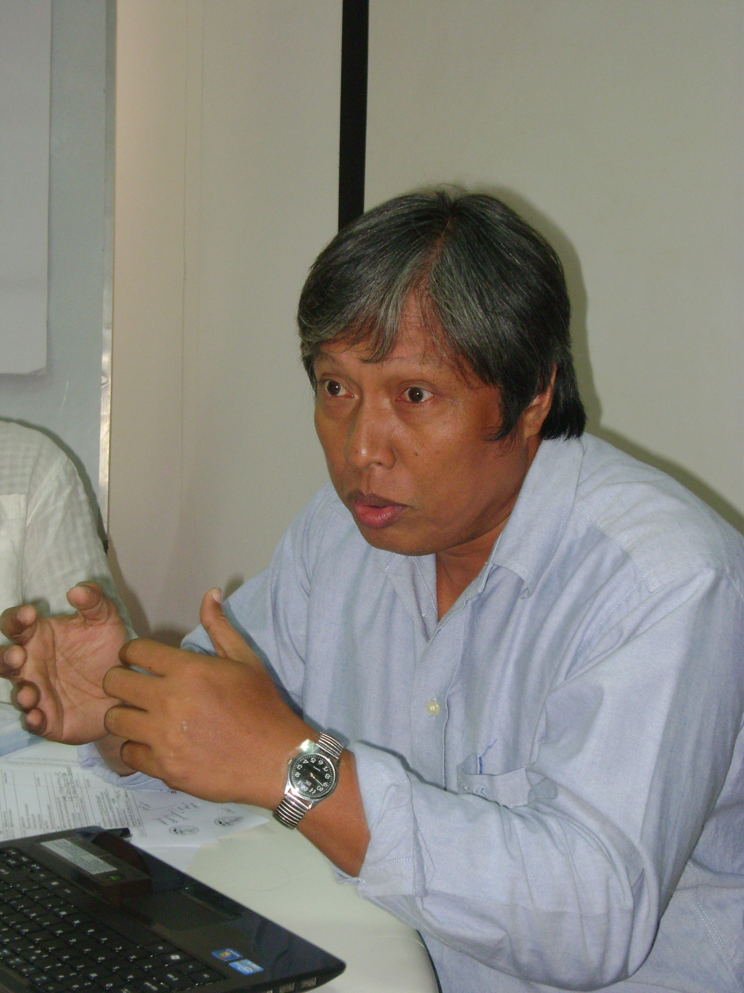
7. Concerns raised by CSOs on the presentations of IAPP, FAO, PRAN investment and IFC included: corporatization of agriculture, sustainable agriculture, and farmers' empowerment. PRAN responded to issues raised by raising questions as well such as how do we deal with waste and losses of farmers given unsold raw products, how to feed the growing Bangladeshi population, and the training program it has for contract growers. PRAN ended by expressing interest in working with the IAPP.
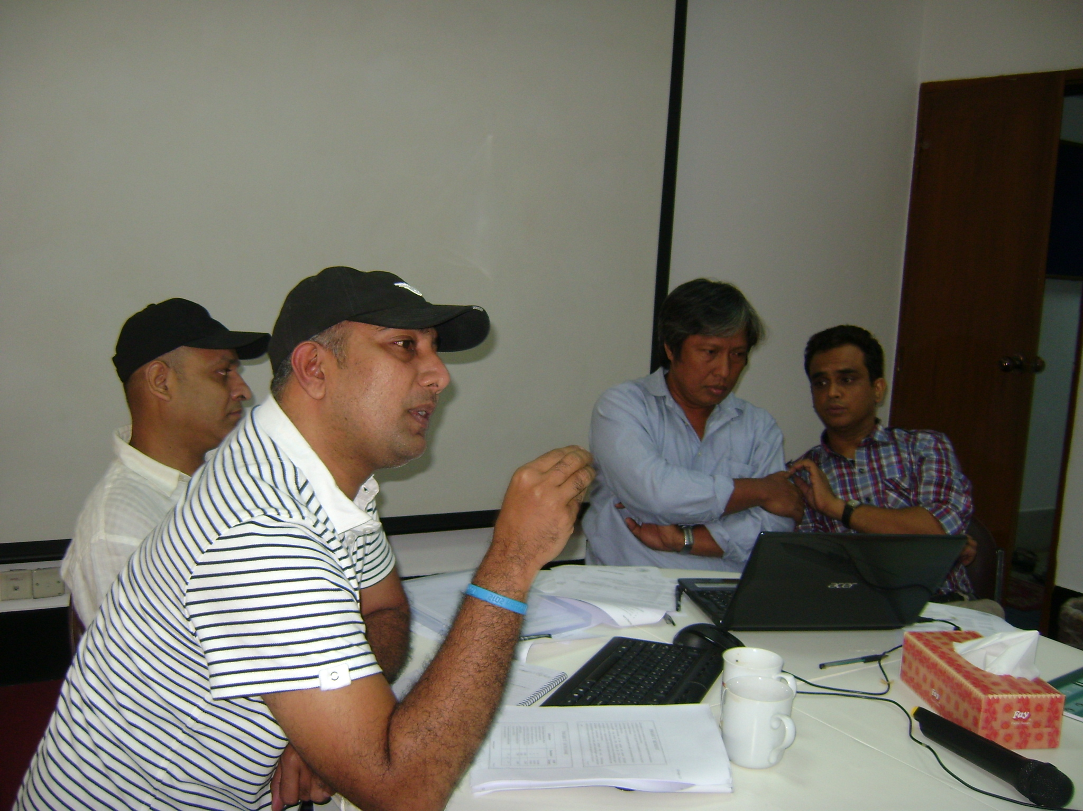
8. Alternate CSO Representative made three points: 1) for the body to consider as baseline the first interaction of actors/actresses from the private and public sector windows of GAFSP-Bangladesh project; 2) GAFSP's unique feature: inclusive multi-stakeholdership allowing producers organizations in highest decision-making body of the project; and 3) looking forward to seeing Producers Organizations sitting in national Steering Committee of IAPP and a continuing forum among stakeholders, affirming the catalytic role of Action Aid in sustaining the interaction.

9. Action Aid ended the session with the commitment to continue the forum and dialogue among the GAFSP stakeholders.

