Annex A
Notes of Individual Meetings

National Association of Dekhan Farmers (NADF)
July 16, 2012/9am
Meeting with: Azizbek Sharipov, Founder and Chairman

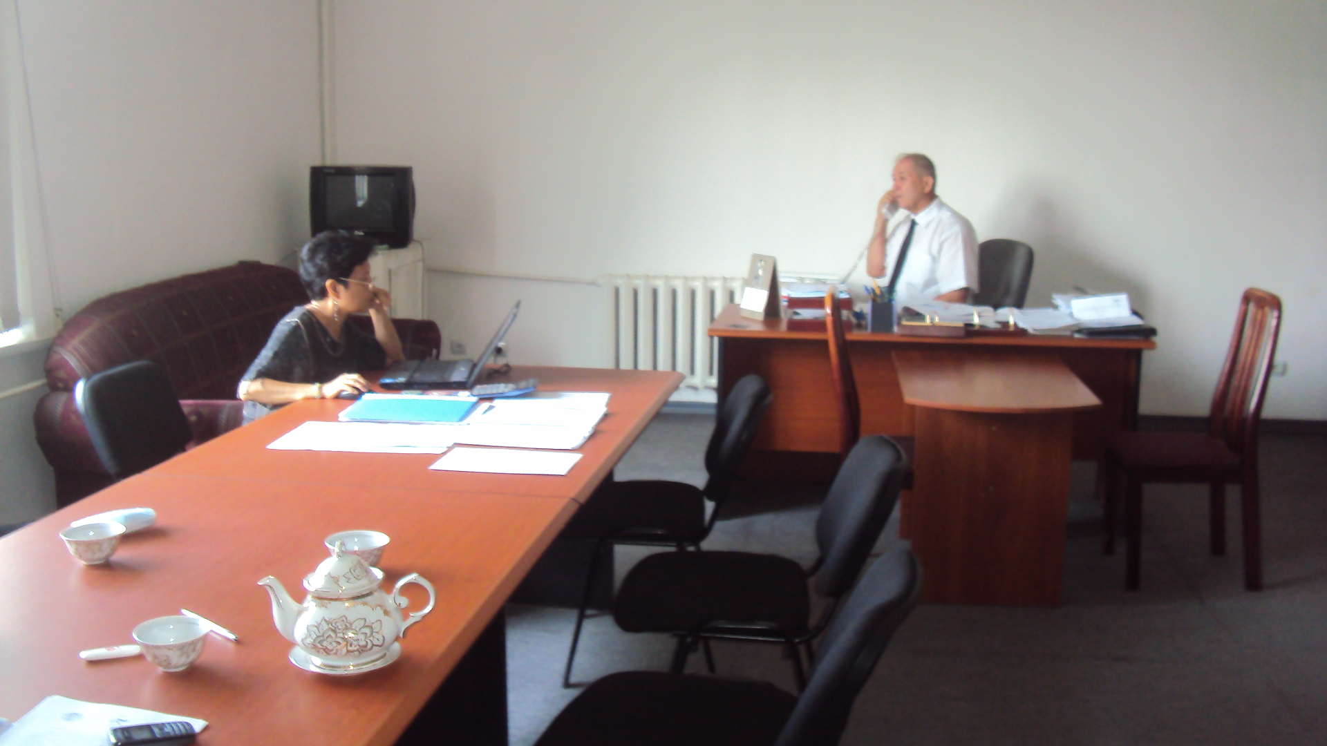
1. The NADF is a non-governmental organization of farmers and was registered on June 2005 with the Ministry of Justice. It currently has a membership of 6911 Dekhan farms. It educates farmers, provides legal advices, protects the rights and interests of members, promotes and facilitates the development of small and medium-sized businesses, deploying all efforts to increase farmer’s knowledge for effective interaction with government agencies, increasing productivity and rural livelihoods.
2. It has implemented projects with several donors, including a project with EC on “enhancement relationships between civil society and local authority”, and with JICA on “improvement and expansion of agricultural services by strengthening agricultural organizations” and with WB on the “conduct of training on Dekhan farm management”. It has close relationships with national agri-related agencies. The founder and Chairman himself used to work as a high-ranking official of the Ministry of Agriculture. Its office is located inside the Ministry of Agriculture building.
3. Mr. Azizbek said that the situation of 80% of the farmers is not good. Some dekhan farmers are big enough and the farmers have closer ties with the government, so they make good in their work. But most dekhan farmers are not close to government and cannot access capital and technology, so they remain poor.
4. For the greater understanding of the Mission Team members, Mr. Azizbek tried to simplify what happened after the collapse of the Soviet era. He said that immediately after the Soviet collapse, local government authorities got hold of the farmlands (then collective farms) and distributed these lands to their relatives and friends. Many of them had no knowledge on farm management, as many of them were formerly workers in the collective farms owned by the state before. Some of the former workers were even afraid to take the land, as they did not know where to access the needed production capital. There were those who were a little richer and more willing to take risks so they got more lands – that is why some dekhan farms are much bigger than the others. Currently there are three kinds of land arrangement: one, individual dekhan farms; two, family farms where two or more families work on the land; and three, collective farms – where every dekhan farmer who works on the land gets a share of the income.
5. Mr. Azizbek hope to forge stronger cooperation with other farmer’s organizations, including with AFA.
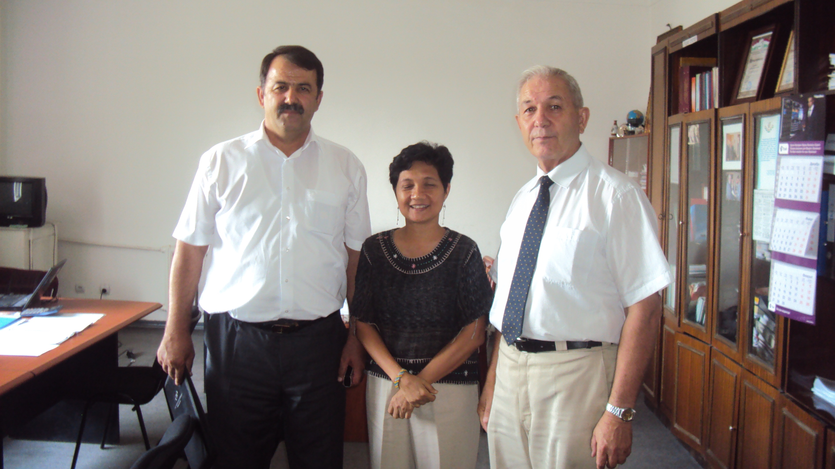

Association of Forest and Land Users in Tajikistan (AFLUT)
July 16, 2012/ 2pm
Meeting with: Dr. Kokul Kasirov, Founder and Chairman
1. AFLUT was organized in 2011. Its current members are organizations and individuals
who are rendering support and assistance to the process of sustainable policy on rational use of forests and lands of Tajikistan by means of development entrepreneur activities in local communities. Its founder used to work in a government forestry department before helping establish this organization.

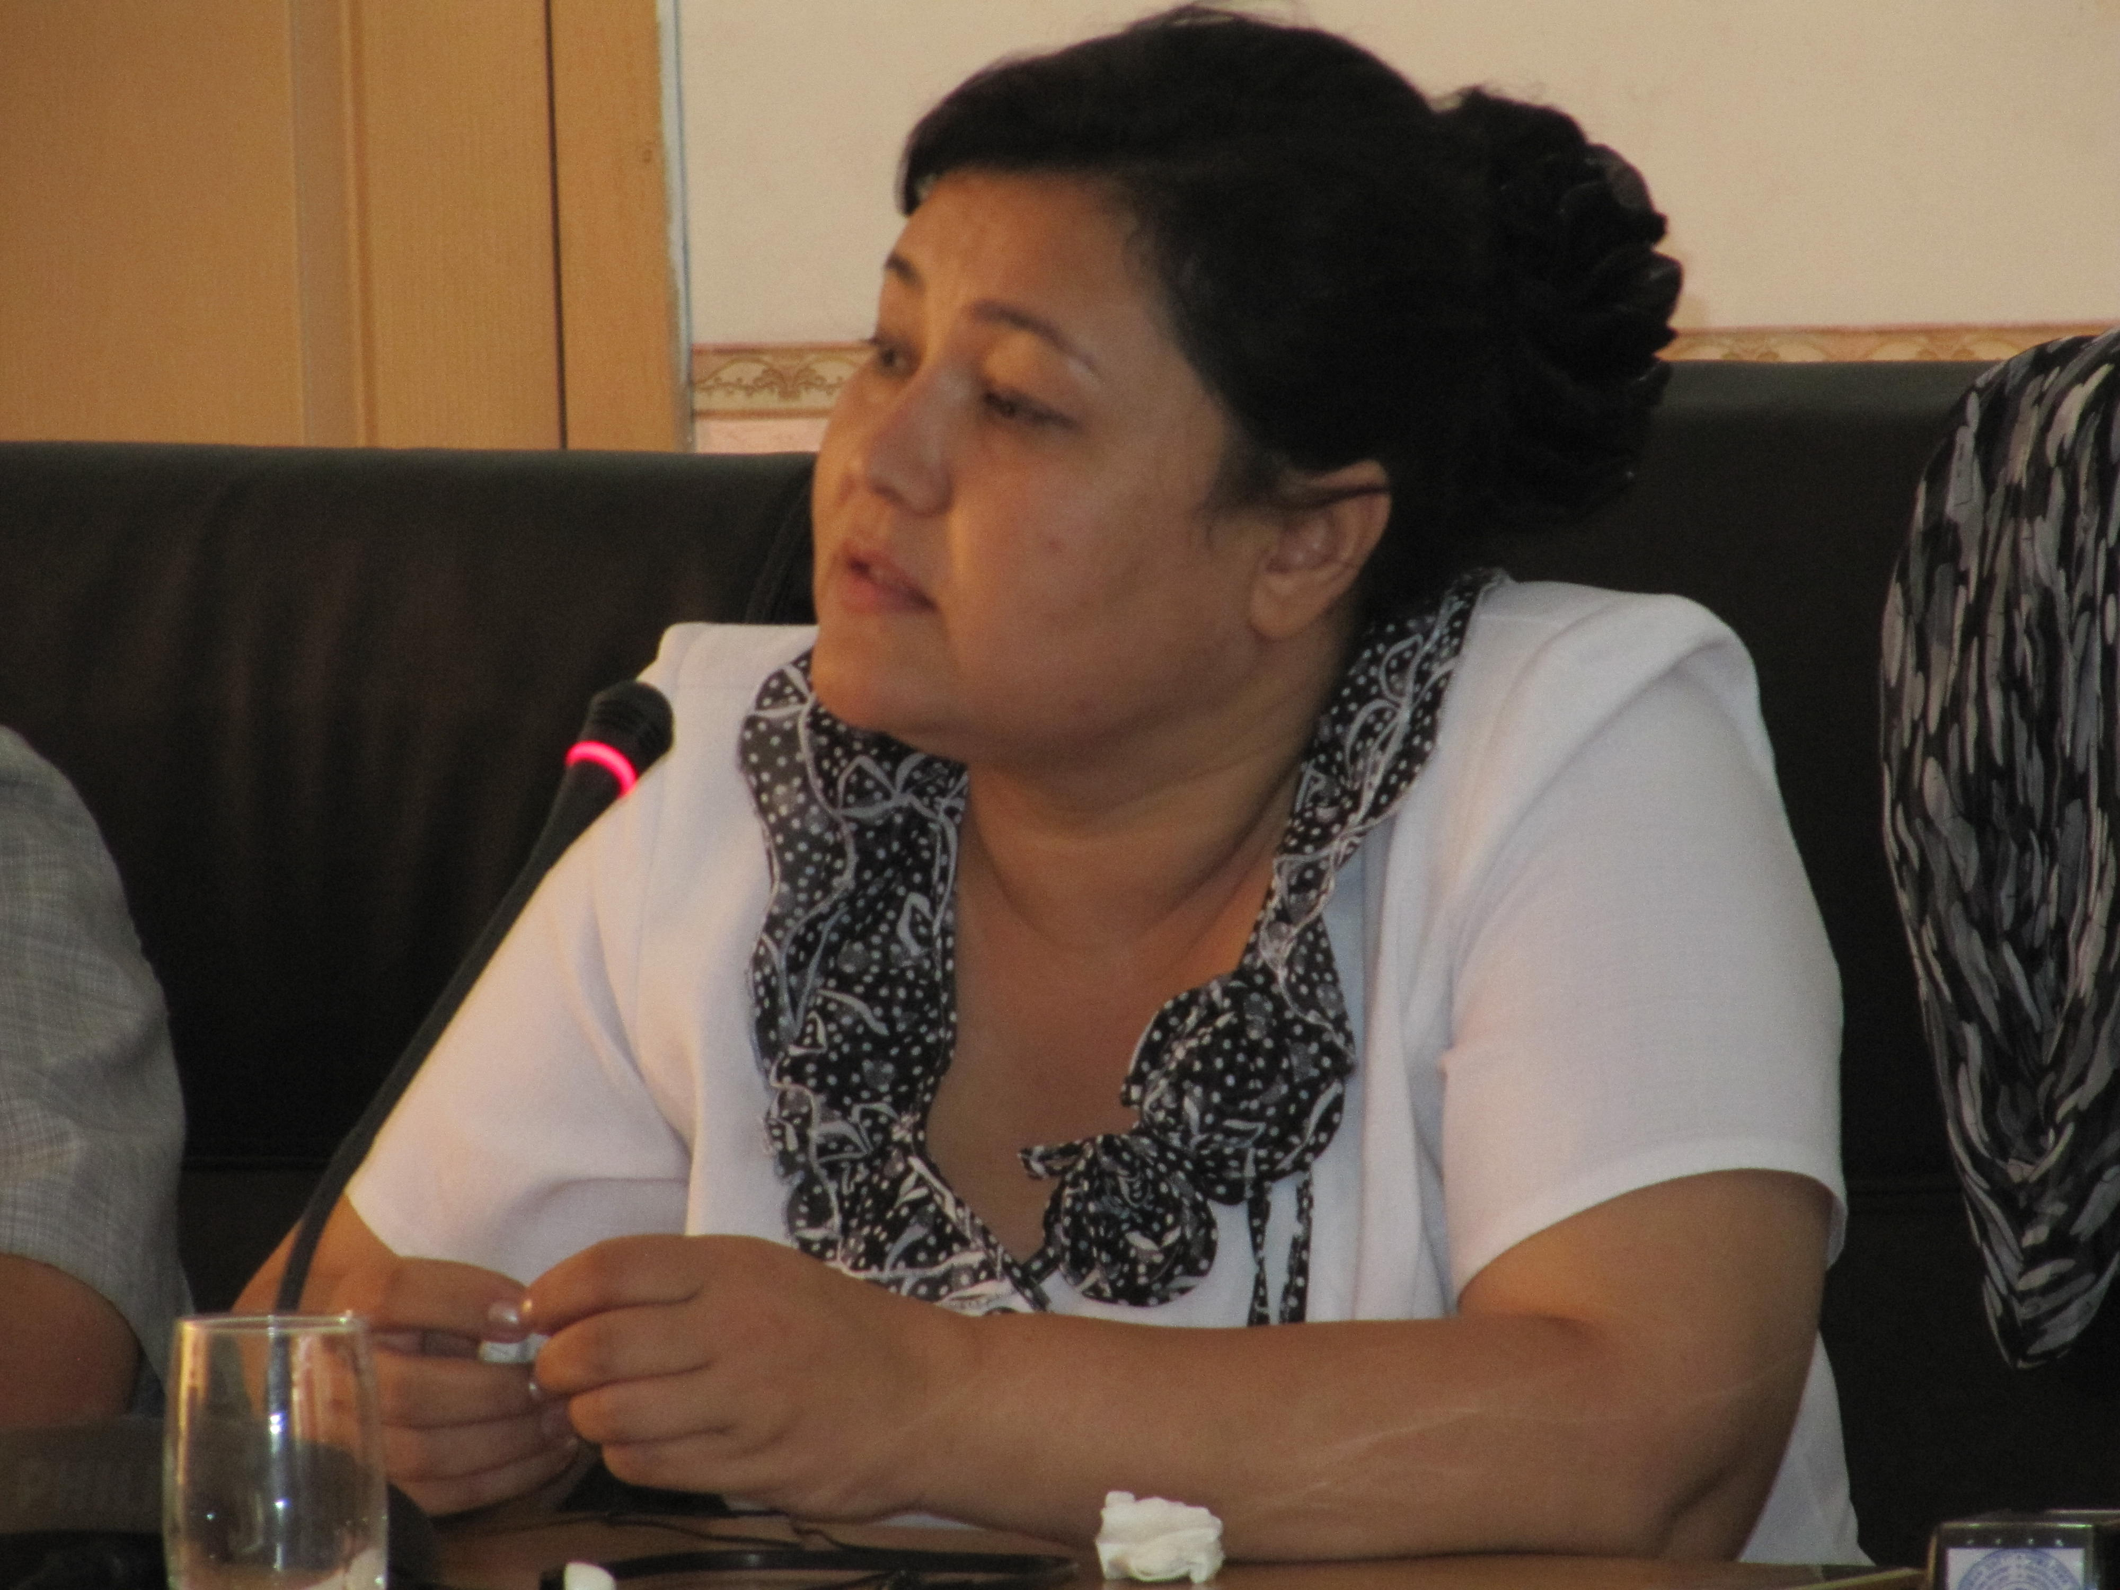
2. As it is a new organization, it is currently promoting actively its organization to other donors and support groups.
FIELD VISIT
Office of NGO Bonuvoni Kathlon
Farms of 3 Men Dekhan farmers
July 17, 2012 / 7am-7pm (including travel)
Meeting with:
--Maksudkhojaeva Gulbahon, Executive Director
--Uraeva Shamsir, dekhan farmer (man)
--Halim, dekhan farmer (man)
--Boboi Farsat, dekhan farmer (man)
--Faizakov Mohmadrahim, dekhan farmer (man)
--woman farmer
1. Uraeva has 5 hectares of land; 3 hectares planted for cotton and 2 hectares for wheat, and kitchen garden (fruits and vegetables). She lives with her husband and three children. Cotton is for selling; they buy the seeds from a factory and can sell the cotton to any factory. As a farmer to She is a member of the district’s ADF (association of dekhan farmers) which has 66 members and which was founded two years ago (in 2010). She joined the ADF to get some support especially during difficult times, get educational training, and improve knowledge about farming. She shared that the ADF is taking the initiative to establish a seed factory to control the price and quality of seeds.
2. The Mission Team visited the farms of the three male farmers. Through training given by the NGO, they shifted five years ago from mono cropping (of cotton) to integrated, diversified agro-economist approach. In their farms we saw various fruits and vegetables planted side by side with each other (tomato, eggplant, cabbage, watermelon, corn, legumes, etc). The farmers said that with climate change, planting several kind of crops help them become more food secure. They said they do not receive support from government but that the government collects a pension fund from them. From the NADF, they get information, brochures, and training on quality production among others. They said that the ADF is demanding from the water authority a reduction in the water fees. She wants to know also the legal basis for the perceived big collection of water fees. The government is just starting to organize the water user association in the area.
3. The farmers said that there is high level of underground water, lack of pumping stations and equipment, and lack of qualified people to manage water distribution and use. The poor state of the drainage system has led to too much soil erosion, leading to increased wetlands and reduced farmlands.
4. Some of the recommendations from the farmers included: (a) provision of technical support –office, irrigation engineers, hydrologists, with the professionals to be given higher salaries so they will not migrate to Russia; and (2) support NGO work in building the knowledge and skills of farmers. 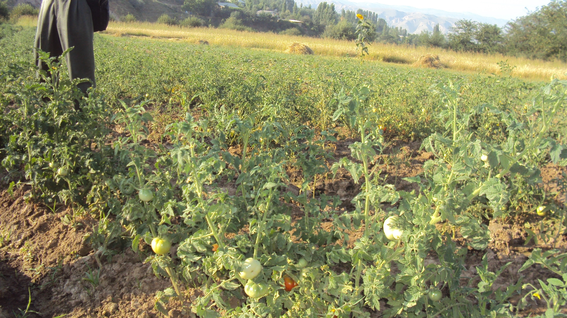
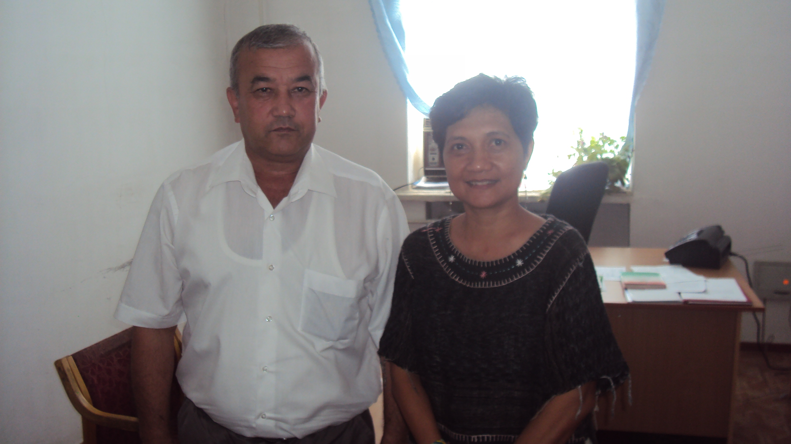
Plant Growing Department, Ministry of Agriculture
July 18, 2012/ 8am
Meeting with: Abbos Yakyokhajaev, Head

1. He gave several information about agriculture and farmer situation in the country. Ninety-three% of Tajikistan is mountainous and only 7% is agricultural land. One of the main problems of Tajik farmers is very poor access to water. The pumps that are on dire need of repair since the collapse of the Soviet era irrigate only 46% of agri lands. After the war, the level of underground water became high and salinization increased, thereby rendering many agricultural lands useless.
2. He was not involved in the design process of GAFSP, but hopes that the project will support the rehabilitation of the irrigation system and reduce salinization.
3. Repairing and other issues regarding water are under the authority of the Ministry of Water. But all the food security agenda is under the Ministry of Agriculture. We have developed activities where these two agencies somehow coordinate –e.g. in Vaish (?). The water ministry cleans and drains the irrigation canal while the agriculture ministry educate the farmers on what crops they can plant to minimize the use of water.
4. The Ministry of Agriculture’s main aim is to ensure food security. And have many activities in the Kathlon region. We give training on how to irrigate, how to prepare the land, how to keep the soil healthy, how to do crop rotation. He is glad that the GAFSP project will cover the Kathlon region, as it is one of the most problematic agricultural areas.
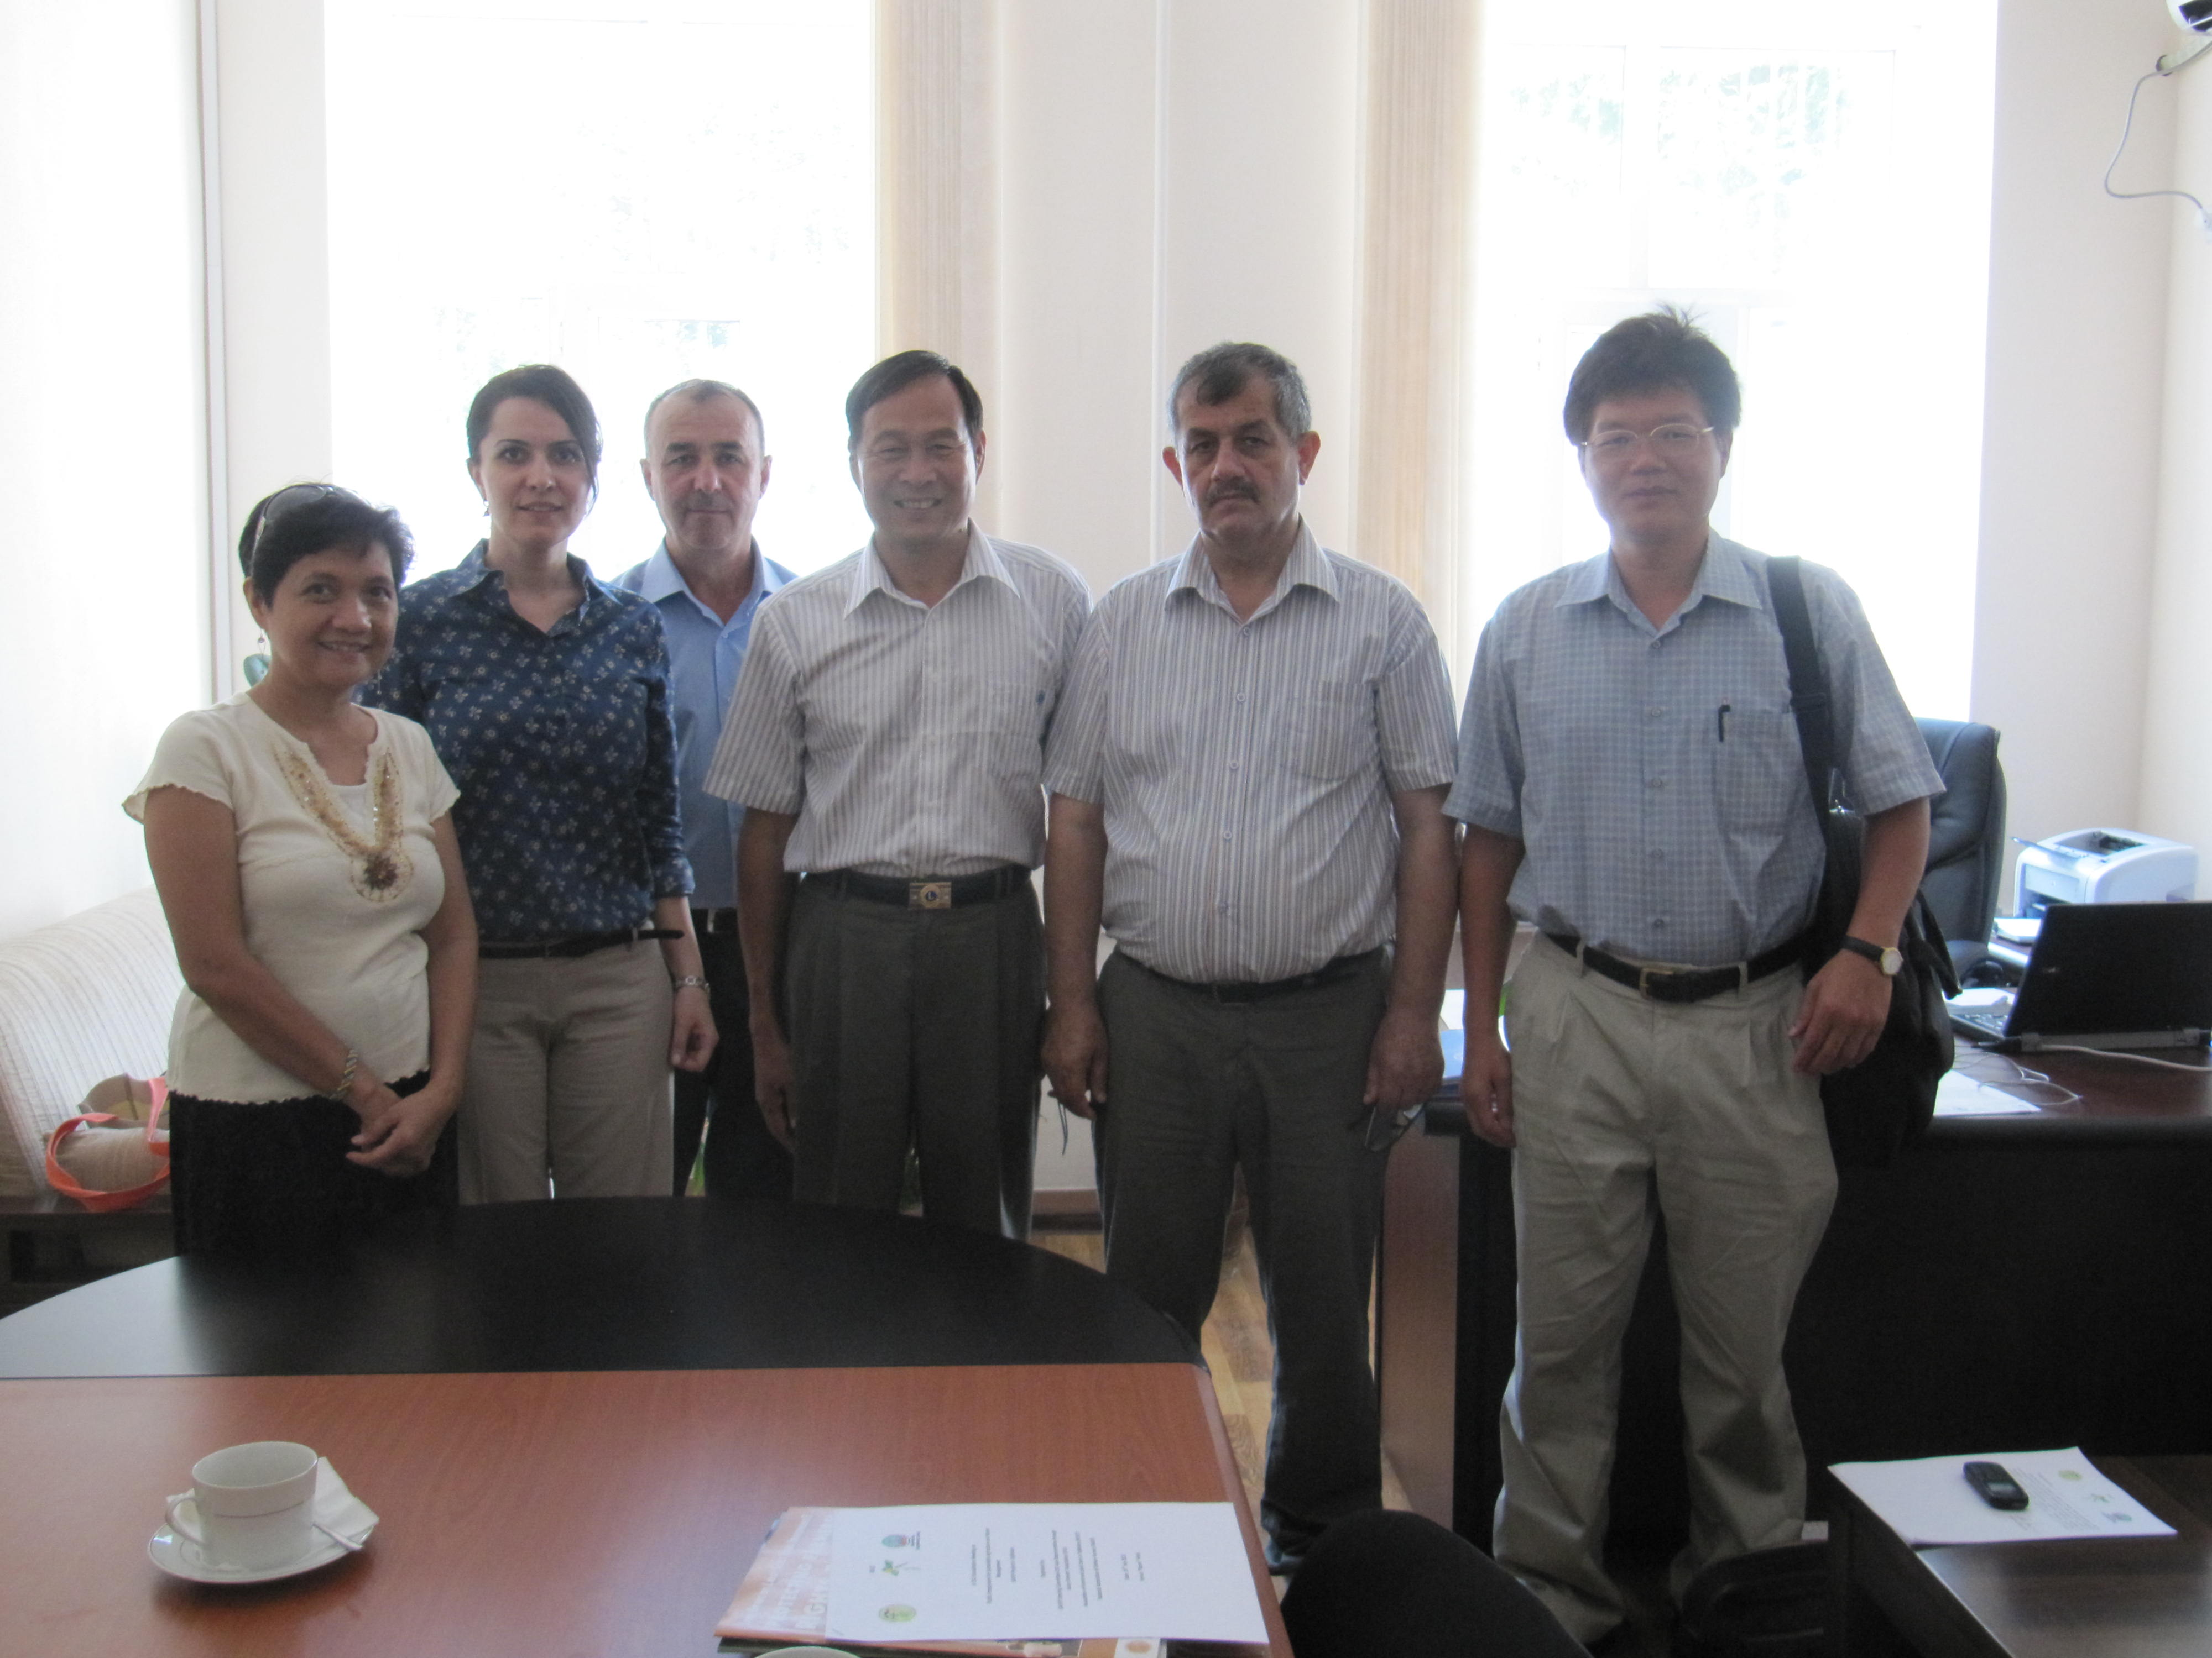
Food and Agriculture Organization
July 18, 2012
Meeting with:
---Takhmina Touraeva, Assistant FAO representative
--Sangibin, FAO officer

1. They do know about the GAFSP project, though Takhmina has been in FAO just for the last 7 months. She is keen to be part of this project and see how best FAO can manage in this kind of partnership. She believes that the project will be very important for the country, esp in Kathlon region. Ninety five percent of agricultural GDP comes from irrigated agriculture and the lands in Kathlon is highly salinized, so any irrigation rehabilitation work in the region will be very important to make agriculture sustainable.

2. The involvement of farmers organizations and CSOs in this project will be very important too especially if we want to clean the rehabilitation system. In some cases, rehabilitation is being done by hand. On the other hand, it is very difficult to ask WUAs to keep the drainage and irrigation system because farmers, especially cotton farmers, are not earning enough and thus may not be able to pay for water maintenance. If all the water fees will come from the water association, the amount of funds will not be enough to clean and repair this irrigation. It will be very important to build the capacity of the WUAs for irrigation management, then to help them buy the needed machineries, even if through credit. Now, women are doing irrigation system and the system has to be cleaned every three years. The men who knew about irrigation have migrated to Russia and are earning more money so they will not come back to the country to work.
3. Civil society and farmers organizations are very weak. There is no voice, no lobby, and no strong participation. The government should allow them to position themselves. The WUAs must be given some independence, to manage themselves. There should be separate function of policymaking and implementation. Once the WUAs feel they can be independent, and then they can be more responsible, they can even earn. There is a Dekhan law. NADF can be more organized, it has a better structure. But it still has less power. It does not have freedom of movement.

4. There is a need to build the capacities of the WUAs, the need for them to build the capacities to understand the complexities of this water management system. If capacities are built, they can be one of the more powerful farmers’ organizations because they are bringing the water. Now we are losing 50-60% of water.

5. The extension service is almost non-existent. Farmers should always receive updated information on how to manage the irrigation system. The idea of an integrated water system management has to be brought out at the national level. In FAO here, we have established a veterinary management system supported by the government. Now, the group can make their own power point presentations and are not beginning to take funds from donors, EU for example. It is treated as an enterprise now.
6. On women farmers: The biggest challenge is to educate them of their rights. It is the women who are dealing with their little plots. They are the ones who need knowledge how to fertilize, how to irrigate. We have to build their capacities. Women farmers are active, all they need is for someone to encourage them more to be very active --- “this is your right as a member of the association”. Many of the members of the water user associations are women.
7. Because of land issue, farmers do not risk planting and investing in their lands. Issue on land titling is not yet clear, although the land titling policy is still in the final stages. The other issue is marketing. Farmers have problems in access to markets so they end up selling their products to the buyers in their areas. They need secured lands, secured access to inputs. Fertilizers here are very expensive.
8. FAO is very strong on integrated pest management. In other projects, we are introducing organic farming. We have contacted four institutes. We will teach the institutes and they will bring the knowledge to the farmers. They are the ones teaching compost to the farmers. In FAO, we are very pro less chemical input. We have organic pesticides. Integrated pest management is very well supported and is a big project here in FAO.
9. FAO is also working on adaptation agriculture, which should bring agricultural technologies, which are adaptive to current conditions. For example, use of saline-tolerant varieties.

World Bank
July 18, 2012
Meeting with: Bobojon Yatimov, Senior Rural Development Officer

1. He knows Mr. Sharipov from NADF and Mr. Kokul from AFLUT as they have worked together for some projects in the past.

2. The Tajikistan WB office has an employment in public works program and when they learned about GAFSP, they became very interested. They applied January 2011; in June 2011 the concept note was approved.

3. The project is now in preparation stage. A general design of the project, almost similar to what has been submitted, with some slight changes is now being formulated. There was a huge mission April-May 2012. The main objective is to create a public works program for the poor people – through cleaning and draining the canals. This will be an opportunity for people to have cash in their pockets, in the immediate term to have more access to water, and better quality of harvest. The target areas are in Kathlon region and Kulyab flat areas. There will be three main components: public works and rehabilitation: which will include manual cleaning of canals, rehabilitation of draining and pump stations, rehabilitation of flat channels in Kulyab. The Kulyab flat channels were built in the 1970’s, and now there is a risk of heavy flooding, especially during the months April-May, when there is heavy spring fall. The second component is the rehabilitation of gates, pumps and drainage systems.

4. How will FOs and NGOs become involved? The PMU will hire an NGO to conduct the survey, an international NGO will do monitoring and evaluation. The whole design of the project is such that we will work with the whole level of government starting at the national level, to the regional chairman, then to the districts, then to jamaats, then to the village. For the public works, there will be two separate processes: selection of beneficiaries and the rehabilitation process. The list will be screened by the NGOs. The NGO will work closely at the local level and monitor the process. Then the social mobilization will come in. The project will work in the area where there is a water user association. USAID have a project of establishing water user associations for the past two to three years. So we will work with USAID on this. Once we have the list of water user associations and their needs, the water user association will then establish the priority areas to clean. There will also be criteria on the selection of beneficiaries. The water user association, the NGO and the PIU will monitor the activities. A completion certificate will be signed and this certification will be submitted to the PMU for payments -- direct to the beneficiaries The water user associations are just newly established so we are limiting their roles in terms of starting to prioritize their needs- e.g. what pumps to rehabilitate, to be part of monitoring and supervision. Capacity must be built first. In terms of organization and water management, the agreement with USAID is that they will set up the water user associations, while we will focus on the rehabilitation of the pumps.

5. For the budget: 5.6 M goes to public works, 13.9 M goes to rehabilitation of pumps; and another 3.5M goes to TA. For the TA ---we will look at the legislation system and will get the pilot area to implement the shift -- like computing the correct tariff for this system. There will also be study tours to see how the system works in other countries. Also bring some advanced technologies in good information management system within the ministry. We will bring international experts. The TA will be handled by the PMU, but there will be a steering committee.

Meeting with Amiruv Nazrulo
July 18, 2012/ 10-11 am
Academe and Researcher
Quotes from the Interview:

1. There are so many rare things you can find here in Tajikistan. Our country is rich in natural resources. The land is not bad, and the water is suitable for agriculture.
2. I just participated in many international conferences- a conference on world marketing in Japan, a conference on water use in Turkey and China, and on implementation of agricultural know technologies in Egypt.

3. Our institution has 5 subjects funded by the government. We are cooperating with the WB, ADB, FAO and Aga Khan Foundation.
4. The main problem with our water is how to develop the mechanism for the use of water. I learned that in Turkey, the government has special pools for conserving water, and they bring this water to the water user, and the water user pays. But the association of the water users should first make a plan, which they submit to the government. Then, according to this plan, the association will send the water to the farmer. The association will also collect the fee from the farmer and then give the collection to the government. If there is in need of repair, the government then has this fund for repairs. If there is a big problem that needs more money, the government will repair and then divide the water to the water user associations, with the corresponding fee.
We in Tajikistan have no water reservoir. We just have a river whose water just keeps on going and going. We don’t have this kind of water storage facility. Sometimes, we put pumps to get the water from the river. We need electricity to do this, and therefore, water becomes more expensive --- and farmers cannot pay for the use of the water. If we have this water pool, we can irrigate more lands. We need to break out of the Soviet system and use modern irrigation systems which are very much working in other countries. There is a need to have a pilot site for the water reservoir. I know how to make this pool as we have done some researches on this already. The government knows about this need for water pool, but funding takes time. The GAFSP may be a possible source of fund for this. With a water pool, we can irrigate as much as 10,000 hectares of land. We can pilot this in an area where we can also expand in new lands for agriculture.
5. Now, 90% of farmers have water debts. Water user associations are organized in many areas, but many are not functional.
6. Most of the government projects are being implemented near Dushanbe, the capital. We should be implementing more in the Kathlon region.
International Fund for Agricultural Development
July 18, 2012
Meeting with: Kenjaeva Zainab, Country Presence Officer
Quotes from the Interview:

1. IFAD was implementing a project, called Kathlon Livelihood Support Project, in five districts, with the State Land Commission as government partner. The main problem with the government bureaucracy in Tajikistan is that we do not have professional expertise – meaning those people who will have good English, computer skills, and project /program management skills. Most of them work with international organizations. This project was suspended following the results of a review mission.
2. The second project is on Livestock and Pasture Development in five districts in Kathlon region, with the Ministry of Agriculture as implementing agency. We hope to start implementation of this project in August this year. This project will have four components: establish village organizations in the project areas; establish small private enterprises for processing of agricultural products, help livestock and pasture groups provide veterinary services and pasture management, and project management. This project is involving other stakeholders from private and international NGOs such as Aga Khan and Caritas. Learning from the lessons of the first project where project management was weak, now IFAD participated in the selection of the Project Director and the local staff.
3. I have been in this position for 1.5 years.
4. Our partner NGOs and national associations have capacities, but they need further technical assistance, some farmer exchange visits and study tours. In the rural areas, we have many women/gender NGOs. In Rio+20, one of them received a UN Women Peace Prize.
5. Many of our people have migrated to Russia. So, much of the agriculture here is done by women and children. Agriculture is a very difficult labor for them. Young girls especially in the rural areas get married at a very young age – at 15 or 16. Though we see improvements now as our women are getting better educated about their rights.

Field Visit in Rudaki District
July 19, 2012/6am-9am.

1. The Mission Team, a dekhan farmer in his farm, the NADF training center and parts of the irrigation system in Rudaki district. Mr. Azizbek of NADF arranged the meeting.
2. The dekhan farmer plants various fruits and vegetables such as tomato, cucumber, watermelon and sunflower. His current two biggest concerns is access to credit and the salinization of his land. While banks are required to give loans to farmers, the bank requires 18 documents to be prepared and submitted by the farmer, and interest rates are high: for every $1 credit, the farmer will pledge $2-3 to get the loan. On the salinization problem, the farmer said that the water association in his area is not functional and does not support the farmer, and the canal is not being maintained; yet the farmers are asked to pay $50/year. The farmers in the area are unable to pay these fees though. He said that there is no project in the area, as all irrigation projects are going to Kathlon.
3. The NADF training center in Rudaki district was established in 2009 with the support of JICA. It is a 2-story building. Inside are meeting rooms, offices, a library and dormitory for both men and women (for participants in the training). There was no activity in this training center for the past 5 months because of absence of any training project.
