2nd CSO GAFSP Mission in Bangladesh
15-27 May 2012

A. Executive Summary

The first GAFSP Mission of CSO-Asia representative has conducted an initial consultation on the approved concept note of the GoB last February 2011 where participants raised some of their concerns about the proposal. They agreed that the GAFSP concept note is relevant and if implemented well, can really respond to food security needs of the country and benefit its small-scale farmers and fishers. Thus the participants in this consultation gave several recommendations; these recommendations were submitted by the CSO-Asia representative to the government.

This second Mission conducted on April 15-27, 2012 in Bangladesh by Estrella Penunia (AFA Secretary General) and Victoria Serrato (Marketing Officer) as AFA secretariat support to the CSO-Asia Steering Committee representative, assisted by Amirul Islam and Asgar Ali Sabri of Action Aid Bangladesh. The mission was aimed to inform CSOs about the final implementation plan and Technical Assistance component of GoB and FAO Bangladesh, facilitate the development of communication and coordination mechanisms among CSOs, FOs and CSO-Asia representative re engagement in the country’s GAFSP and CIP processes, together with FAO mission team, do a mapping of the outreach, expertise and of CSOs and FOs who would like to engage GAFSP and identify the needs of the farmers’ organizations, especially their members in the target areas.

Coordination meeting with the Project Director of GAFSP-Bangladesh (Mr. Khalid Mahmood), World Bank (Mr. Ousmane Seck) and FAO Bangladesh in-charge in the GAFSP TA component and Florentina of FAO Rome, day-long consultation-workshop attended by 40 representatives from 15 organizations (representing FOs, NGOs and INGOs), IAPP-GAFSP Project team and AFA; and mapping exercises in Rangpur and Barisal with the Mapping Team members: Florentina Williamsonnoble, Mahmud Hossain, Asna Zareen, Amirul Islam, Asgar Ali Sabri, Estrella Penunia and Victoria Serrato were conducted.

Among the key information generated by the Mission include:
- Updates on IAPP project implementation including criteria of selection of beneficiaries, project sites, farmers’ group and status of hiring of project staff at the field level, b) composition of the FOs and CSO representative in the Project Steering Committee, c) capacity needs of FOs and CSOs, and d) identified development interventions and mechanisms to strengthen FOs and CSOs to engage the government and meaningfully participate in all development processes.

The objectives of the Mission were generally achieved and expresses sincere thanks to the hosting and facilitation of AAB and the generous sharing of information and time by IAPP project team, FAO as well as FOs and CSOs during the consultation workshop and mapping specifically those working in the IAPP Project sites.

B. Main Report

- Introduction

The Government of Bangladesh (GoB) has submitted its final Implementation Plan, which the Steering Committee of GAFSP has approved. The TA Component, which FAO is managing, has likewise submitted its Plan, which the GAFSP Steering Committee has also approved. The TA component has included capacity building goals and activities for NGOs and organizations of small-scale farmers and fishers, not only for the GAFSP but also for the whole Country Investment Plan.

The CSO-Asia representative has conducted an initial consultation on the approved concept note of the GoB last February 2011. During this consultation, the participants raised some of their concerns about the proposal. They also agreed that the GAFSP concept note was relevant and if implemented well, can really respond to food security needs of the country and benefit its small-scale farmers and fishers. Thus the participants in this consultation gave several recommendations; these recommendations were submitted by the CSO-Asia representative to the government.

One of the recommendations by the CSO-GAFSP Mission team during the first country visit last February 2011, was to map who among them are working in the priority regions (Rangpur and Barisal currently), the scale of their work as well as their reach, and the sustainable technologies that can be up-scaled / adapted in the GAFSP areas.

- Objectives

This second Mission conducted on April15-27, 2012 in Bangladesh by Estrella Penunia (Secretary General) and Victoria Serrato (Marketing Officer), AFA Secretariat staff support to the CSO Steering Committee – Asia Representative assisted by Amirul Islam and Asgar Ali Sabri of Action Aid Bangladesh, was aimed to inform CSOs about the final implementation plan and Technical Assistance component of the GAFSP project in Bangladesh and FAO respectively, facilitate the development of communication and coordination mechanisms among CSOs, FOs and CSO-Asia representative re engagement in the country’s GAFSP, do an initial mapping of the outreach and expertise of CSOs and FOs who would like to engage GAFSP, especially in the GAFSP areas; and identify the capacity building needs of the farmers’ organizations and CSOs, agreed on coordination mechanisms among CSOs and outline key activities that CSOs can implement to build the capacities of FOs so that they can meaningfully engage in GAFSP and other agri- development processes in the country.

- Activities

On April l5, Ms. Estrella Penunia together with Victoria Serrato, Amirul Islam and Asgar Sabri of Action Aid Bangladesh visited the offices and met with IAPP-GAFSP Project Director (Mr. Khalid Mahmood), the World Bank (Mr. Ousmane Seck), FAO Bangladesh in-charge of the GAFSP project (Mr. Mahmud Hossain and Asna Zareen) and FAO Rome (Florentina Williamsonnoble). On April l6, a day-long CSO Consultation Workshop was attended by 40 participants from (15 NGOs/INGOs, 2 FOs, government representatives, IAPP Project team headed by Mr. Khalid Mahmood (IAPP Project Director), Mr. Mahmud Hossain, Asna (FAO Bangladesh) and Florentina Williamsonnoble (FAO-Rome) and facilitated by Sarah of AAB Country Coordinator graced the event with their presence in the morning session while afternoon session focused on mapping of CSOs and FOs expertise, needs and interventions facilitated by Estrella Penunia.

Field visits in the seed processing plant of KKM (April 17), a national farmers’ federation assisted by Action Aid Bangladesh. The mission team had an opportunity to met and discussed how KKM operates their enterprise, scale of operation and potential to expand so that many farmers will be served and have access to quality seeds.

Field visits in two districts were conducted by the mission team. Both in Rangpur (April 18- 19) and Barisal (April 26-27), consultation workshop held and discussed the GAFSP-IAPP project and conducted initial mapping of FOs and CSOs working in the project sites.

Initial results of the mapping exercises in Rangpur were presented in April 25 with the government representatives and CSOs. It further discussed needs interventions to help FOs strengthen their capacity to enable them engage the government and actively participate in the project and all development processes concerning small scale farmers.

- Key Findings/Information Gathered

Project Updates

Project Context.

The Integrated Agriculture Productivity Project (IAPP) is a comprehensive project aimed at increasing agricultural productivity and livelihoods in agro-ecologically constrained areas by strengthening integrating of key aspects impacting agricultural production. This project may impact to agriculture development by ensuring proper implementation of each project component that have clear and well defined outcome indicators, strategies and activities. The set project operational structure defined clearly how the project will operate and be managed at the district level by the Project Management Unit (based in Dhaka) and Regional Project Implementation Units (Rangpur and Barisal) where PMU and RPIUs will coordinate, at their respective levels, the activities of various implementing agencies, including the research institutions, the line departments for extension, BADC (seeds and inputs supply), community level service providers and any CSO/NGO.

Together these constitute a pilot approach to addressing the problem of low productivity growth. Success achieved in this project can be scaled up nationally, especially in the context of the complementary, long-term National Agricultural Technology Program which is supported by the Bank.

Complementary Projects. The IAPP project is one of the approaches in addressing the problem of low productivity growth and if this project will succeed, IAPP shall be scaled-up nationally which is complementary project of the National Agriculture Technology Program (NATP), a program supported by the World Bank.

Project Site Selection. The objective of the project is focused on increasing agricultural productivity and livelihoods in agro-ecologically constrained areas through strengthened integrated of key aspects impacting agricultural production: 1) research-extension-farmer linkages in order to furnish relevant technologies and practices to farmers; 2) technology promotion with enhanced availability of improved seed, to ensure sizable spread effects; 3) introduction of improved crop and water management practices; and 4) training and capacity building of farmers’ groups along with promotion of key productive assets.

The project sites selected by the project team included two districts – Rangpur, Kurigram, Nilfamari and Lalmonirhat districts in the North and Barisal, Patuakhali, Barguna and Jhalokathi districts in the South.

The criteria for selection of farmer-beneficiaries include farmers who is marginal and small scale farmers cultivating less than a hectare of land. According to the Project Director, the project will tap existing organizations and will only organize if needed. The integration of agriculture-fishery-livestock departments/ministries and other support agencies such as irrigation, research and extension would be the strategy to help facilitate in responding to issues and concerns of farmers during the course of project implementation.

CTA and Project Implementation Team. The Chief Technical Adviser for the TA component (c/o FAO, 1.5 million USD) was already selected, Mr. Mahmud Hossain. (not sure if Mr. Mahmud Hossain was appointed as CTA)

Project Implementation Manual.

The Environmental Impact Assessment Management Plan.

Technical assistance

Impact Assessment.

Views from CSOs re. project updates.

Presence, Expertise/Experience and Capacity Needs Mapping

Presence. Participants to the Workshop shared briefly their initiatives, programs, areas of operation and “expertise/experience/track record”. They also shared their capacity needs to engaging the government and participate in all processes.

Expertise/Experience.
The work of CSOs attended the consultation focused more on advocacy, promotion of organic/sustainable agriculture, food security, business development and management, technical, marketing and sustainable livelihood.

Capacity Needs. Sincere thanks to the participants in the consultation workshops, meetings and field visits for sharing of information and expressed the needs on how FOs shall be strengthened and empowered to engage and participate in development process as well as strengthening the organizational endeavors including their livelihood and markets to achieve food security and nutrition.
One of important concerns raised was knowledge sharing and exchange visits to learn and share experiences that could be of help in their organization as well as a farmer specifically in enhancing agriculture farm productivity and market access. Below were the initial results of mapping identified by the mission team classified into 5 areas of capacity needs:
- Capacity needs on organizational management: Networking and coordination; federating, Member mobilization and building trust within groups, Leadership development, Organizational management, Negotiation skills and Support to registration
- Capacity needs related to project development cycle and management: Overall understanding of how the PCM works, Investment planning, Participatory planning, Project formulation, Project implementation, Monitoring and evaluation
- Capacity needs related to empowerment are: Awareness raising on the benefits of being organized, Knowledge of Government’s governance processes, Negotiation skills, Strengthening the role of women and Awareness of legal rights
- Capacity needs in business development and management includes: Business development, Financial management/book-keeping, Resource mobilization and capital formation, Access to finance, Access to markets and Awareness raising on how being organized can help the group be more competitive on the market
- Technical capacity needs includes Agriculture production technologies (Seeds, Production systems) and bridging the gap between research and training

CSO Coordination Mechanism and CSO Representatives to GAFSP Project Steering Committee

Sustaining CSO involvement. The Government of Bangladesh (GoB) is open to engage CSOs under the IAPP-GAFSP. In order to sustain CSOs meaningful involvement in the GAFSP Bangladesh Project and to lay the ground for a CSO platform re ODA projects, participants to the CSO Consultation-Workshop agreed to be involved in the development processes specifically in addressing food security and nutrition, food sovereignty, etc. through the following mechanisms: 1) Among CSOs/FOs in Bangladesh specifically those CSOs/FOs working in the GAFSP project sites; 2) Among CSOs/FOs and GAFSP official; and 3) Between CSO GAFSP SC representative and CSOs in Bangladesh to ensure proper coordination among CSOs & FOs, Action Aid Bangladesh shall take the lead in the coordination e.g. conduct a forum.
While the Farmers’ Organization can directly link to GAFSP and AFA in order to maximize their participation in the processes.

Coordination. Action Aid Bangladesh was selected as CSO focal organization to coordinate GAFSP processes among CSO in Bangladesh and GAFSP SC-Asia. They have a certain level of trust to Action Aid and thus, entrusted to represent in behalf of the CSOs

Partnership with AsiaDHRRA/AgriCORD. IFAD, a member of the GAFSP Steering Committee, through its Belgium-based partner AgriCord and its Asian member, AsiaDHRRA, will be making available small funds for CSO meaningful involvement in GAFSP, including Bangladesh. The Bangladesh CSO Forum for GAFSP, thru Action Aid Bangladesh, will be accessing this facility.

Representatives. The GoB through the IAPP Project Team had already appointed and/or selected representatives to the National Project Steering Committee composed of two FO representatives (one representative in each district of Rangpur and Barisal) and BRAC as CSO representative.

5. Conclusions and Recommendations

The Mission objectives have been generally achieved supported by the active participation of the project team of IAPP, the CSOs and FOs and the able coordination work by AAB staff. Further meetings of CSOs shall be conducted to finalize capacity needs and prioritize interventions to FOs specifically those operates in two districts where IAPP project will be implemented. AAB as a CSO focal organization shall take charge in coordination with the CSOs participated in the consultation workshops and with the FAO and IAPP project team to get updated about the project and how those interventions will complement with to benefit small scale women and men farmers in Bangladesh.

6. Action Points/ Next Steps
The participants during the consultation – workshop identified some of the key activities as follows:
- Finalize capacity needs of Farmers/FOs identified including the results of mapping of FOs in Rangpur and Barisal
- Technical supports identified: seed conservation, negotiation, facilitation, Business development, Registration process of FOs;
- Farmers exchange visit – to learn from other experiences and exchanges of information; Intellect to support in enhancing the FOs
- Access to farm tools and production inputs, information and better price of agriculture produce in the market
- Macro-level policies to strengthen farmers to influence policy makers in areas of a) Disaster risk reduction preparedness – hardware and software, b) Gender dimension – 30% women membership to get involved in the project, c) Access to website and d) Environmental and social framework
- With support from IFAD-AgriCord, through Action Aid Bangladesh, will prepare a proposal to access fund to support CSOs identified activities to strengthen FOs and CSOs to engage the government and meaningfully participate in the development processes. A proposal, not more than 15,000 USD, will be drafted by AAB commented and approved by the current members of the Bangladesh CSO Forum for GAFSP, and will be submitted to AgriCord/AsiaDHRRA within the month of May.

7. Annexes

7.1. Coordination Meetings

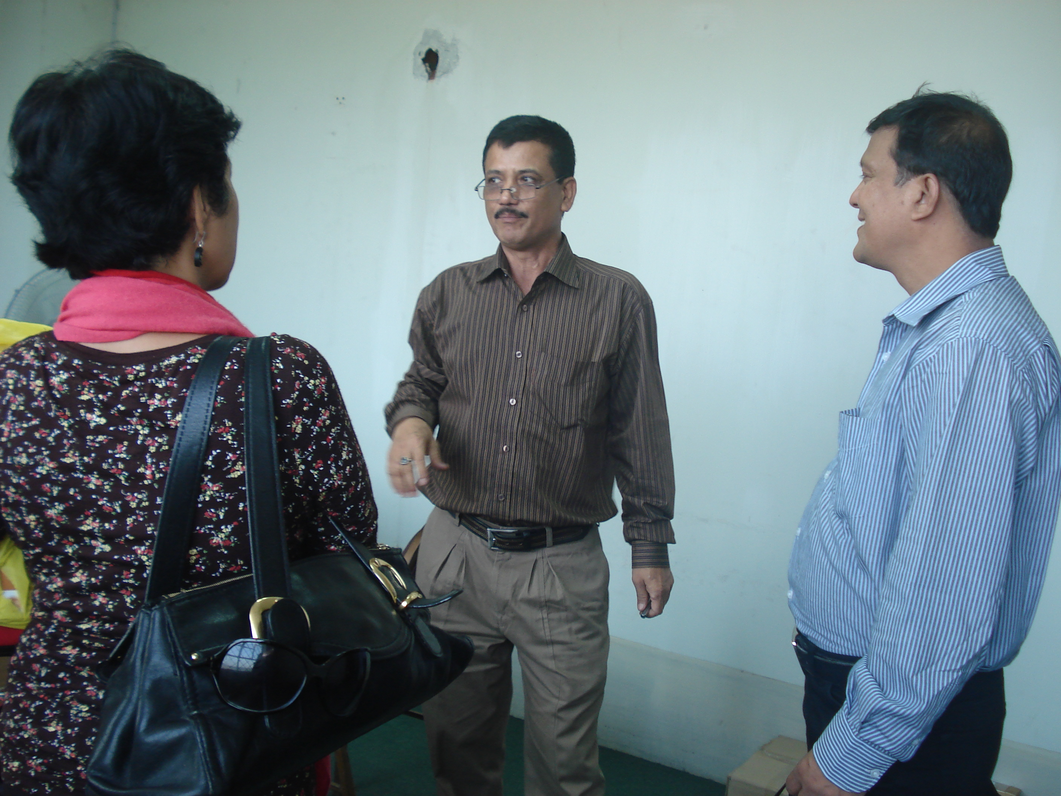
April 15, 2012 Meeting with Mr. Khalid Mahmood, Md. Mahmud Hossain and local Host Amir and Sabri of AAB. Discussed the role of AFA as secretariat support to CSO SC-Asia Representative, updates from IAPP Project Director and AFA introduced its support role to the CSO Steering Committee – Asia Representative and invited the IAPP team to attend the consultation to present the status of IAPP project implementation. Mr. Khalid Mahmood confirmed to attend the consultation workshop with his project team.

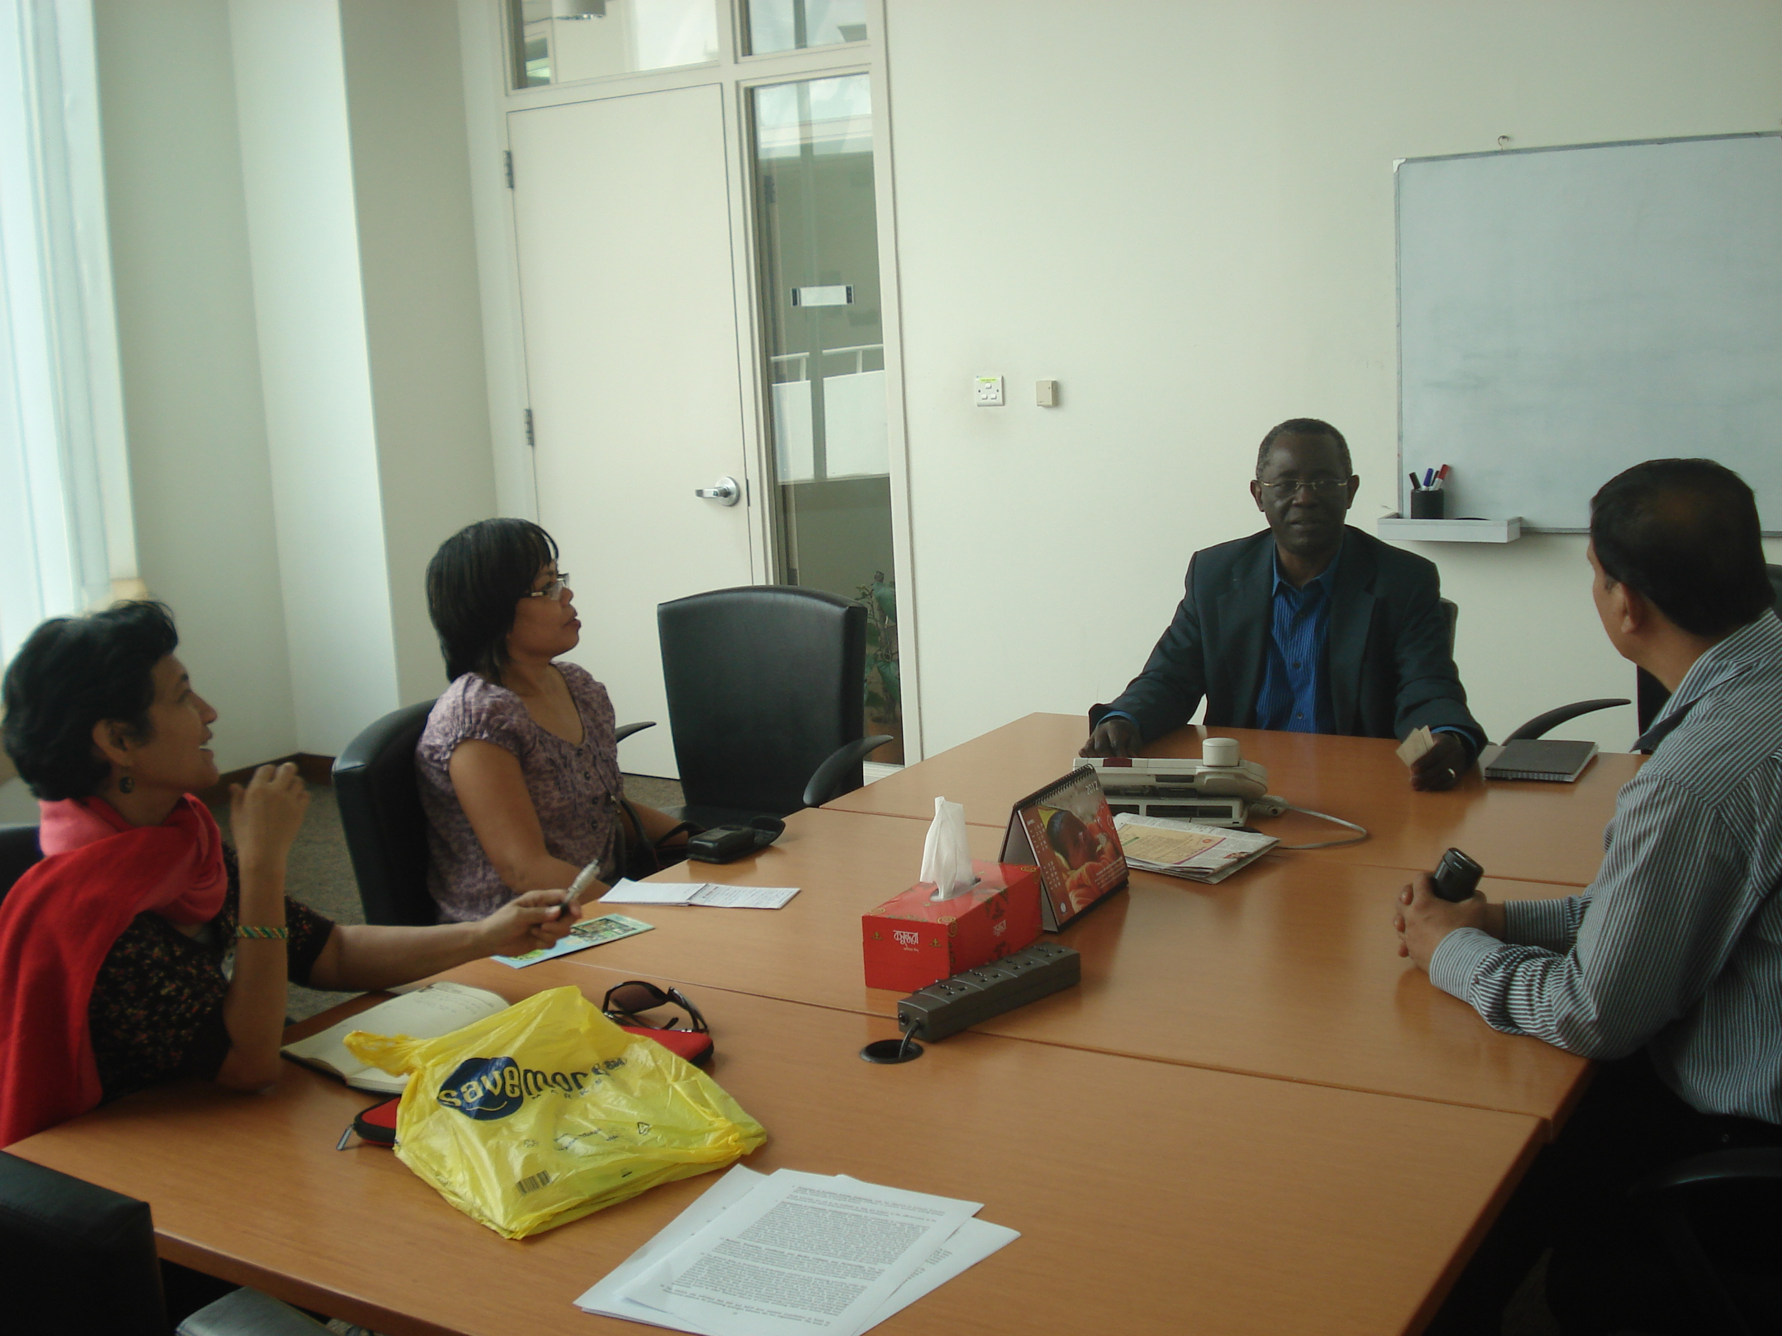
Meeting with Ousmane Seck of the World Bank-Bangladesh (April 15, 2012). Mr. Ousmane Seck discussed about the current programs of World Bank specifically the NATP which is complementary to the IAPP-GAFSP Project.

Field visits at KKM Processing Center, a national farmers federation assisted by AAB (April 17, 2012)
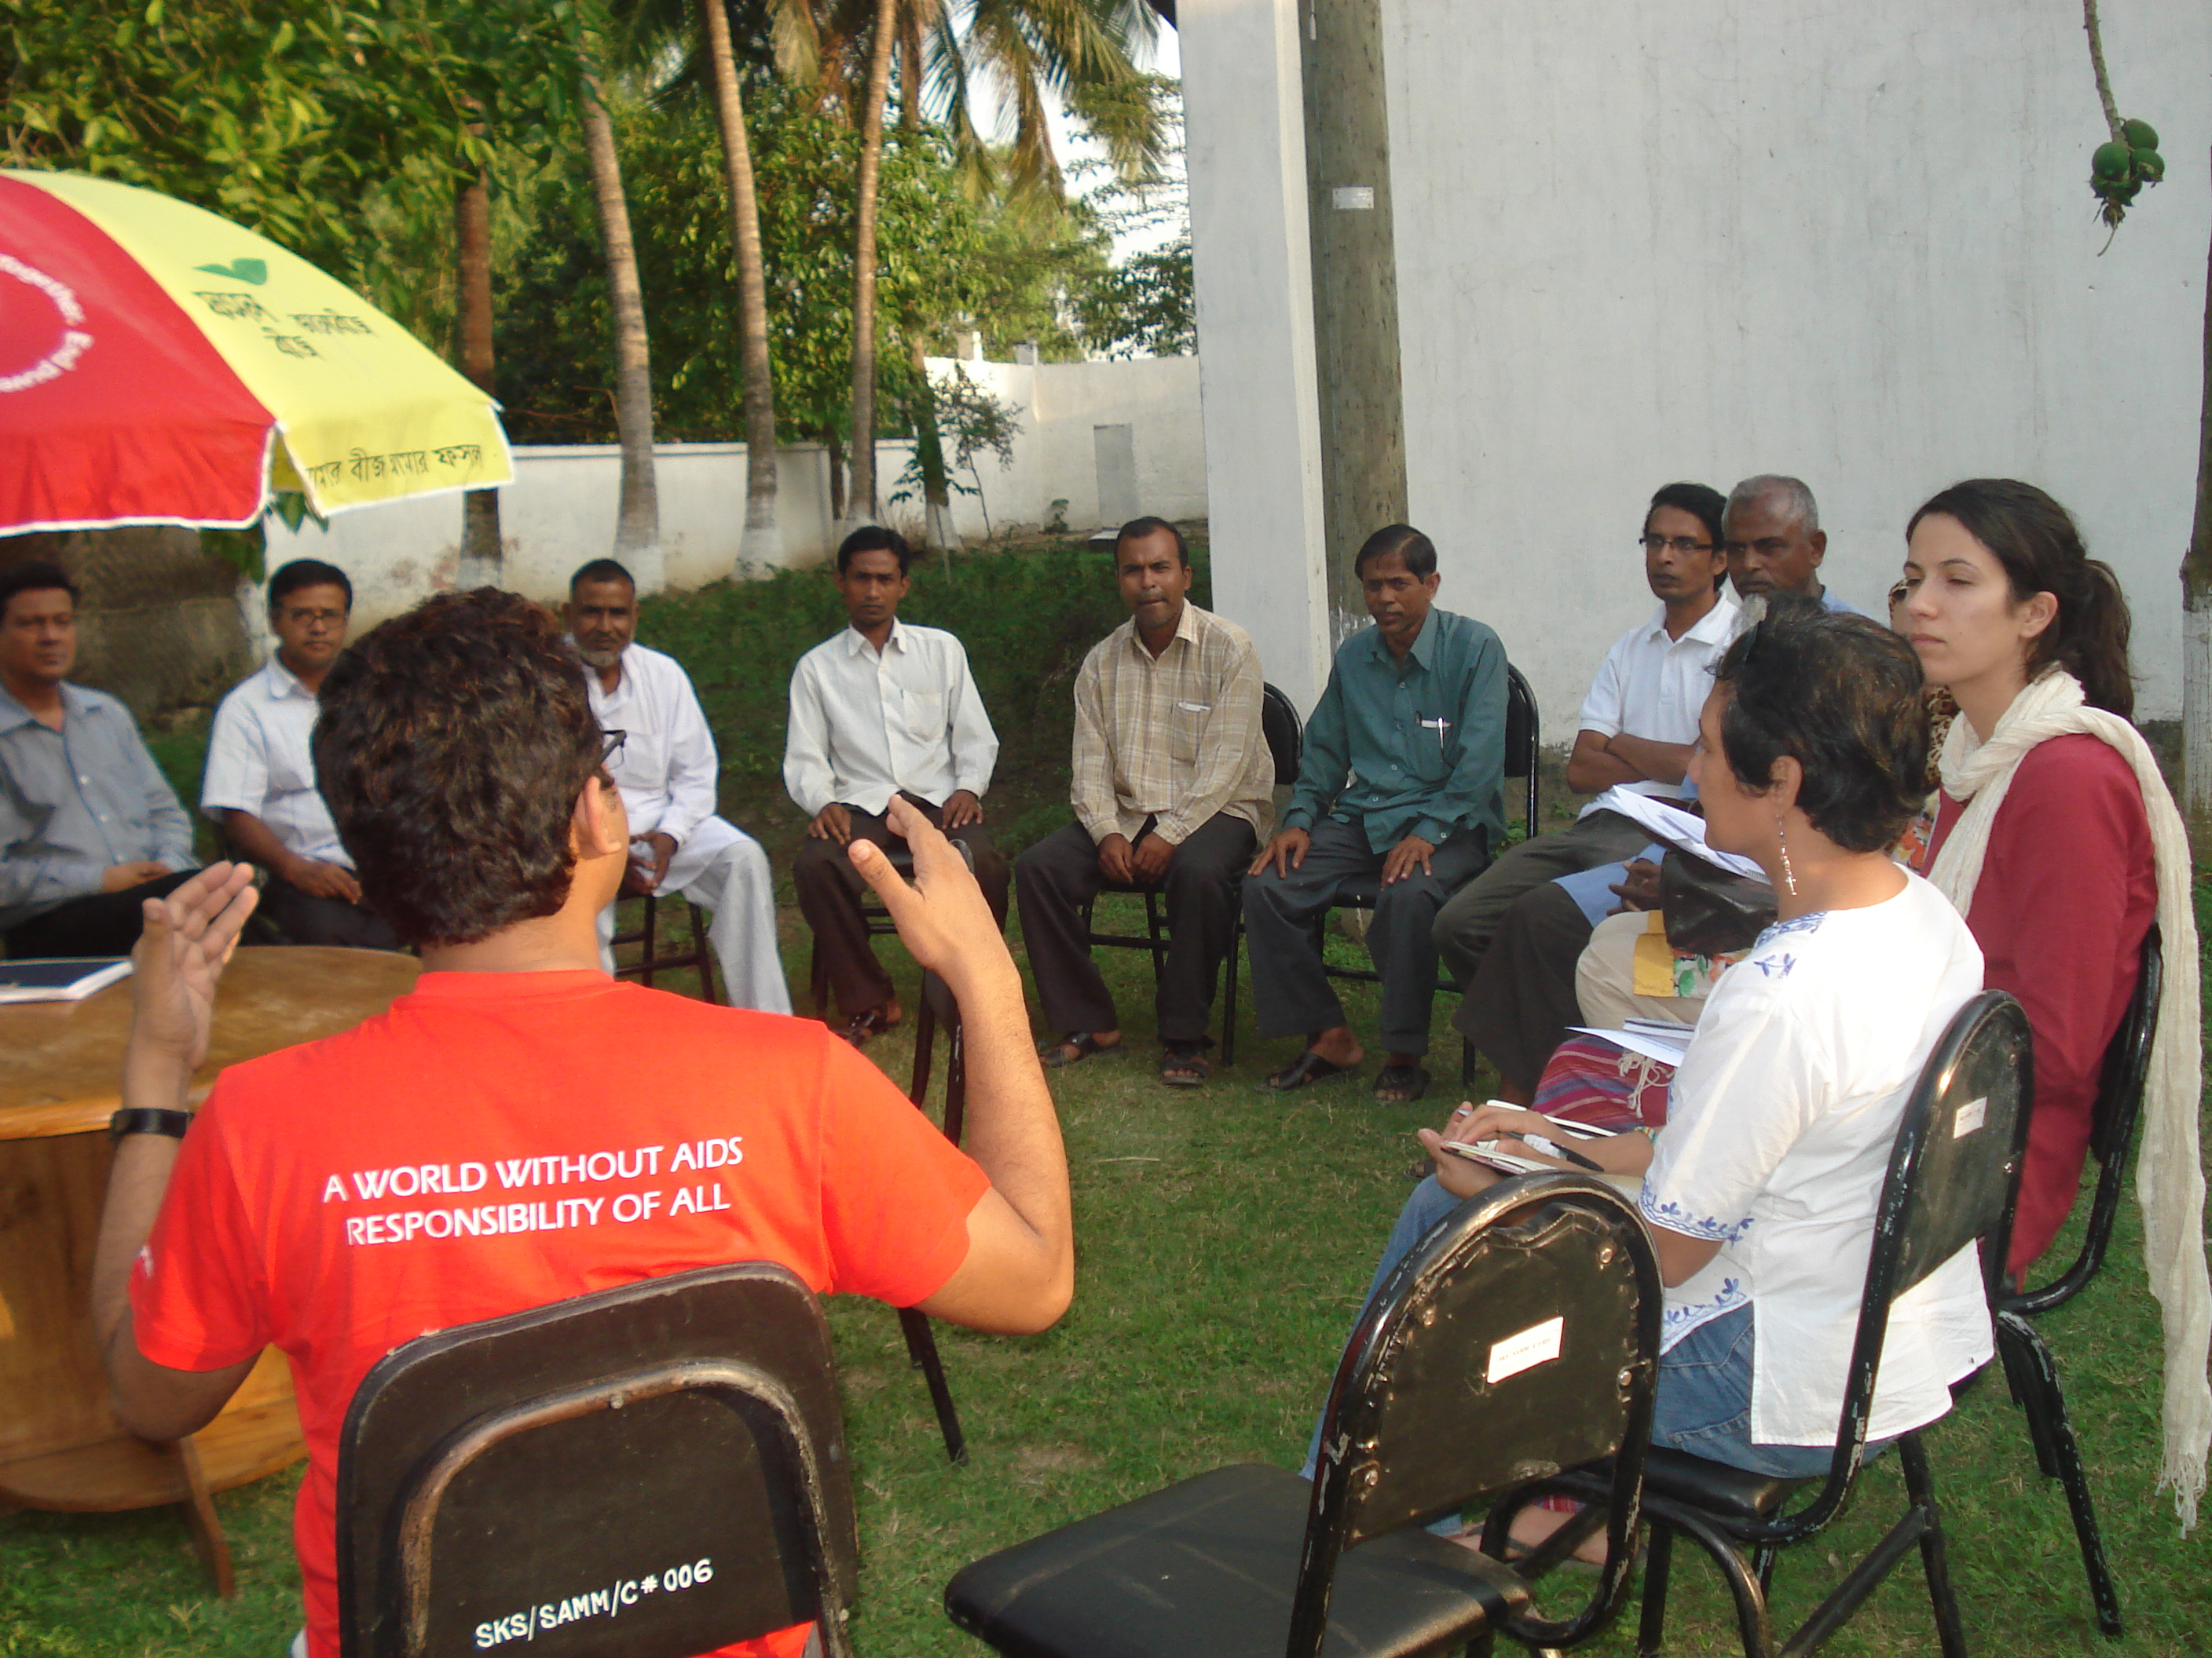
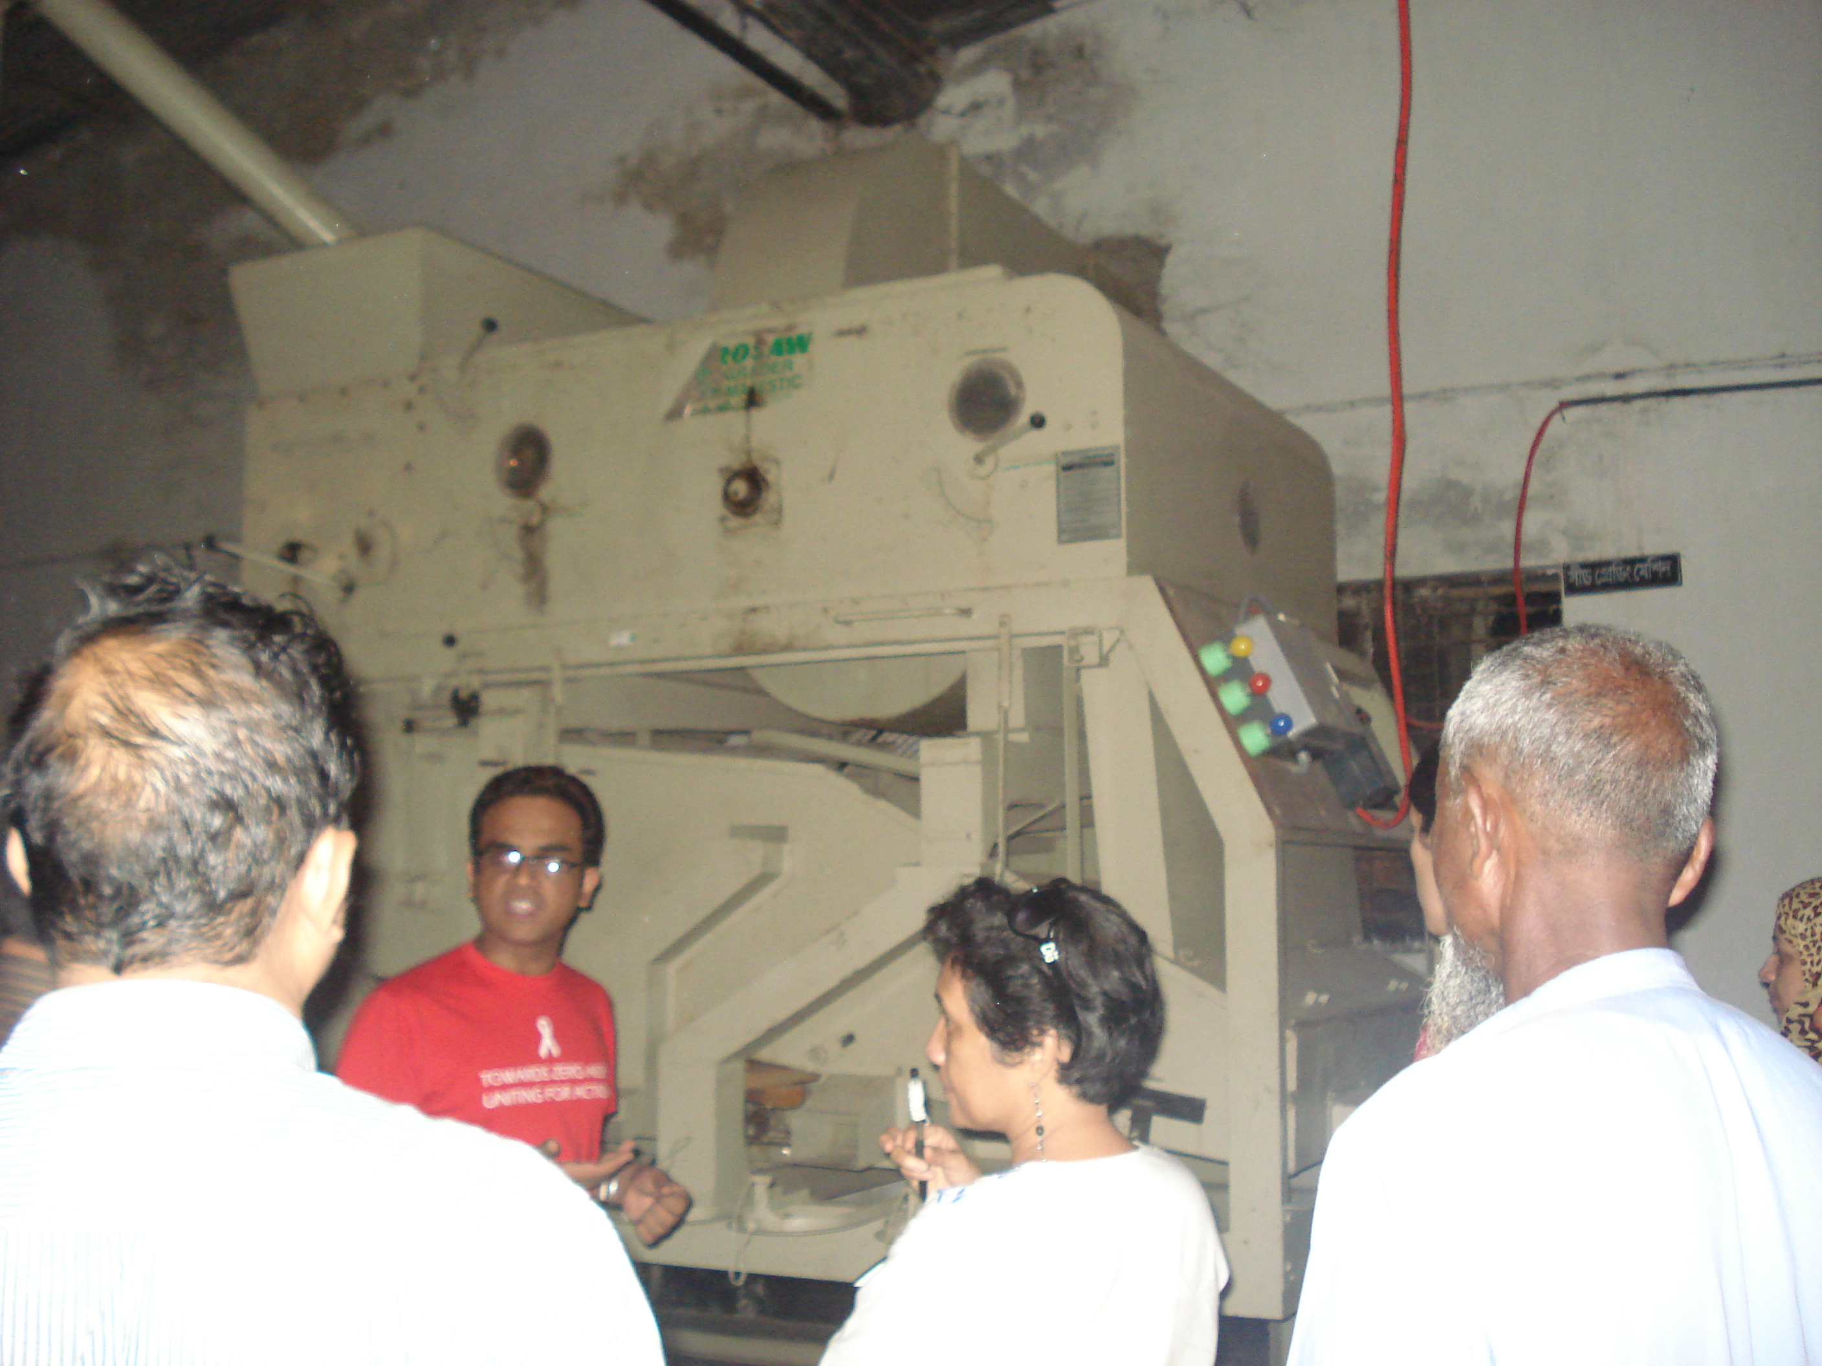

Consultation-Workshop in Rangpur (April 18, 2012)
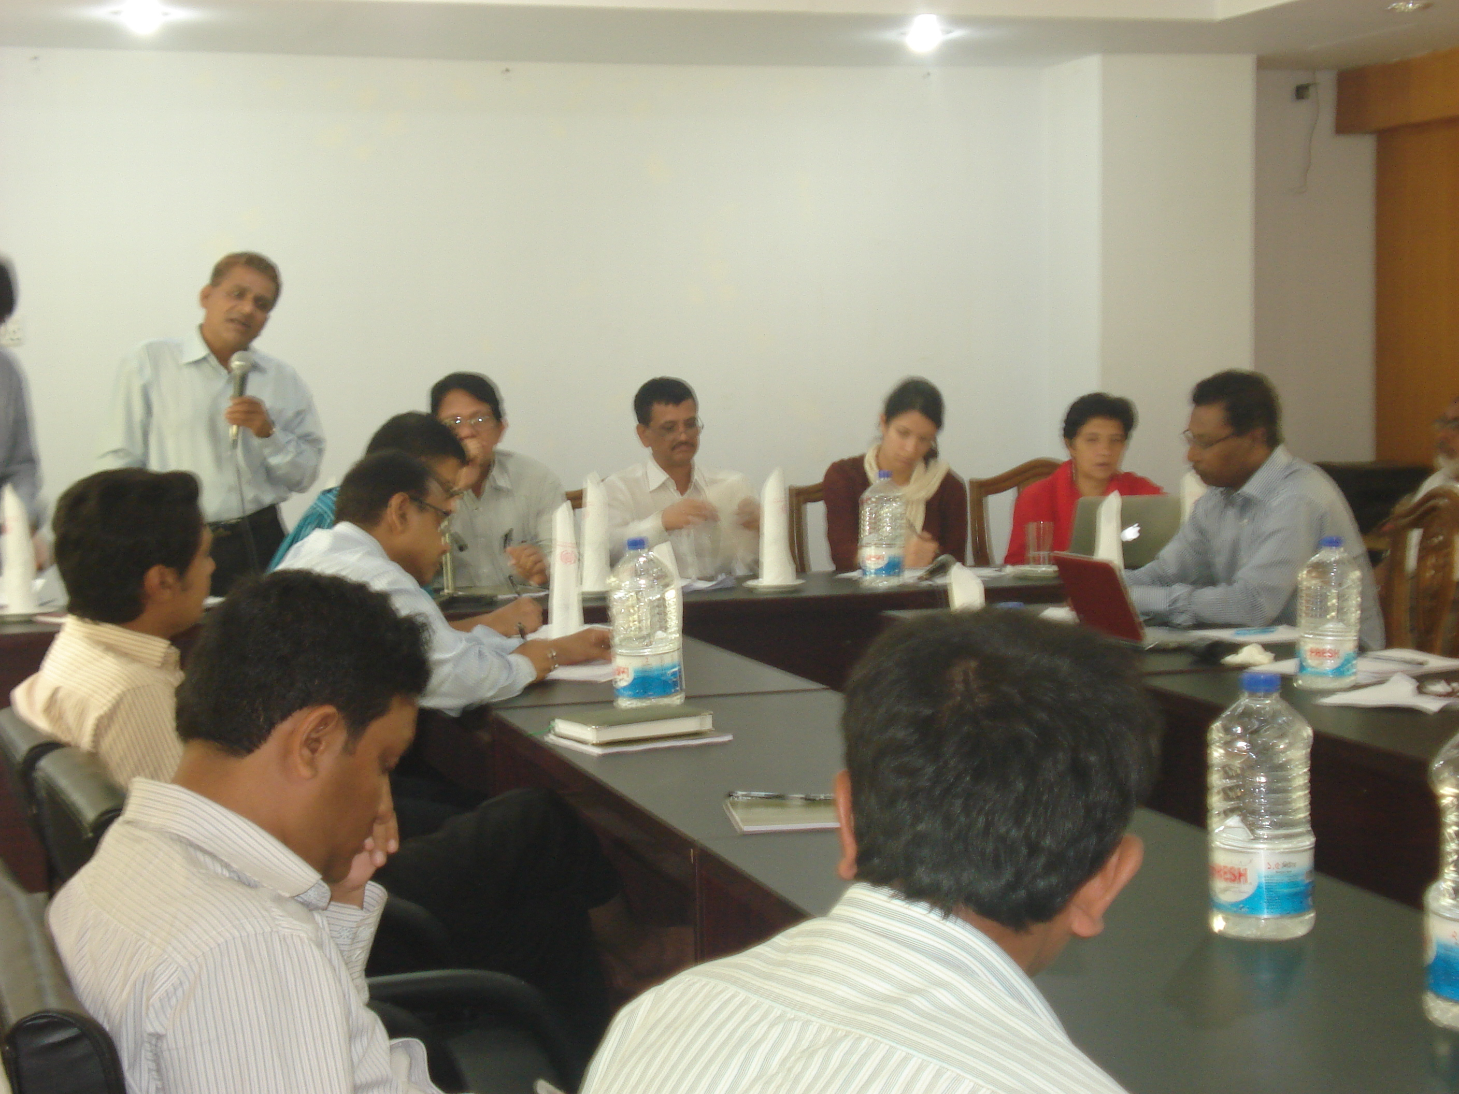
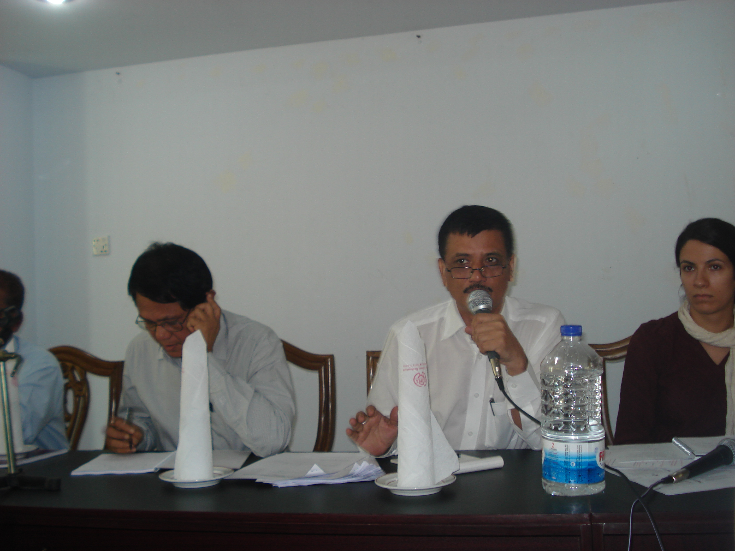
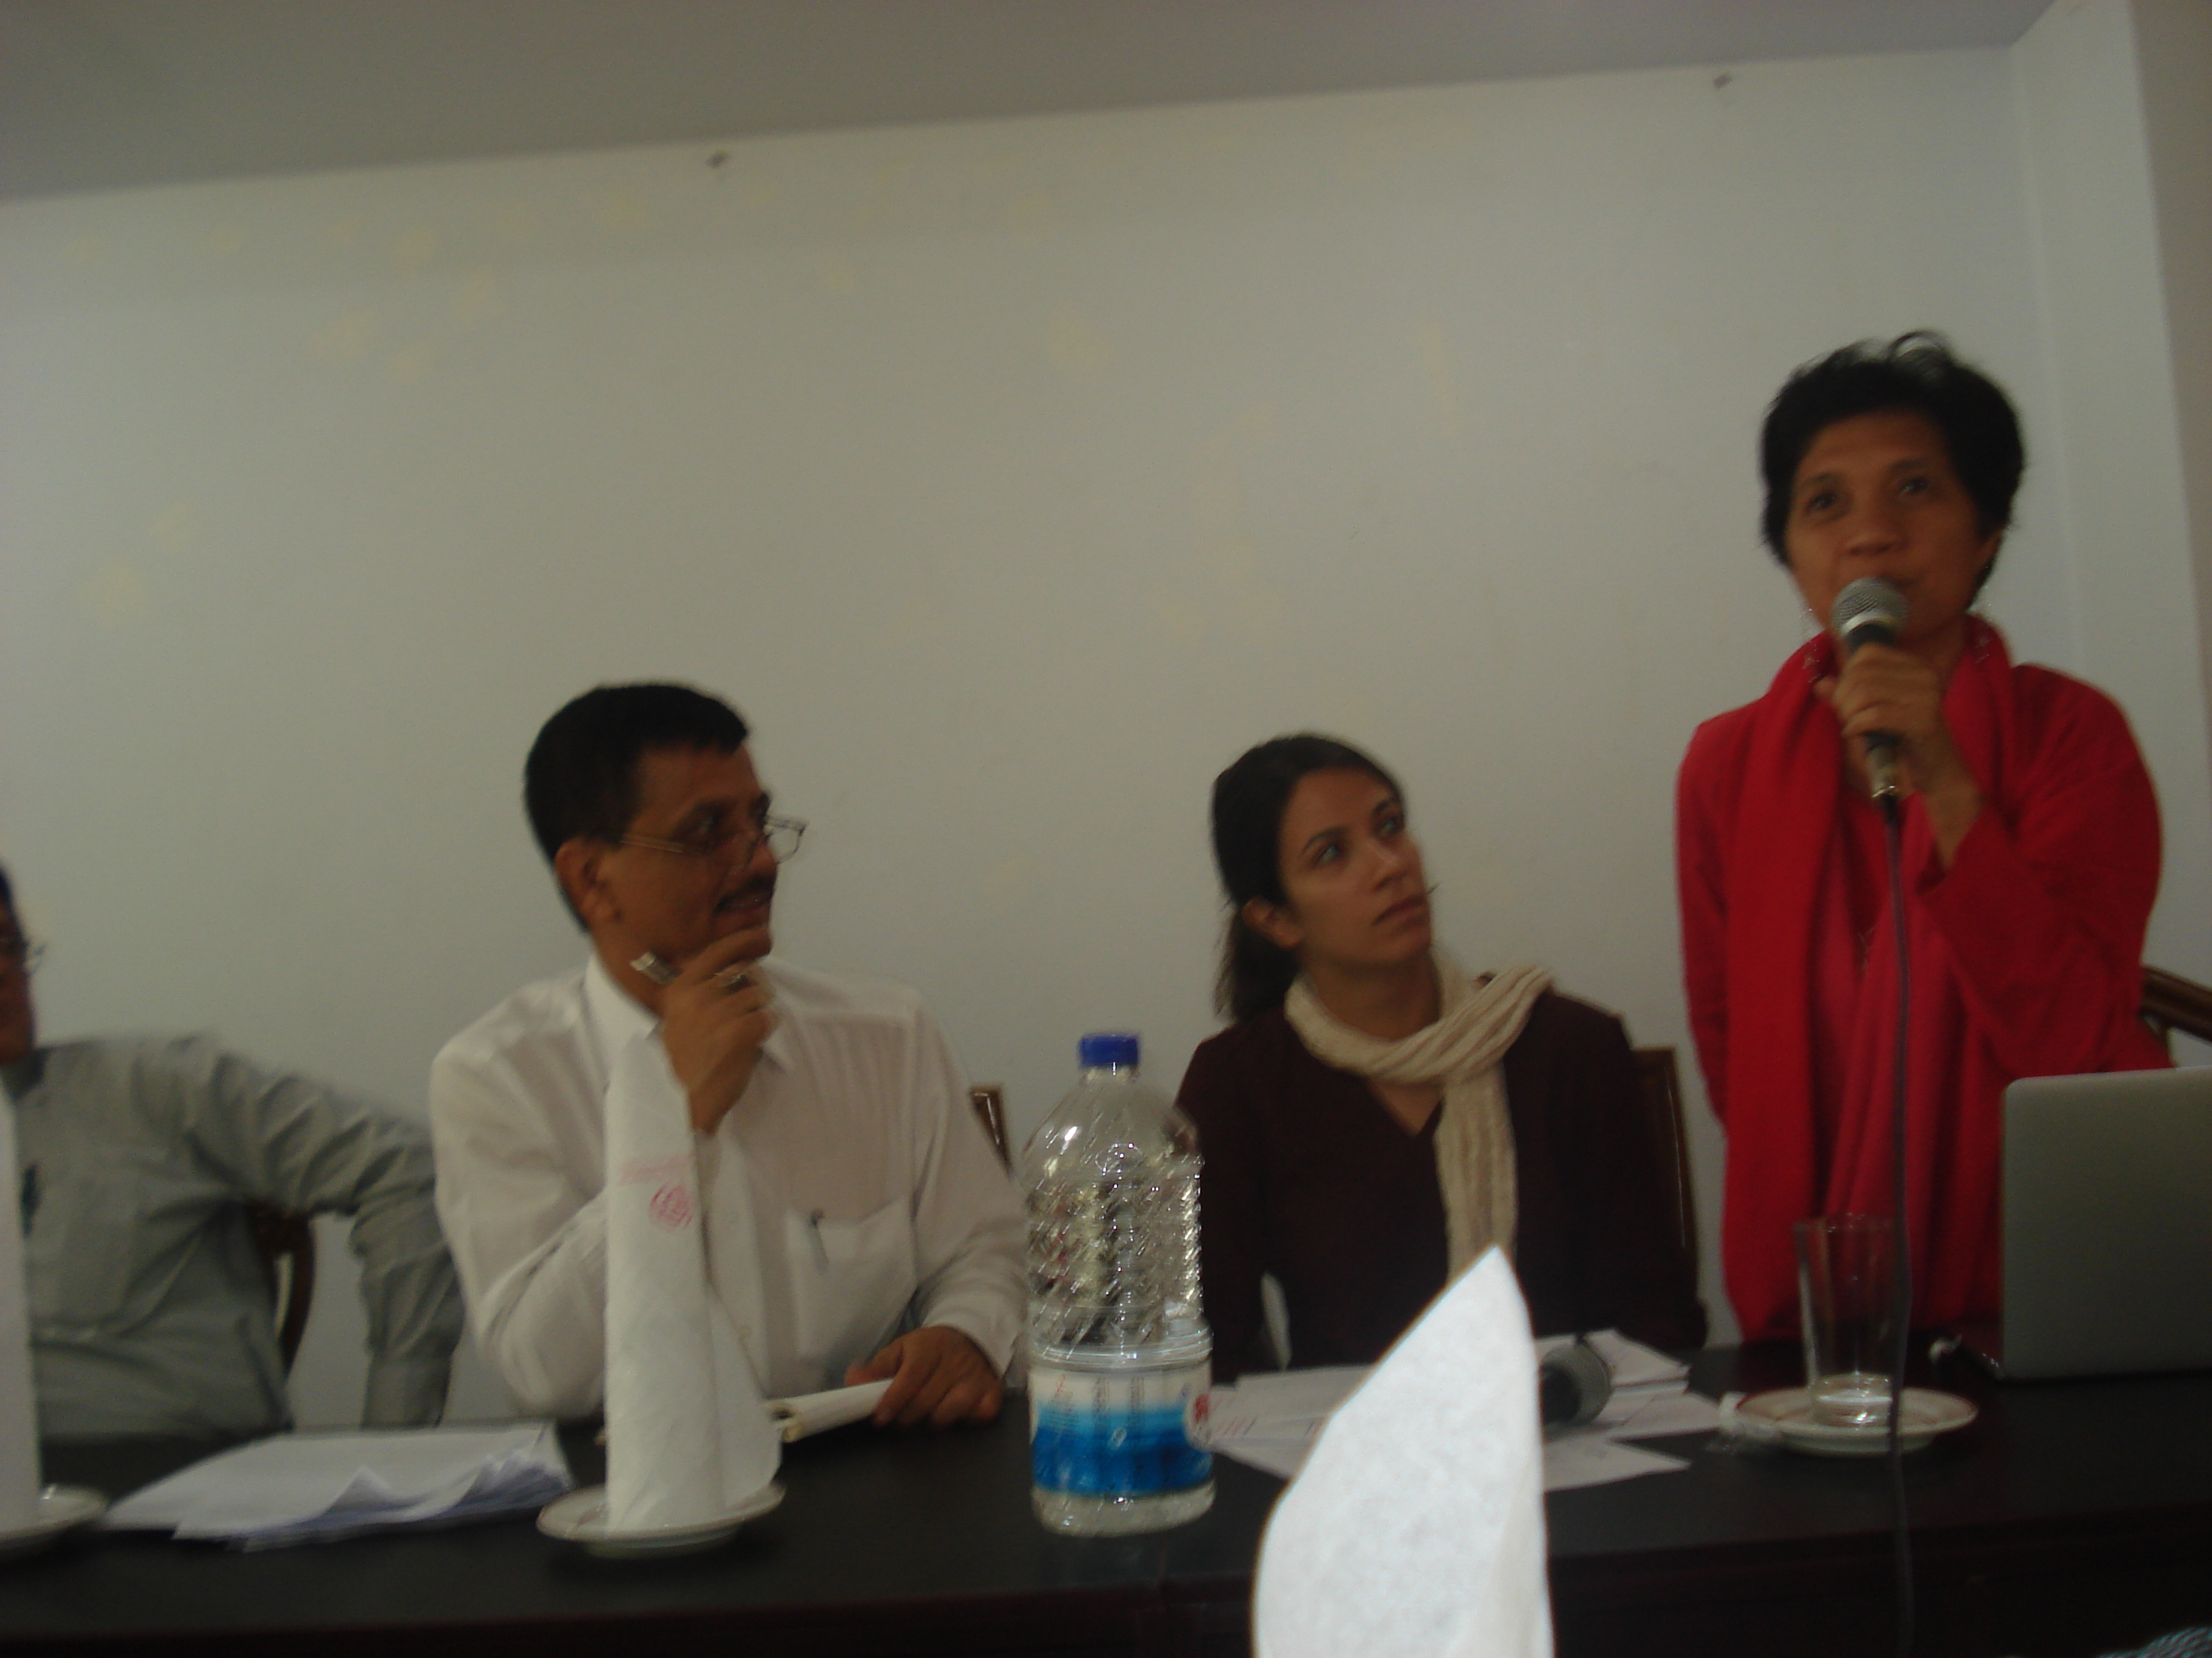
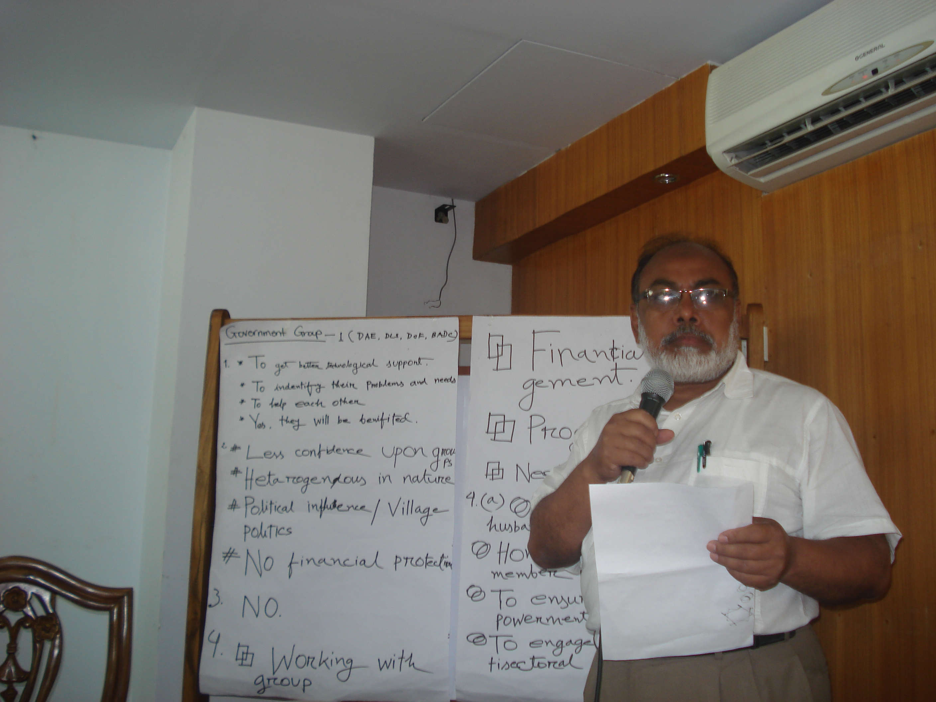
The consultation workshop in Rangpur district participated by farmer groups, NGOs, Government personnel and FAO held last 18th of April, 2012, shared about the mapping exercise of Farmer Organization and gathered initial information about farmer groups, as well as their capacity development needs in order to strengthen their organizations to engage the government and meaningfully participate in the development processes

Field Visits to FOs in Rangpur. The IPM group is a newly organized by the government in Feb and the ICM club (former IPM group but later changed their direction into ICM) organized by an NGO
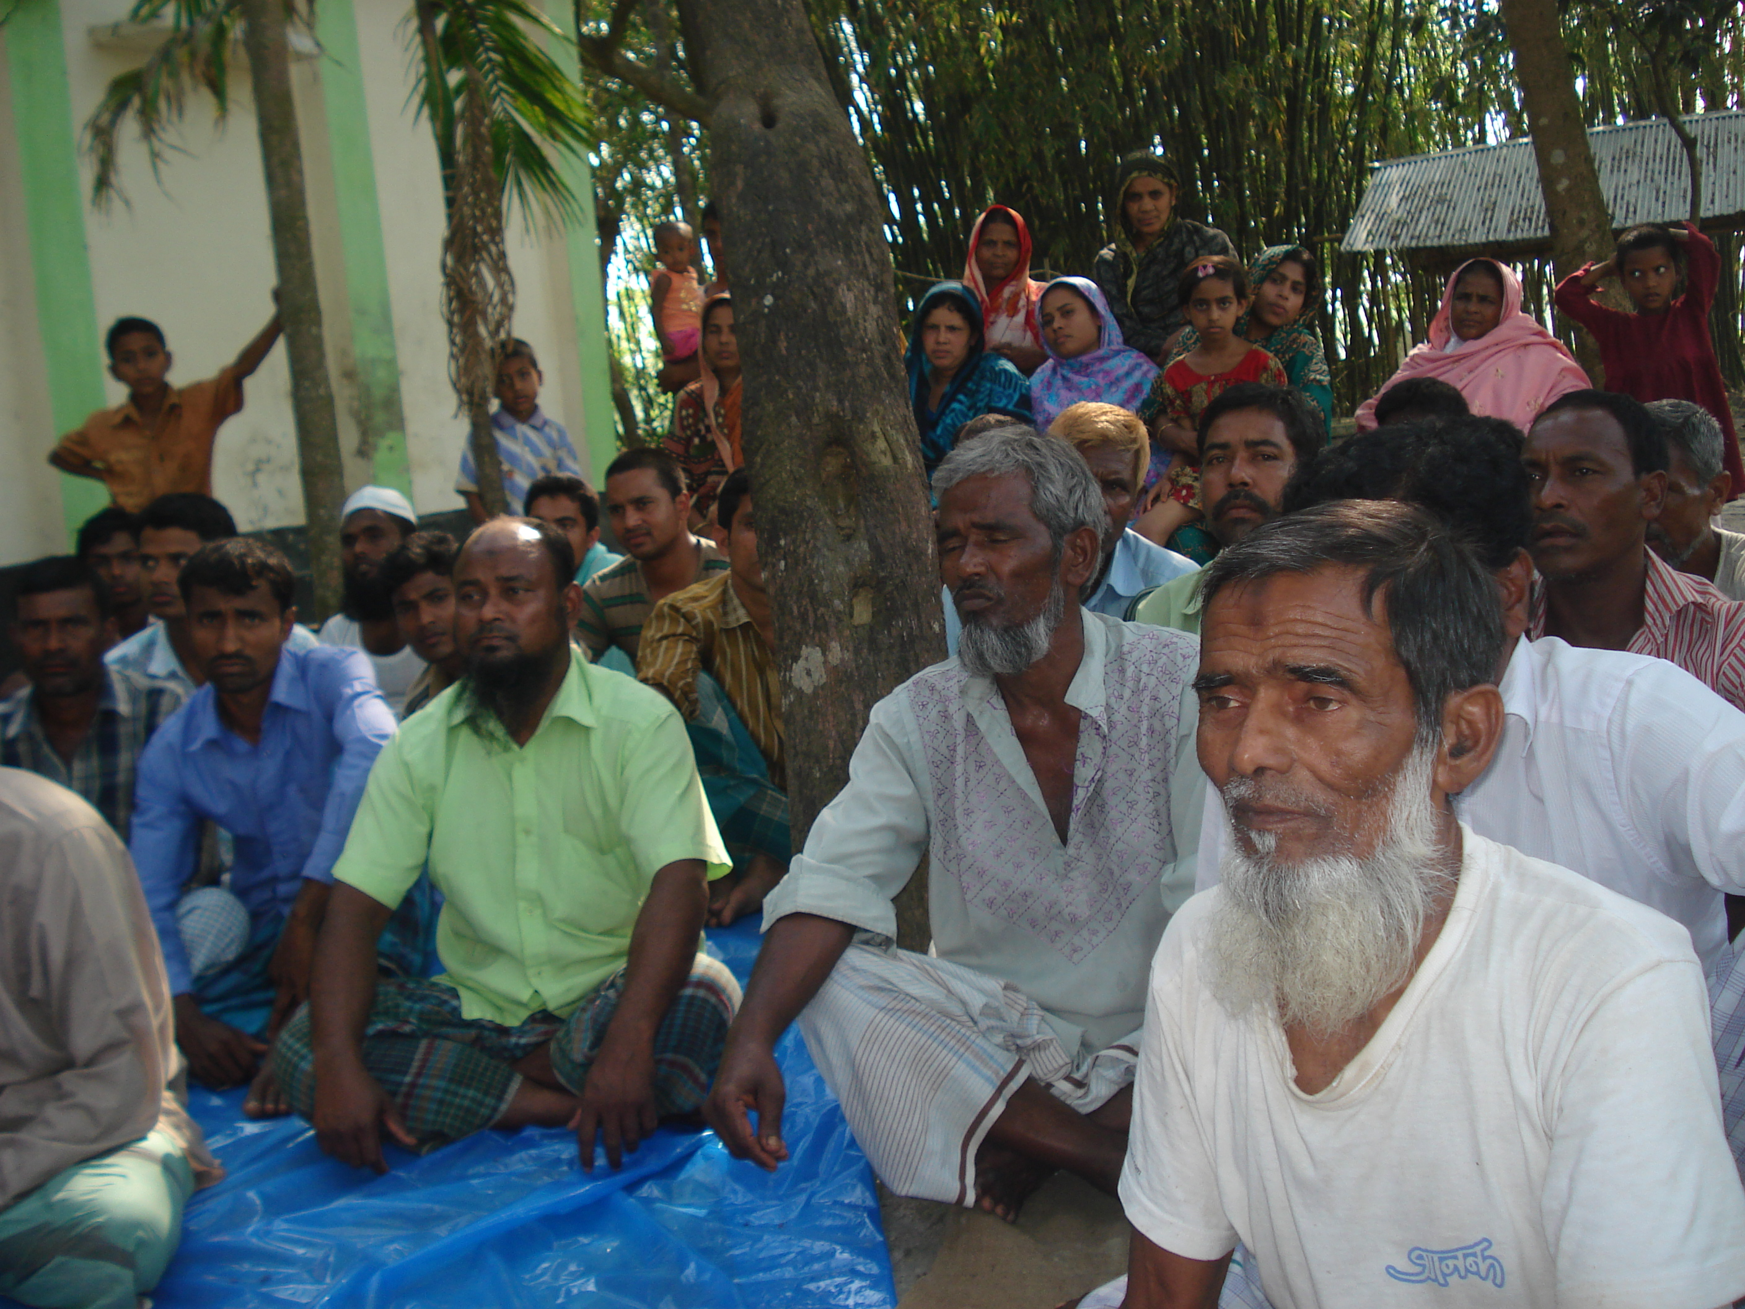
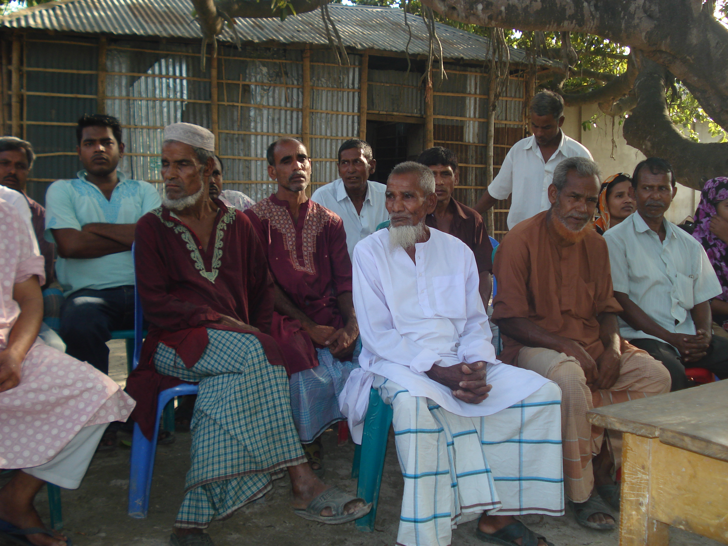
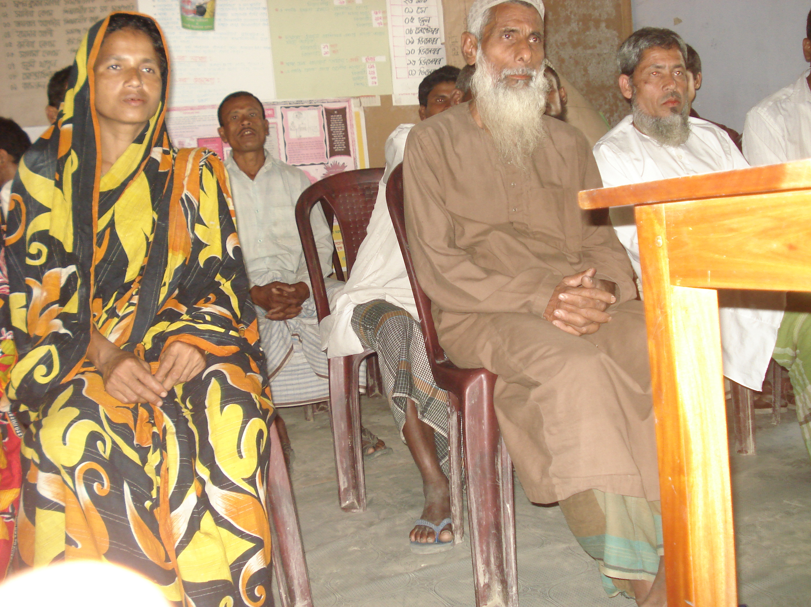
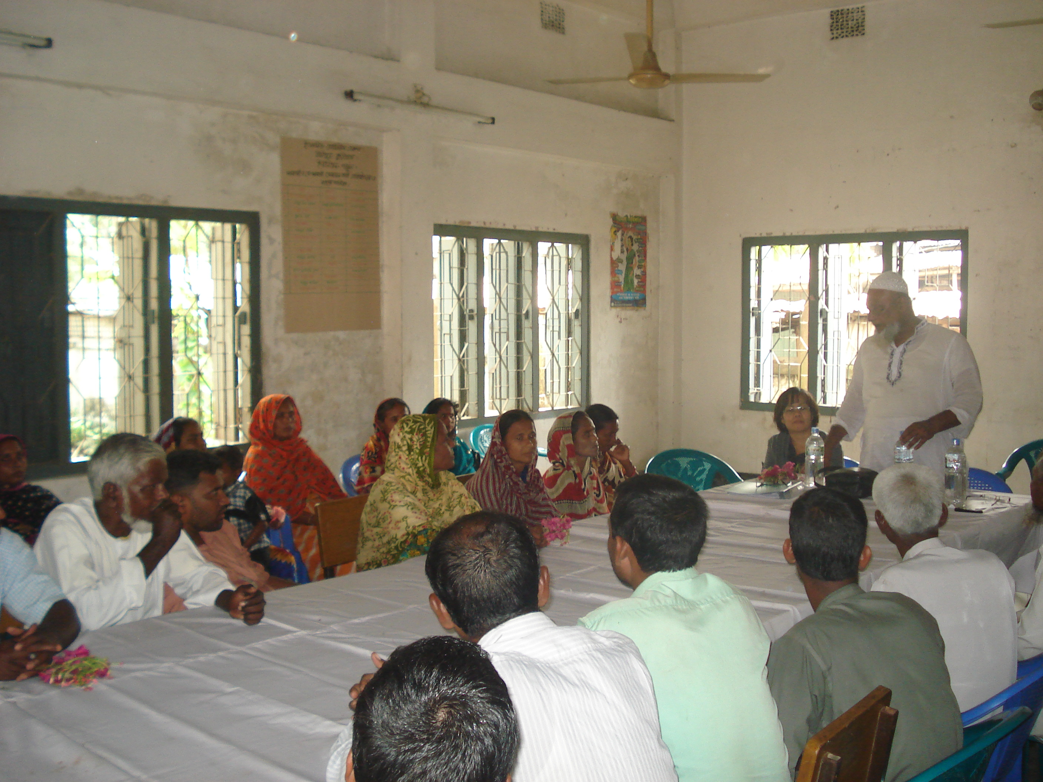

April 25, 2012 meeting at FAO office with the government and CSOs
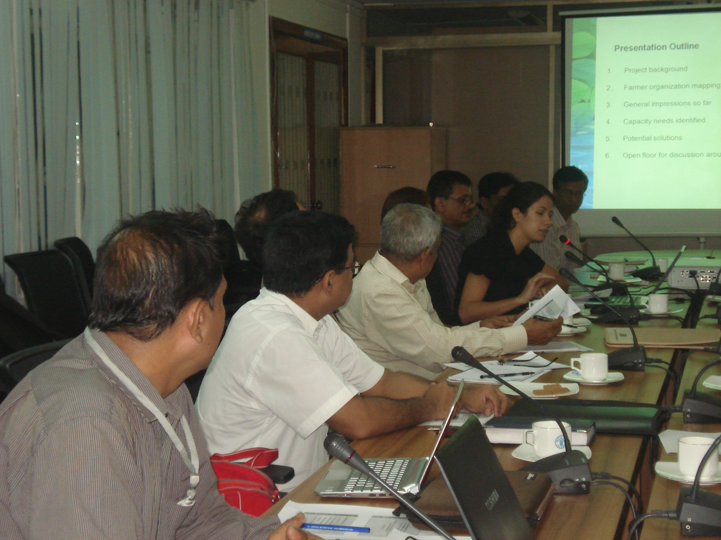
Florentina WilliamsonNoble of FAO Rome facilitated the meeting with the government officials and CSO representatives. She presented the initial results of mapping of capacity needs and possible interventions to strengthen FOs in areas of organizational management, empowerment, Project development cycle, technical and business. It was raised that providing FOs space to participate in the process shall be a strategy to participate and raise voices while capacitating themselves during the process. Further meeting with CSOs shall also be conducted to finalized priorities to be supported under the TA component of the GAFSP project.

Consultation-Workshop in Barisal (April 26, 2012)

Mapping of FOs/CSOs in Barisal during the consultation workshop with 6 representatices from CSOs, FOs, Farmer Federation (KKM) and government including the local government unit of Barisal.
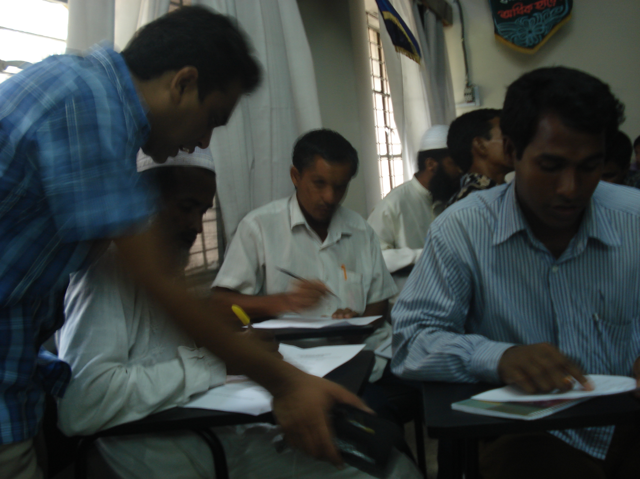
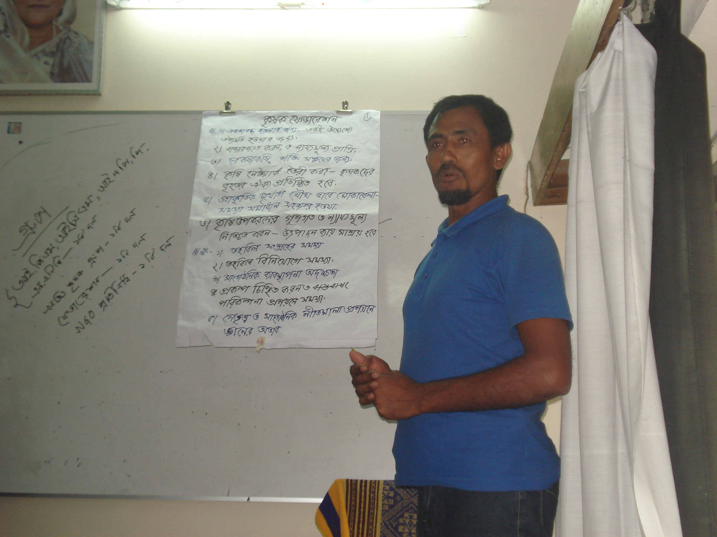
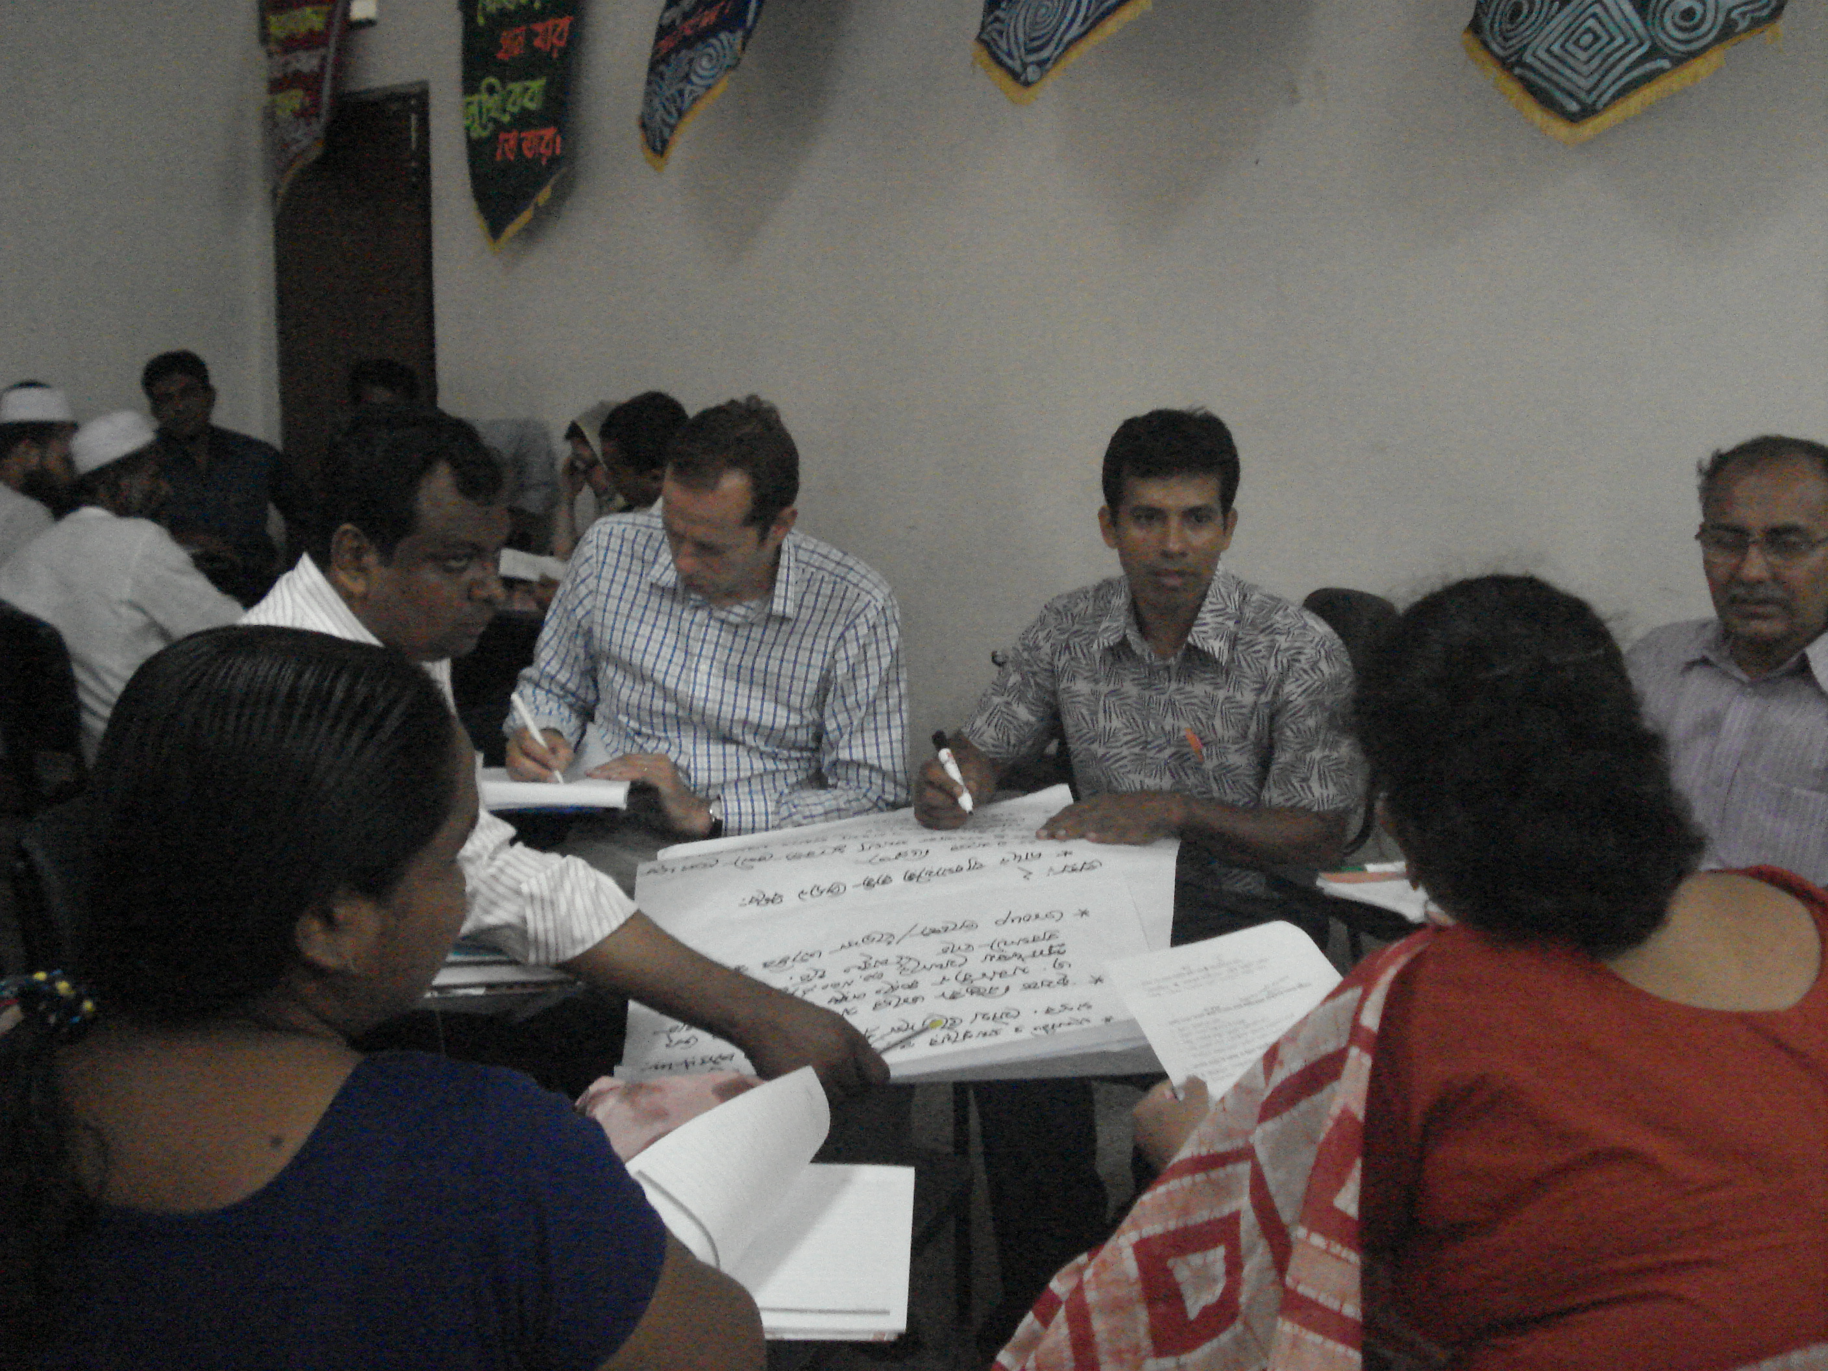

Conducted field visit/survey in the IAPP project sites in Barisal
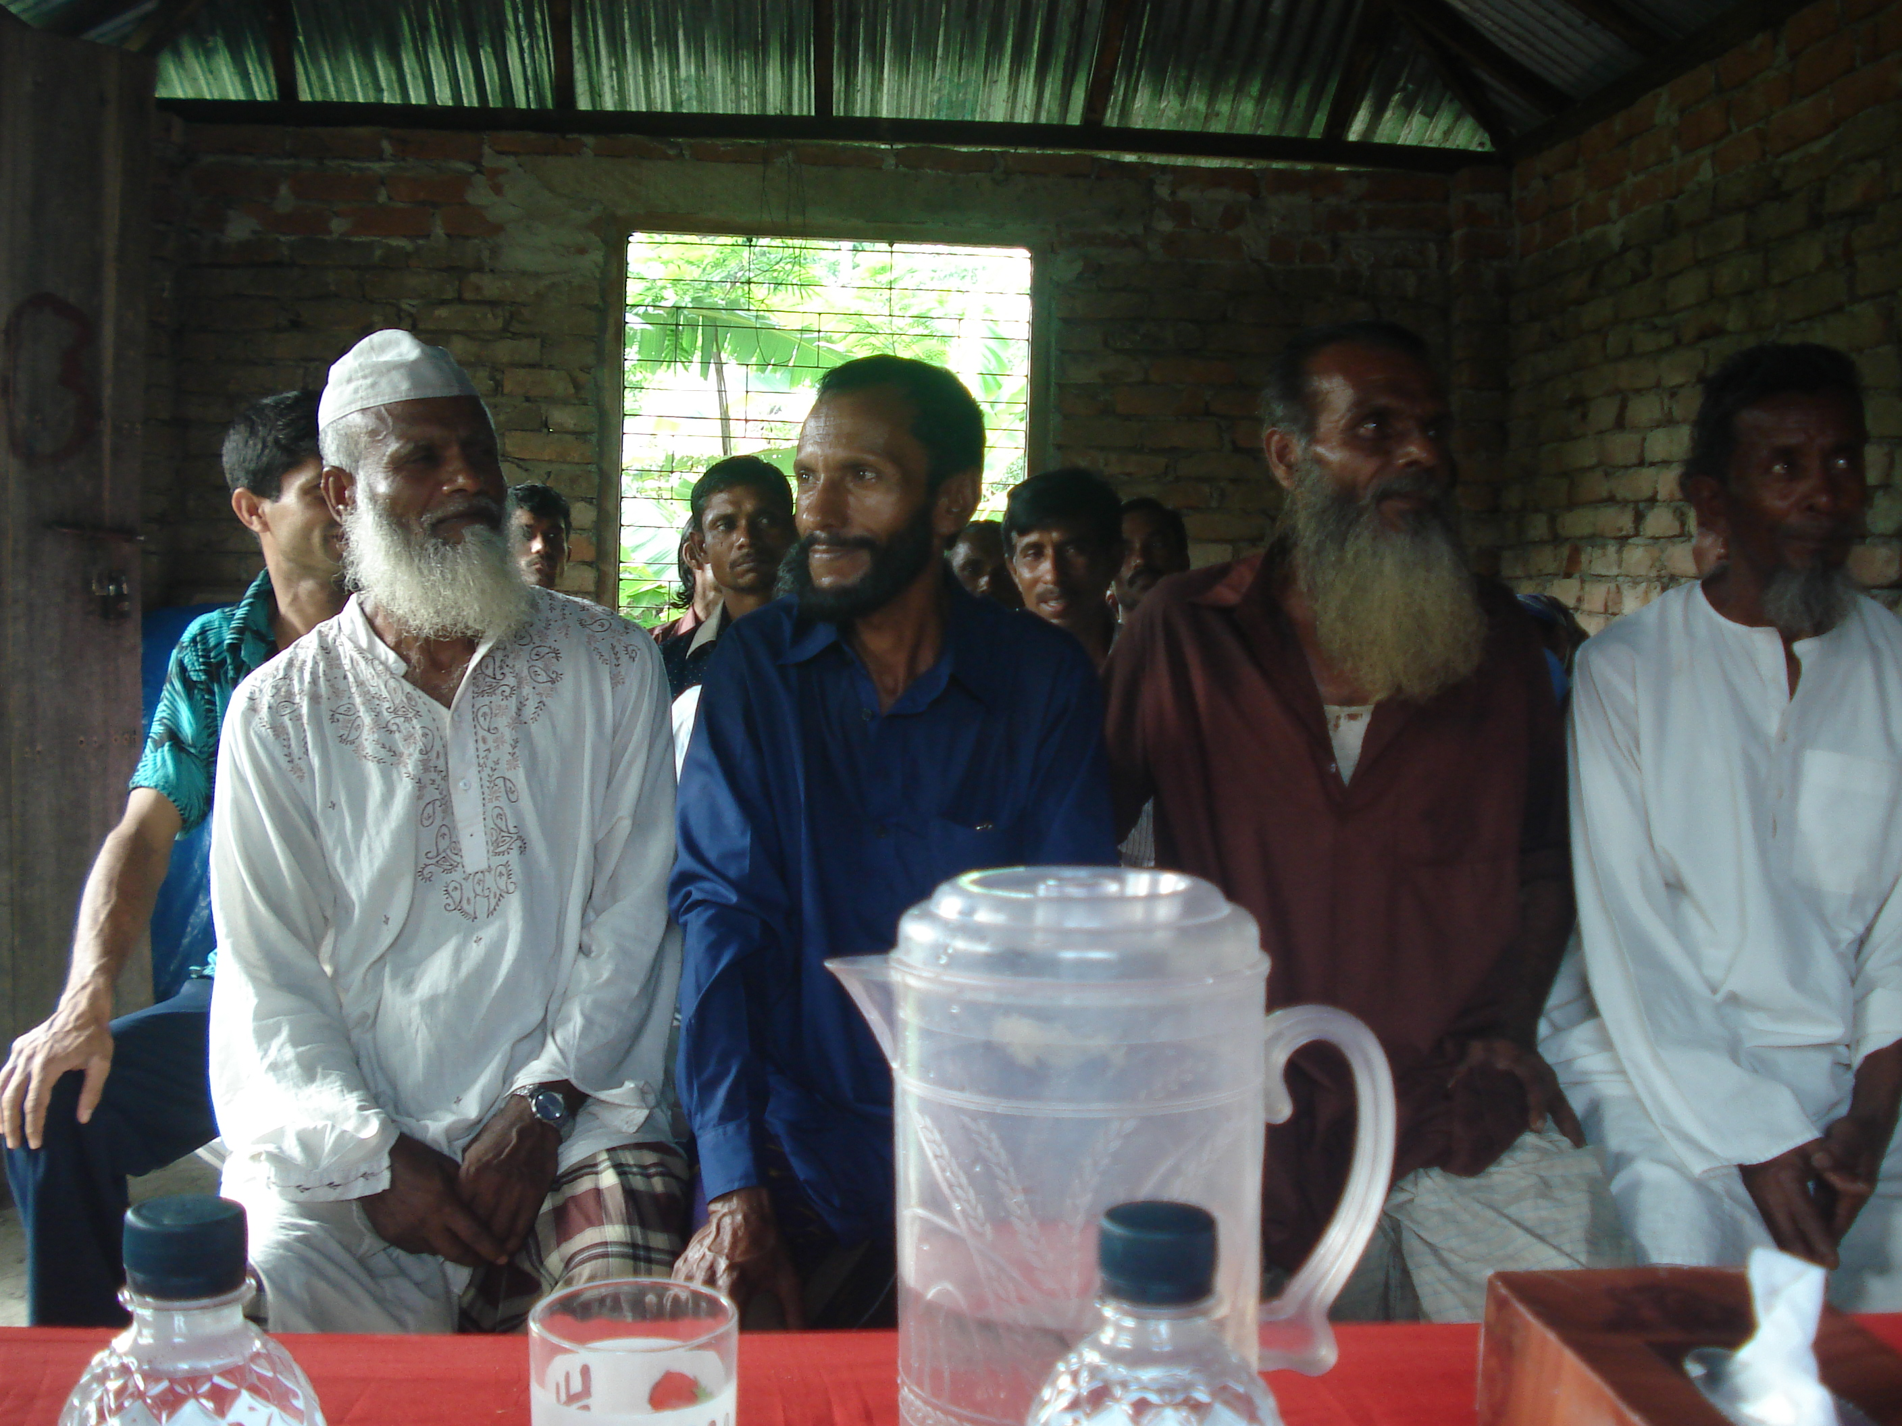
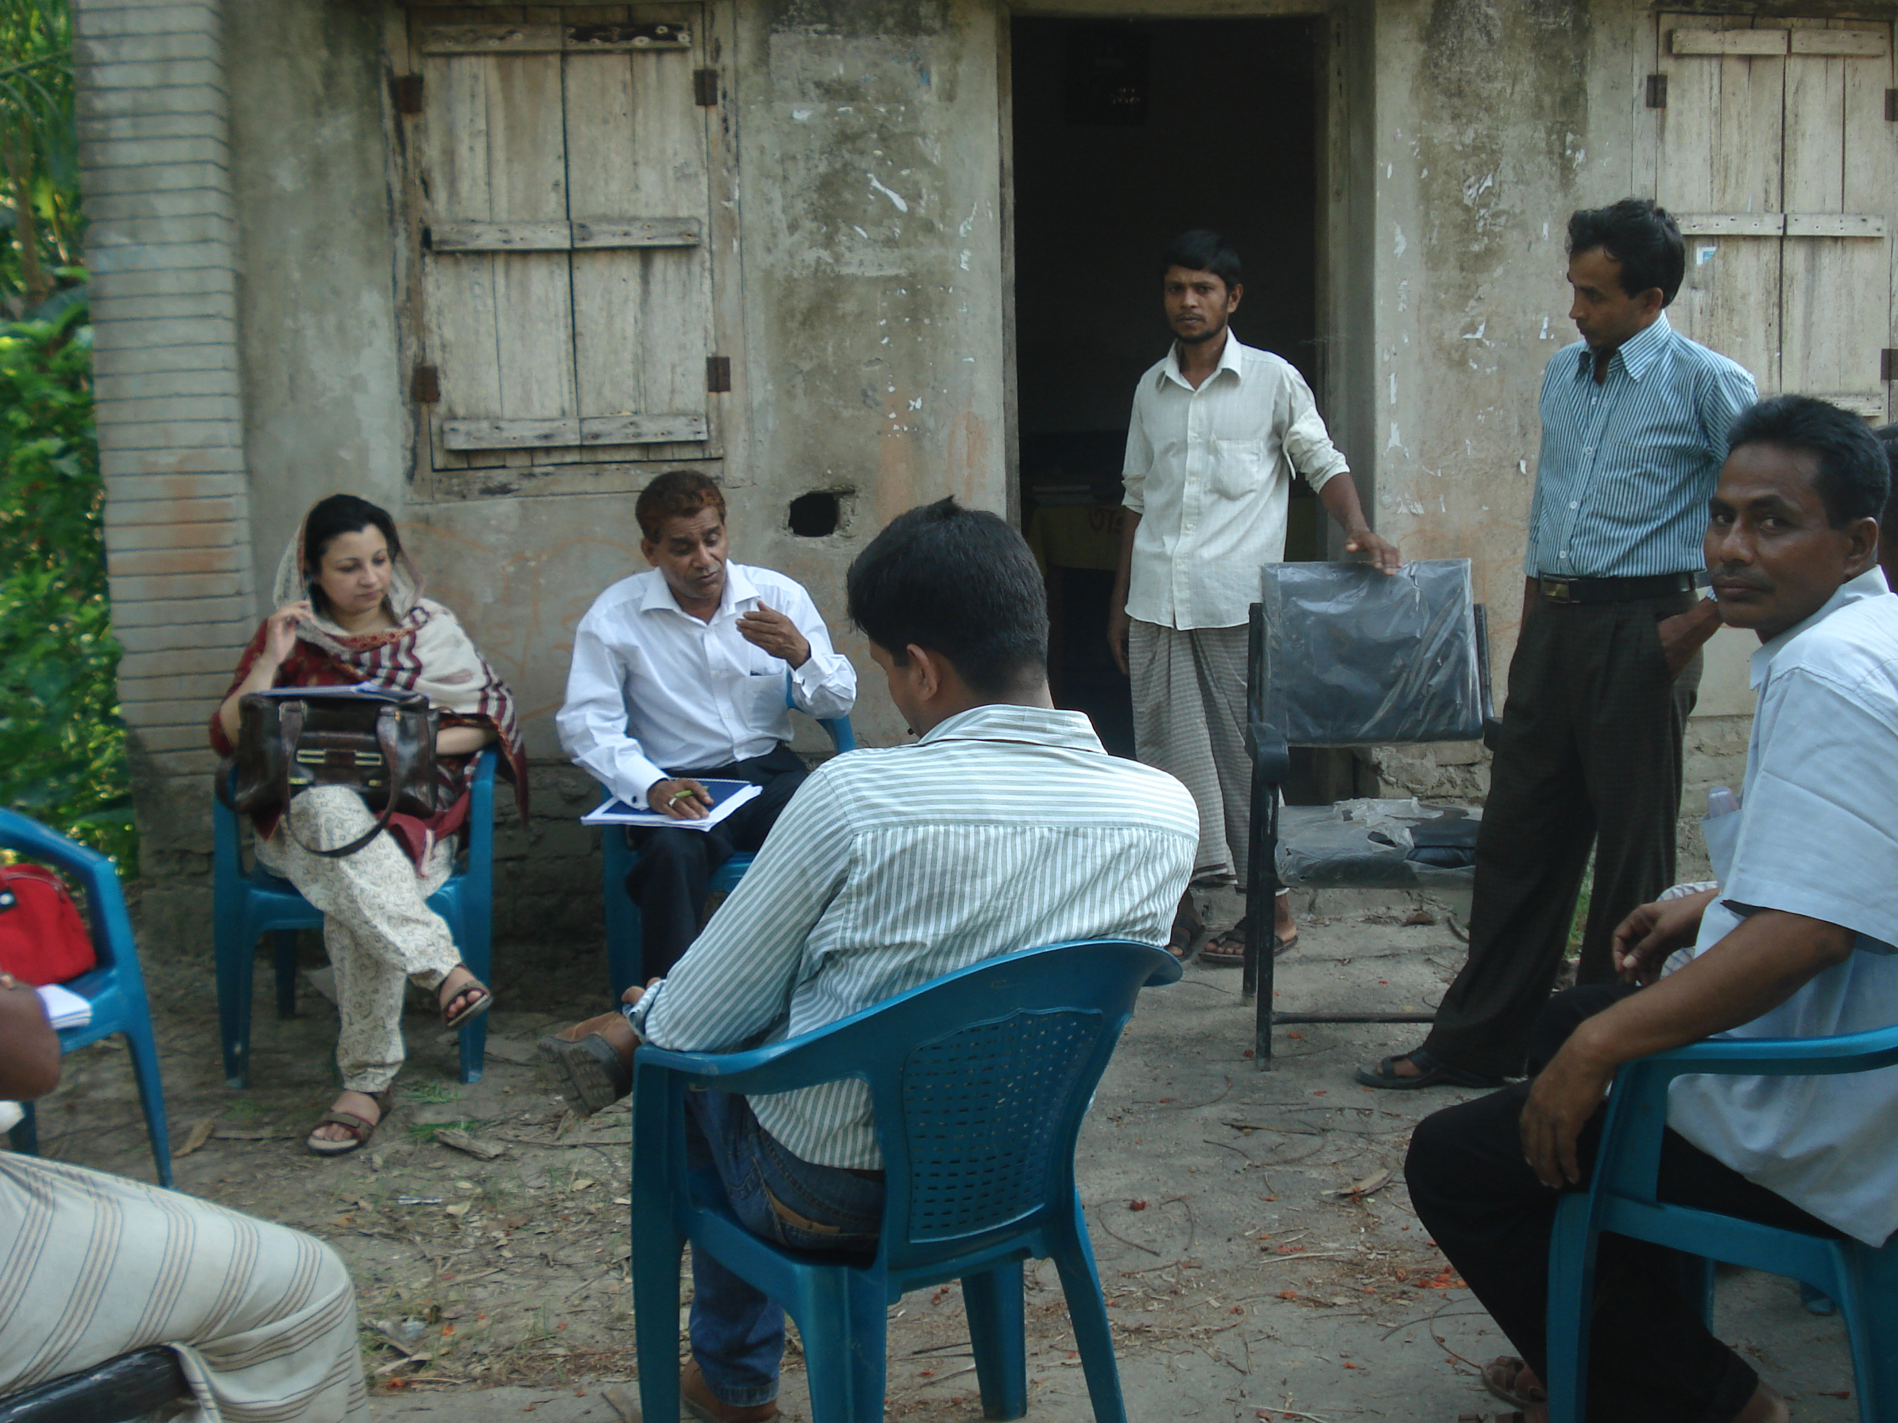

Compared to FOs in Rangpur districts, FOs in Barisal were just organized in Feb 2012, no significant activities undertaken apart from organizational meetings conducted, no clear direction such that objectives of organizing them were not so clear among leaders, FOs were not as enthusiastic as the farmers in Rangpur, no or little understanding about the IAPP project and no experience yet in engaging with the government nor participation in the development processes as also stated of FOs in Rangpur.

7.2. CSO Consultation, Flower Hotel, May 3, 2012

Opening Remarks
Ms. Farah Kabir, Country Director, Action Aid Bangladesh facilitated the morning session. She highlighted that IAPP is a facility to define platform and discuss the rights of farmers across Bangladesh. This consultation was a venue to know CSOs working with the communities, their initiatives and strategies to help farmers get out of poverty, change the agriculture scenario for better access to food and addressing food security issues of the country in general.

She then discussed the objectives of the consultation:
  - Inform CSOs about the final Implementation plan and TA component of GoB and FAO-Bangladesh/ respectively.
  - Facilitate the development of communication and coordination mechanisms among CSOs, FOs and CSO-Asia representative re engagement in the country’s GAFSP and CIP processes
  - Together with the FAO mission team, do a mapping of the outreach, expertise and of CSOs and FOs who would like to engage government in GAFSP and CIP processes.
  - Together with the FAO mission team, identify the needs of the farmers’ organizations, especially their members in the target areas.
Introduction of participants followed.

Participants
A total of 40 participants (30 male and 0 female) from seventeen organizations: two representatives from farmers’ organizations, 8 from local/national Non-governmental organizations (NGO), 6 from UN/ International NGOs, academe, representatives from the GAFSP - CSO steering Committee, Ministry of Agriculture/IAPP team, Food and Agriculture (FAO) and FAO Team leader for the Technical Assistance component to the GAFSP. See annex – Attendance sheet.

UPDATES ON GAFSP IMPLEMENTATION, CIP PROCESSES IN BANGLAADESH was presented by Mr. Khalid Mahmood, Project Director – IAPP)

The project Integrated Agricultural Productivity Project (IAPP) was one of the steps towards addressing food security in climate change risk prone areas designed to enhance the productivity of agriculture (crops, livestock and fisheries) in pilot areas in Rangpur, Kurigram, Nilfamari and Lalmonirhat districts in the North and Barisal, Patuakhali, Barguna and Jhalokathi districts in the South.
IAPP was approved by the Steering Committee of the GAFSP in October 2011 and awarded a grant amount of US$ 50 million to be managed by the World Bank and the FAO as Supervising Entities (SEs). The World Bank was entrusted as the SE for an investment project, funding partly by GAFSP grant (US$ 46.31 million) and partly by GOB contribution ($17.16 million). In February 29, 2012, a total of 4.03 US million released for investment of which 0.884 million was actually spent for implementing technical interventions:
- 50 trials established (200 trials will still be set up)
- Technology adoption through Livelihood Field School (LFS)
About 423 participants with 20-25 farmers per group of which 33% are women
- Monitoring using the Farmers input card and bank for input support
- IEC (campaign and grievance redress system)
- CSOs should be involved in the decision making processes and in project implementation

Ms. Florentina Williamsonnoble presented also the role of FAO under the IAPP project. She said that the Food and Agriculture Office (FAO) is mandated to implement the Technical Assistance component of the IAPP which focused on capacity development to increase inclusiveness and participation of CSOs. In order to respond to real needs, mapping of FOs and CSOs were conducted to understand the complicated landscape of FOs as well as define capacity development interventions to strengthen FOs ability to partake in investment programming processes.

RESULTS OF DISCUSSIONS DURING OPEN FORUM

Major Issues and concerns
- Exclusion of landless people to participate in the project. This specifically affects women participation as they lack access to land.
- Land issues need to be addressed to fast-track awarding of land which is imperative for farmers to participate in the project and other development processes,
- Issue on how to engage the right CSOs and FOs to include in the process
- Farmers’ access to quality seeds (including seeds tolerance to saline water) from accredited dealers/suppliers and its method of seed production
Because of changes in agriculture landscape from rain-fed to irrigated land, 61 out of 64 farms have destroyed fish diversity due to chemical pesticide usage in irrigated rice farming. Around 15,000 rice varieties exist before green revolution. Many hybrid seed varieties were produced which affects the genetic diversity and because government has to grow more food to address food insufficiency. However, farmers are exposed to water with arsenic. There’s a need to plan for future agriculture – livestock and fishery in a more holistic approach (Ubinnig) as well as mechanism to ensure that farmers are able to get quality seeds.
- There was no crop-livestock-fish farm diversification/integration. Each component was treated separately – agriculture, livestock and fishery following the mono-cropping system.
- Issue on technology up-scaling and promotion of good practices
It’s a realization that when the technology is being up-scaled, results were not successful as compared to the results during pilot test. How government could help in up-scaling successful technology or good farming practices?
- Decreasing land for agriculture production and increasing saline areas. Land and water are two major resource needed in agriculture production and in increasing productivity.
- Issue on Food Safety
“Food safety” is being neglected and focused only on good agriculture practice. People are ignoring this issue because of increased productivity. Uses of chemical in production – affects quality and safety of food produced with poisons. We have to make use of traditional knowledge in producing seeds without using chemicals. Likewise in fishery, use of chemicals and feeds affects quality of water. There should be a holistic and comprehensive way of looking at the situation, needs and interventions. On sustainability, how private sector be engaged in the process? (Fed mohdul haque khan – bangle poribesh andolon)
- FOs/CSOs have no space to raise voices or lobby for support to small scale farmers
- Issue on sustainability of the project beyond project period (Helvetas)
- Farmers access for a better price of their agriculture produce specifically during harvest season (Afzal - IDE)
- Impact of climate change and food price volatility (Md. Ali Shamsuddin - KKM) - Two major concerns of farmers: 1) impact of climate change – government has no mechanisms or programs to help farmer to recover the investment affected by climate change and 2) Farmers are encourage to produce higher yield. However, when farmers harvest their produce, the price is low and not stable, thus farmers do not get any benefit. What mechanisms or support from the government to address these concerns?

Responses to issues and problems
Below were the responses from the IAPP team and ministry of agriculture
- Mr. Khalid Mahmood explained that selection of farmer-beneficiaries includes marginal and small scale farmers. He further explains that the project will tap existing organizations and will organize if needed. The integration/convergence of agriculture-fishery-livestock departments/ministries and other support agencies such as irrigation, research and extension will help in responding to issues and thus, facilitate project implementation
- Access to quality seed - Farmer seed producer shall be trained to strengthen their skills in producing quality seeds. Also, the project will utilize breeder seeds, GM. The seed certification system will monitor and ensure the quality of seeds produced. The process will follow such that BADC will release foundation or certified seeds to the Department of Agriculture Extension, DAE will then release to farmers for trials. The DAE will work together with the farmers. If seed producers claimed that their seed is good, they will not undertake the certification process
In addition, government provides input subsidy using bank card issued to farmers as well as established seed storage facility to farmers and help farmers’ strengthen their capacity on proper storage technology. Irrigation support will also be provided by the government.
- Technology supports promoting crop-livestock/fish integration /diversification at the household and community level. The Department of Agriculture and Extension will lead in integrating all agencies working on rural development to address capacity needs of farmers.
- On water management - Private sector will be tapped for irrigation and water distribution process to improve efficiency in water management
- On food safety – there should be proper handling the application process from production until harvesting and market of products following the GAP on proper use of chemical fertilizers and production of organic manure
- Suggested to develop knowledge management platform e.g. indigenous knowledge in addressing climate change (Shaficul Islam - University of Liberal Arts in Bangladesh). There were existing knowledge products in the website and such products are shared among organization (internal) and later maybe open to public
- On market access - It’s a government counterpart to address issues related to marketing. This shall be integrated and probably in the mobilization component to tap assistance from other department to address issues of farmers access to market.
- More research are needed specifically on climate change
- Suggested to develop a mechanism for CSOs/FOs to raise voices at different level in the implementation process and engaging with the government e.g. FAO/ WB /government

Further discussions between CSOs and the government will be held (25April) to discuss mechanisms on how CSOs participate in the GAFSP processes (Mr Hossain)
Will bring more government agencies’ representative to attend on 25April to answer questions raised and further discuss issues and concerns. Inclusion of women representative should be ensure in the selection of project beneficiary (Badrul – IAPP National consultant)

Lastly, Mr. Mahmood said that the IAPP is a pioneer project. If the project will succeed, this can be extended, at least to cover more than 2 districts and your suggestions will be addressed.

Composition of CSO National Project Steering Committee Representatives
The objective of CSO Steering Committee representative was, to see NGOs/FOs are meaningfully and significantly involve at all levels – from design, implementation, ME of GAFSP project. Thus, CSOs/FOs should have representative in this PSC and implementation committee. Mr. Khalid Mahmood said that the PSC composed of the President of the FOs in Rangpur and Barisal district, and at the regional level. BRAC seats as CSO representative.

Farah concluded the first session. The project has time limitation with set objectives and deliverables, the process allowed integration, inclusive and participative in all processes. This consultation with FOs/NGOs was not sufficient, but the good thing was, the group started the process to get involved all stakeholders. However, a comprehensive approach has to be developed and activities supportive to agriculture productivity and food security. A mechanism should include landless farmers as project beneficiaries. Likewise, platform of farmers should be raised and be heard by the government.
MAPPING OF CSOs/FOs Existing Programs, Expertise and Capacity Needs
Florentina discussed the objectives of the mapping exercise as follows:
- Identified community-based group
- Gathered more info as much as possible, then narrow down a bit once
- Identified NGOs working with the community under GAFSP-IAPP
Mapping tool was distributed to fill-out by each representative
Mr. Hossain suggested establishing link to national FOs, provide list of FOs and contact details

Brief background on the GAFSP project was given to refresh the participants, and then discussed how CSOs can meaningfully engage with the government in the IAPP-GAFSP. Esther shared also that the government don’t know about NGOs/CSOs, their expertise, weakness and works. Thus, mapping exercise aimed at gathering brief information about NGOs/CSOs, their expertise, programs and services as well as identifies areas of support/interventions.

Guide questions were discussed to facilitate the sharing session: How to engage? Existing expertise, Projects/programs, Existing capacities of FOs and Needs/support needed to be able to engage meaningfully in the processes

Results of Mapping of CSOs/FOs in Bangladesh
CSOs focused on advocacy, promotion of organic/sustainable agriculture, food security, business development and sustainable livelihood. Below are the details:
- Solidarity is a national NGO with support from BRRI and directly assisting Community Based Organizations (CBOs). They are practicing food resilient rice. For them, training was not enough to address issues confronting farmers. Responses should address issue on how to sustain the services e.g. technical support on seed production
- IFSN (International Food Security Network) - Engaged with IFAD/FAO implementing programs and project related to achieving food security at the country and international level.
- ALRD is a Non-Government Organization working directly with the farmers. It established an independent FOs, promotes sustainable/organic agriculture and developed community seed system. Integration of savings collection within the production and mgt system was implemented to address basic and immediate needs. Also, ALRD is working with 200 partner networks on agriculture, land as key issue. Local level innovation promotes local seed production technology. Moreover, marketing of farmers’ produce was done through linking the cooperative to markets.

- Esho Desh Gori is a local NGO (based in Kurigram) assisting 15 Farmer Organizations that focuses on environment, crop diversification and promotes Indigenous Knowledge System (IKS). Technical and application techniques are some of the farmers’ concerns that need to be responded e.g. methods of chemicals and fertilizers application as well as the level of inputs to be applied.
- RSDS Bangladesh – a national NGO based in Rangpur working on food security. Food Security defined as– security of human life and addressing issues on climate change. It has 350 Unit Federation, youth, Farmer Field School, conduct development activities - CLP, Agriculture and social program, Vermin composting, Organic fertilizer, seed-banking, meat production, rice-fish culture. Short duration rice, -stress tolerance varieties, rice bank from federation, mungbean production and vegetable are needed by the farmers in the area. IKS farmers’ user friendly technology remains a challenge to the group.
- IDE is an international agriculture-based NGO facilitating technology to market (backward/forward) that includes system development: technology commercialization, market system development and rural market development. In Rangpur, IDE has 20 FOs focused on specific commodity in the whole supply/value chain. In Barisal, around 10-20 groups with more than 100 farmers that includes, women, youth, It focuses on High Value Crops (HVCs) to earn profit e.g. wheat crops. IDE has partnership with BRRI, IRRI on conservation agriculture, seed preservation as well as working with the private sector e.g. seed, fertilizer, etc., veterinary services, processing company, golden harvest (export market), irrigation system and water mgt, water system management. IDE strategy focused on per commodity looking at increasing productivity towards commercialization of produce. It deals on Association of farmers/consolidators. They maintain trust between private sector and government and bringing all together. It has to dealt on reality having competition due to open market but competition will create and help improve quality and price competitiveness
- Hunger Free World has established 45-50 FOs in Barisal and Rangpur. Established farm demo, indigenous farming system under USAID project
- University of Liberal Arts (ULA) focused on technology and research such as organic agriculture, climate change and its impact to agriculture
- Action Aid Bangladesh (AAB)
Initiatives on water management thru rain water harvesting, maintain diversity and water board. Future scenario – for possible GAFSP program in the future: conduct Farmer Field School taken into consideration the impact of climate change in cropping pattern to ensure adaptation strategy
- Inter-cooperation HELVETAS
Works on technology dissemination/extension since govt has limited resources
Nursery owners were organized at the district level – national – international society. HELVITAS believes that initiatives should come from local. The huge gap is about access to finance
- UBINIG - Practicing green crops no chemicals applied, uses local seed varieties and local technologies Sustainable agriculture, production of safe food
Issue on how to upscale the technology
- KKM – a national farmers’ federation. A beneficiary of EC-Funded project through Action Aid Bangladesh but it is now managed and sustained by KKM. KKM established village level organization since 2009.
Needs - Livestock management, linking farmers to technical experts (DBM)
Communication barrier should facilitate service delivery e.g. para nurse
- ICM Club – is a local farmer-organization, organized in 2011 with total members of 50 women and men farmers. The group was formerly an IPM group focusing on pest management training. After which, the group decided to engage into integrated farming, thus, they organized into ICM club.
- BADC – with expertise in irrigation and water management. Promotes Livelihood Farmers School (LFS).

Highlights of CSOs/FOs needs
In order for FOs/CSOs to meaningfully participate or engage government, the following needs have to be responded:
- At the Farmers’ level
Farmers priority is food security, discussion with the farmers should be done on a per sector approach
  - Land related issues such land tenure, sharing arrangement. That even farmers achieved profitable level, at the end of the day, only 50% left due to this share-tenant relationship
- Systematization on gathering of existing technologies, good practices and pilot testing at the farmer level and dissemination e.g. IPM, FFS where farmers knew the details of production system
- Technological training e.g.; hands-on training as well as helping them to apply those learning to equip farmers increased productivity and improving living condition
- Support to improve market access, access to finance through structural change to provide options to farmers sell their produce
- At the Farmers’ Organization
  - Engaging FOs with the government needs legal personality of the organization
  - Organizing skills – e.g. conduct farmers training to develop their capacity, organize and managing the activity, crafting policy to develop cooperation and unity
  - Need FO capacity to build and organize farmers’ livelihood and own business organization through strengthening FOs capacity in managing the enterprise e.g. skills in facilitating and negotiating with the suppliers, etc., finance and investment
- Farmer Organizations have to establish linkage with other group e.g. national organization – to be able to participate in development processes from local to national level, access to affordable service provider (intellect resource) as well as other infrastructure support
  - Farmers involvement were missing in the policy development processes e.g. agriculture-related state level policy
  - Mechanism should include harmonic learning/exchange visits, knowledge product development and sharing
  - Mechanism should be in-placed to access updated market information, address food price spikes and farmers to play active role in the supply/value chain
  - Technology that is pro-farmers not for the Multi-National Corporations (MNCs) and are adaptable by the farmers and prioritized the interest of the farmers
- At the CSOs level
  - There are huge organizations working in Bangladesh. Further understanding of individual and capacity of the organizations and needs as well as defining their roles in rural development to develop trust and facilitate coordination among stakeholders to address in a holistic approach
  - Empower and enhance sense of ownership through participatory process
  - Need to execute MOU among actors working in the area/district
  - Market development approach to make it sustainable e.g. linking producers-consumers and sharing of information that is right and responsive to farmers
  - Maintain a balance in using natural resources e.g. water to ensure sustainability and protect the environment

CSOs Coordination mechanism
The Government of Bangladesh (GoB) was open to engage CSOs under the IAPP-GAFSP. CSOs and FOs should engage with the government in addressing food security and nutrition, food sovereignty, etc. through the following mechanisms:
  - Among CSOs/FOs in Bangladesh
  - Among CSOs/FOs and GAFSP official
  - Between CSO GAFSP SC representative and CSOs in Bangladesh
    - To ensure proper coordination among CSOs & FOs, Action Aid Bangladesh shall take the lead in the coordination e.g. conduct a forum
    - Action Aid Bangladesh as CSO focal organization to coordinate GAFSP processes among CSO in Bangladesh and GAFSP SC-Asia
    - There’s a certain level of trust to Action Aid and thus, can represent in behalf of the CSOs
    - Farmers’ Organizations can link directly to GAFSP & AFA to maximize their participation in the processes

WAYS FORWARD/NEXT STEPS
- Capacity needs of Farmers/FOs - results of mapping of FOs shall be added to identified needs in the consultation
- Technical supports identified - seed conservation, negotiation, facilitation, Business development, Registration process of FOs; Farmers exchange visit – to learn from other experiences and exchanges of information; Intellect to support in enhancing the FOs
- Tools and production inputs
- Access to information and better price of agriculture produce in the market
- Macro-level policies to strengthen farmers to influence policy makers
  - Disaster risk reduction preparedness – hardware and software
  - Gender dimension – 30% women membership to get involved in the project
  - Access to website
  - Environmental framework and social framework
- CSO meeting to discuss further with the government – scheduled in April 25, 3pm, venue will be announced

7. 3 DESIGN AND PROGRAM of GAFSP-CSO COUNTRY VISIT Bangladesh April 15-27, 2012

Rationale
- The Government of Bangladesh (GoB) has submitted its final Implementation Plan, which the Steering Committee of GAFSP has approved.
- The TA Component, which FAO is managing, has likewise submitted its Plan, which the GAFSP Steering Committee has also approved. The TA component has included capacity building goals and activities for NGOs and organizations of small-scale farmers and fishers, not only for the GAFSP but also for the whole Country Investment Plan.
- The CSO-Asia representative has conducted an initial consultation on the approved concept note of the GoB last February 2011. During this consultation, the participants raised some of their concerns about the proposal. They also agreed that the GAFSP concept note is relevant and if implemented well, can really respond to food security needs of the country and benefit its small-scale farmers and fishers. Thus the participants in this consultation gave several recommendations; these recommendations were submitted by the CSO-Asia representative to the government.
- One of the recommendations by the CSO-GAFSP Mission team during the first country visit last February 2011, was to map who among them are working in the priority regions (Rangpur and Barisal currently), the scale of their work as well as their reach, and the sustainable technologies that can be upscaled / adapted in the GAFSP areas.
- Conduct an industry analysis on the selected crop of KKM
Objectives for GAFSP
- Inform CSOs about the final Implementation plan and TA component of GoB and FAO-Bangladesh/ respectively.
- Facilitate the development of communication and coordination mechanisms among CSOs, FOs and CSO-Asia representative re engagement in the country’s GAFSP and CIP processes
- Together with the FAO mission team, do a mapping of the outreach, expertise and of CSOs and FOs who would like to engage GAFSP.
- Together with the FAO mission team, identify the needs of the farmers’ organizations, especially their members in the target areas.

Expected Output
- Mission report submitted to GoB, Supervising entities, GAFSP Steering Committee by May 5, 2012. The report should contain information that will address objectives 2.2, 2.3 and 2.4 stated above.

Program
Date | Activities
April 14 | Arrival
April 15 AM | AM: meetings with government officials in charge of GAFSP, FAO team  PM: individual meetings with FOs: Bangladesh Krishok Federation, Krishok Moitree, Central Farmers’ Alliance  And other FOs who is based in Dhaka but have partner FOs in Rangpur and Barisal (have any idea who they are)?  - Meeting with IFSN-Bangladesh
April 16 | CSO Consultation / Mapping  AM: Updates on GAFSP implementation  Resource Persons:  --Mr. Khalid Mahmood, Project Director  --Ms. Florentina Williamson-Noble, FAO  PM: Mapping /sharing Session on CSO/FO activities, identification of capacities, needs with FAO Team
April 17-20 | Visit and consultations with farmers in Rangpur  (AFA, AAB to join FAO; will help in making itinerary)
April 21 | Rest
April 22-23 | National organic rice industry analysis  (see separate sheet for detailed program)
April 24-27 | Visit and consultations with farmers in Barisal  (AFA, AAB to join FAO; will help in making itinerary)
April 28 | Departure
April 29-May 5 | Report writing and submission to GoB, SE, GAFSP SC

Mission Team Members
  - Victoria Serrato, Marketing Officer, AFA
  - Ma. Estrella Penunia, Secretary General, AFA
  - Amirul Islam, Deputy Director, Food Rights and Sustainable Livelihoods, Action Aid Bangladesh and Secretariat –in-charge, Kendrio Krishok Moitree (Central Farmers Alliance)
  - Asgar Ali Sabri, Director, Program, Policy and Campaigns, Action Aid Bangladesh

7.4. Program of the CSO Consultation Meeting on Global Agriculture and Food Security Program (GAFSP) Proposal of Bangladesh

Organized by:
GAFSP Steering Committee-CSO Asia Representative
16th April 2012
Meghna Hall (3rd Floor), Bangladesh Institute of Administration and Management (BIAM)
63 New Eskaton, Dhaka-1000
Objectives:
- Inform CSOs about the final Implementation plan and TA component of GoB and FAO-Bangladesh/ respectively.
- Facilitate the development of communication and coordination mechanisms among CSOs, FOs and CSO-Asia representative re engagement in the country’s GAFSP and CIP processes
- Together with the FAO mission team, do a mapping of the outreach, expertise and of CSOs and FOs who would like to engage government in GAFSP and CIP processes.
- Together with the FAO mission team, identify the needs of the farmers’ organizations, especially their members in the target areas.

Time | Content
08.30- 09.00 | Registration (with Tea)
09.00- 09.15 | Welcome and introduction of participants  Introduction of consultation
09.15 10.00 | Updates on GAFSP Implementation, CIP processes in Bangladesh  Resource Persons :  --Mr. Khalid Mahmood , Project Director  --Ms. Florentina Williamson-Noble , FAO
10.00- 11.00 | Open forum  (questions for clarifications, feedback )
11.00-11.15 | Summary of Discussion
11.15- 11.30 | Tea
11.30-13:00 | Sharing Session : Guide Questions  1) Based on the updates given, how would you like to engage your government with regards GAFSP, CIP processes?  2) What are the expertise of NGOs that will be helpful in achieving food and nutrition security in the country?  3) Where are your projects/activities located?  4) Who are your partner farmers’ groups, esp in Rangpur and Barisal regions (where GAFSP project areas are)?  5) What are the capacities/technologies of your partner farmers groups?  6) What are your needs in terms of meaningful engagement with governments on GAFSP and CIP processes?
13.00- 14.00 | Lunch
14.00- 15.00 | Continuation of Sharing Session
13.00-15.00 | Plans for Meaningful Engagement with Government on GAFSP and CIP processes  --Coordination mechanisms  ---among CSOs/FOs in Bangladesh  --- among CSOs/FOs and GAFSP officials /FAO  ---between CSO GAFSP SC representatives and CSOs in Bangladesh
13.00-15:30 | Tea Break
15.30-16.30 | Ways Forward  Response from FAO (tbc)
16.30-17.00 | Concluding and Vote of thanks

7.5 List of participants (April 16, 2012 CSO Consultation)

7.6 Highlights of the Results of consultation workshop in Rangpur (by Florentina and initial results and findings presented in April 25 meeting with CSOs and government officials including the IAPP project team and FAO)

Producer Organization Mapping Exercise
Workshop with Civil Society, Farmer Organizations and Government
Rangpur, 18th April, 2012

Summary

Introduction
A consultation workshop with the participation of farmer groups, NGOs, Government staff and FAO was organized in Rangpur on the 18th of April, 2012, in order to share about the Farmer Organization mapping exercise and to gather information about farmer groups, as well as their capacity development needs in order to strengthen their organizations. A detailed list of participants is attached at the end of this summary.
Approach

The workshop began with an explanation about the GAFSP-funded Integrated Agricultural Productivity Project (IAPP) and about the technical assistance component for capacity development. Under this TA component, the project is looking at strengthening the capacities of farmer organizations to participate in the project cycle, which is why the mapping exercise is being conducted.

Following the introduction, the large group was split into 5 groups around the following lines:

- Government staff (DAE, DoF, DLS, IAPP)
- Federated groups
- NGOs/CSOs
- NATP and IAPP groups
- IPM and ICM clubs

The groups were asked to respond to the following four questions:
- What are the benefits of farmers being organized?
- What (non-technical) constraints does your organization face?
- Is your organization involved in the design, implementation and evaluation of large-scale agricultural development projects by the government or other development partners?
- What do you need to strengthen your organization so that you could be more involved in these projects?
  - In order to get women more involved, what is needed?

Following the group discussions, the large group came together to share their thoughts.
Overall findings
Many of the groups understood the benefits of organizing. They shared that belonging to an organization helps members build confidence, identify and share problems, affirm their rights and increase their knowledge. They realize that individuals alone can’t get things done, and coming together increases their competitiveness in marketing, it helps them to increase production and enhance the quality of their products. Further it limits expenditures of technology and knowledge is developed through sharing. Additionally, it allows the stakeholders to build a powerful voice to use for advocacy with the government.
Several constraints were shared. Many of the groups expressed that mobilizing their members was a challenge, including mobilizing savings. In general, finance was a concern of many of the groups, as well as a lack of physical space for the organizations. Other constraints were around a lack of leadership skills and general confidence within the group. Political interference was also mentioned as an issue.
The groups at the workshop were not involved in development project design, implementation or evaluation.
In terms of capacity needs, support is required in a variety of areas. A main focus of this discussion was on the need to build linkages and exchanges between farmer organizations, so that groups can benefit from the experiences of other groups. Areas for strengthening also include needs assessment, financial management, program planning, communication, and working with groups. It was also mentioned that support is needed in technical areas and for training on agricultural development. In terms of strengthening the participation of women, there was an agreed need on awareness building of husbands, as well as specific targeting of women for groups and leadership positions.
Annex – List of Participants– need to finalize
- KKM
- IPM and ICM clubs
- IAPP group members
- ICM FFS – women- only group
- NATP farmers group
- NATP Common Interest Group members
- Action Aid
- RDRS
- iDE
- Badorganj (iDE- formed group)
- Bread for the World
- Solidarity Kurigram
- Kurigram NGO ???
- MJSKS
- DLS
- DAE
- DOF
- IAPP PMU
- FAO
- AFA

